Development Server
I have made a change, so that the currently assigned (Test Group 2) is automatically selected in the All Queuess field upon opening Edit Incident form

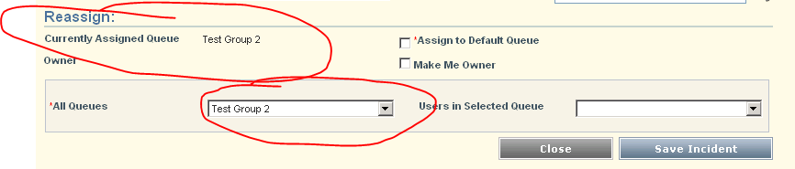

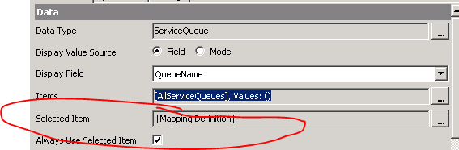

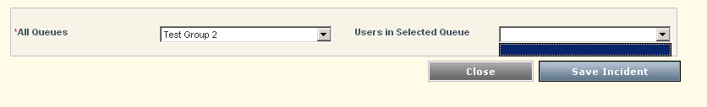
I currently have to select a different queue and then go back and select the original (Test Group 2), for the users to display in the Users in Selected Queue field.
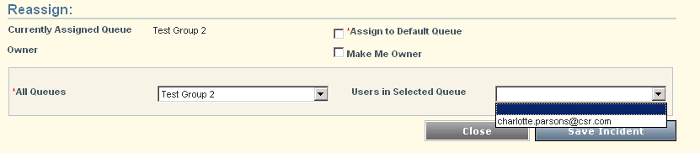

Are you able to help me change the functionality of Users in selected Queue field, so that the members of that queue appear without having to reselect the All Queues field?.

