New as-group policy for our API user – To only let them run jobs that have groups = API_JOBS or RISKJOBS
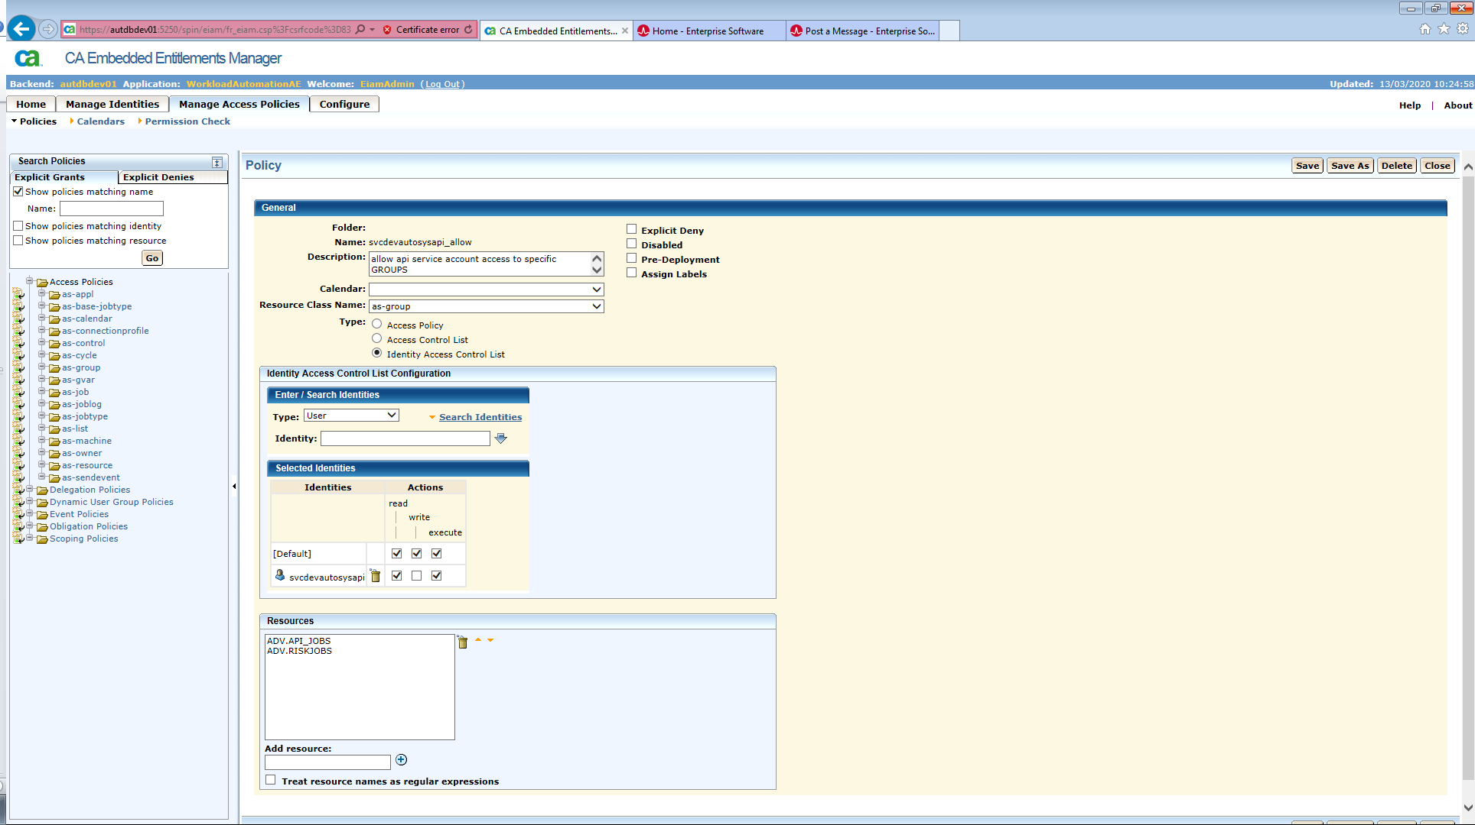
Our explicit deny policy set at the same time for the API user:
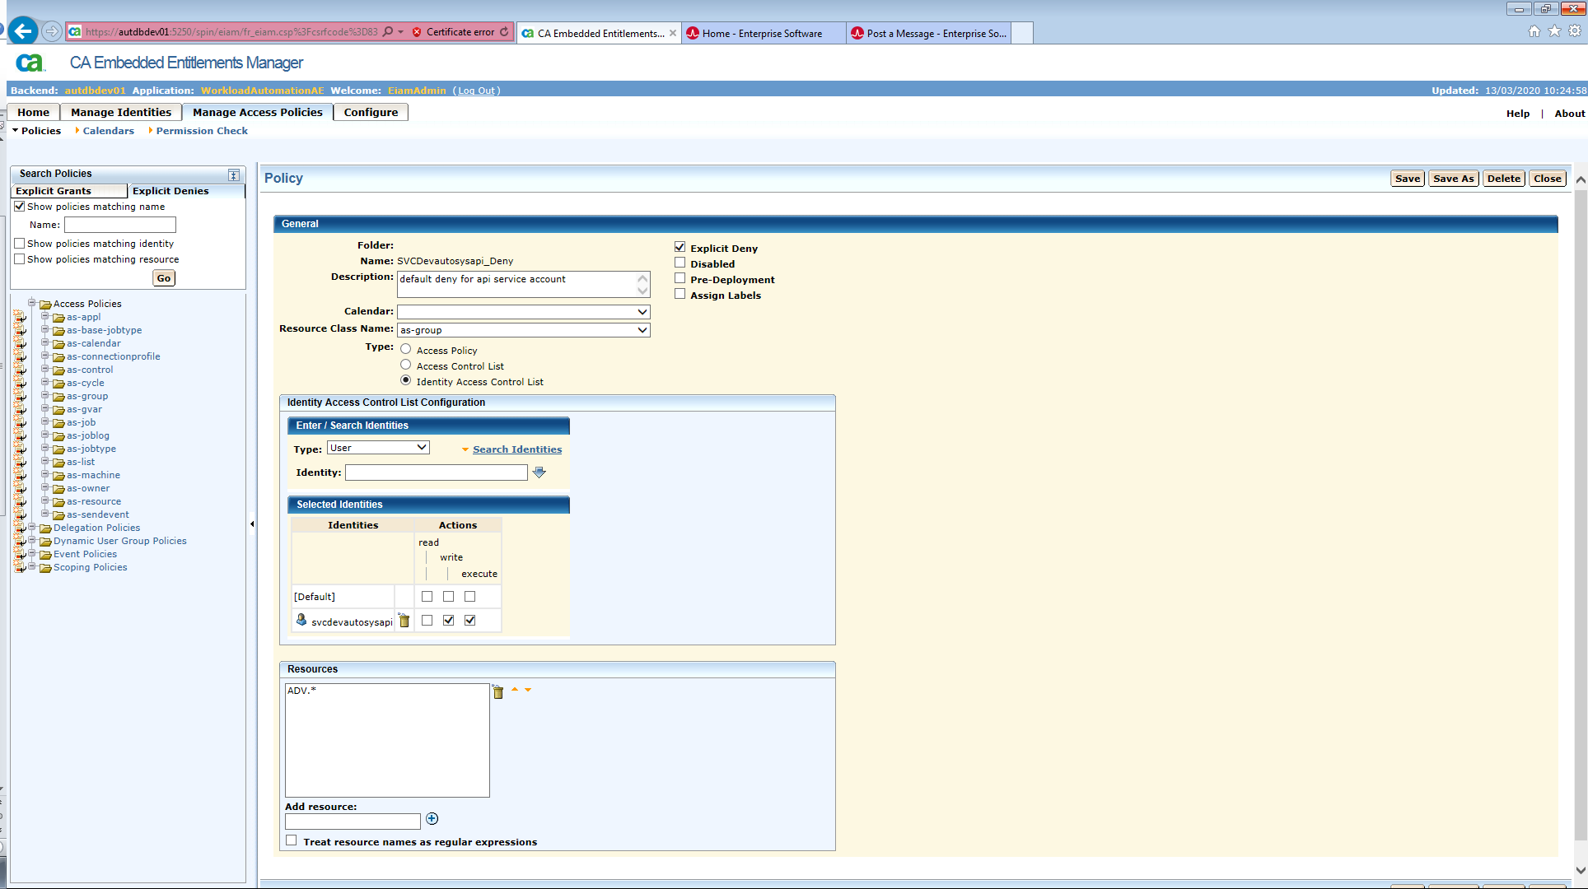

We then added in a new as-owner policy to ensure only certain owners could be inserted into our environment:
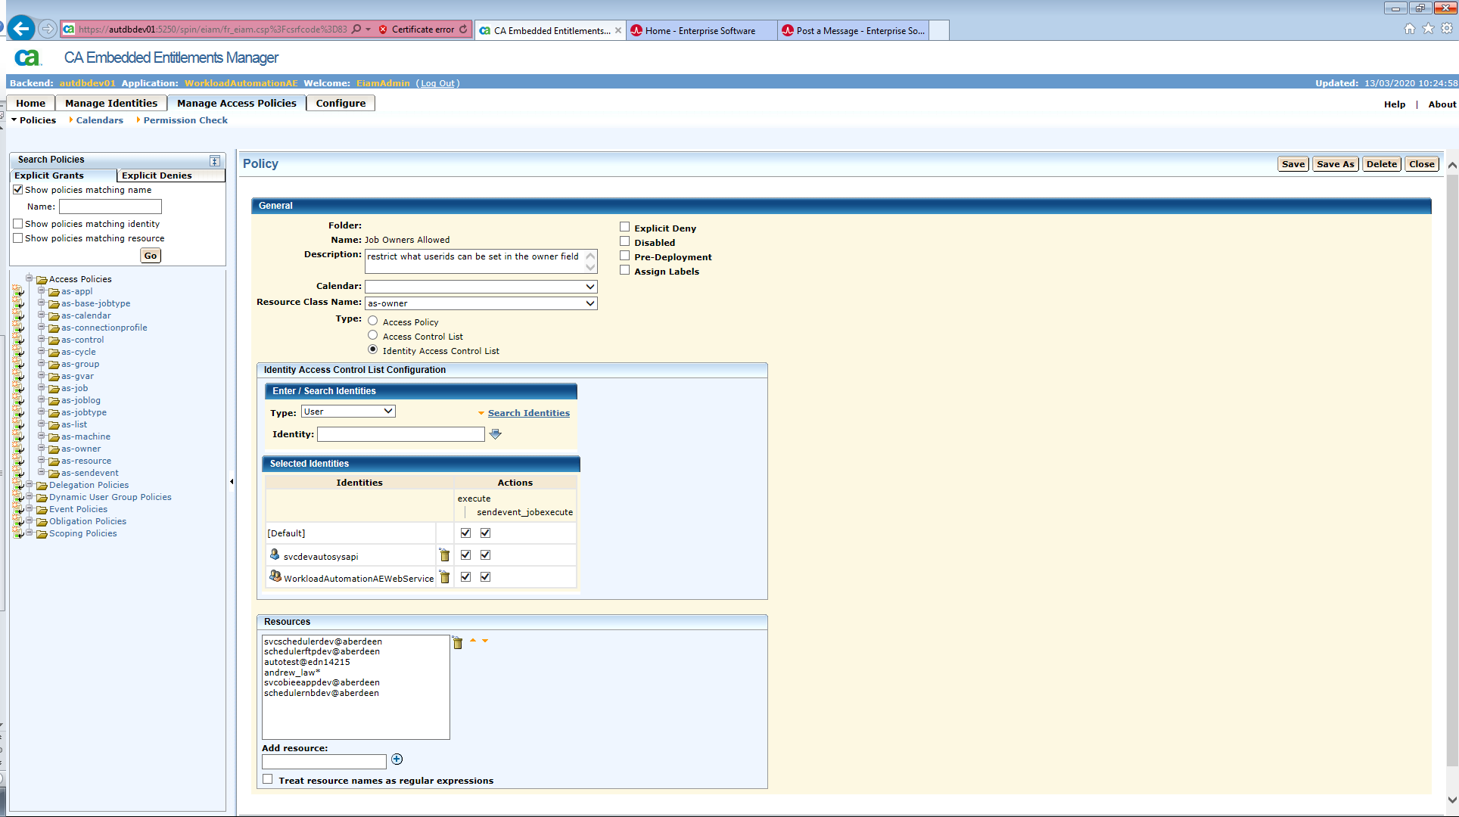
This then blocks our API user from running and we get the following error when firing off a POST command:
<!doctype html><html lang="en"><head><title>HTTP Status 403 – Forbidden</title><style type="text/css">h1 {font-family:Tahoma,Arial,sans-serif;color:white;background-color:#525D76;font-size:22px;} h2 {font-family:Tahoma,Arial,sans-serif;color:white;background-color:#525D76;font-size:16px;} h3 {font-family:Tahoma,Arial,sans-serif;color:white;background-color:#525D76;font-size:14px;} body {font-family:Tahoma,Arial,sans-serif;color:black;background-color:white;} b {font-family:Tahoma,Arial,sans-serif;color:white;background-color:#525D76;} p {font-family:Tahoma,Arial,sans-serif;background:white;color:black;font-size:12px;} a {color:black;} a.name {color:black;} .line {height:1px;background-color:#525D76;border:none;}</style></head><body><h1>HTTP Status 403 – Forbidden</h1><hr class="line" /><p><b>Type</b> Status Report</p><p><b>Message</b> Forbidden</p><p><b>Description</b> The server understood the request but refuses to authorize it.</p><hr class="line" /><h3>Apache Tomcat/8.5.24</h3></body></html>

