I have imported CI from ITCM by pdm_discimp command

This is MDR Configuration

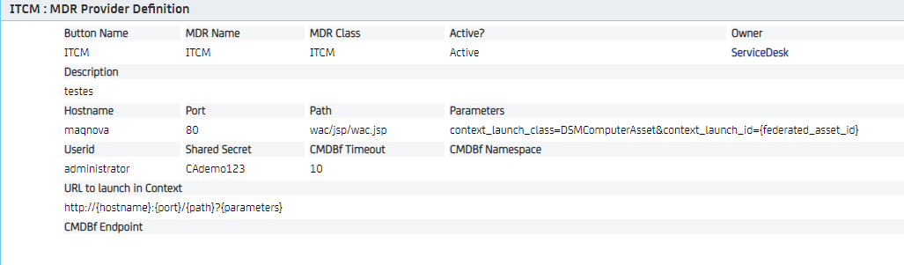

Some queries from mdb database:
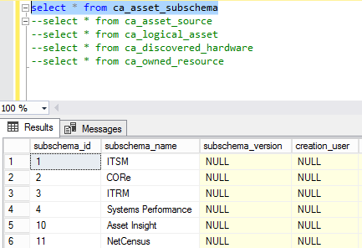

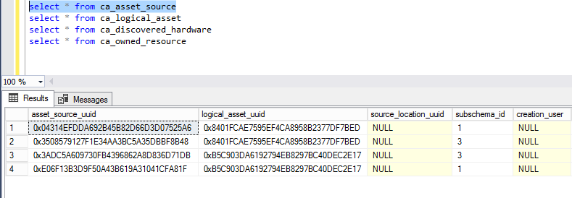
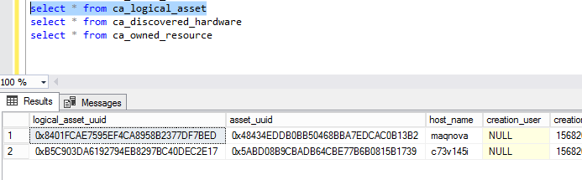

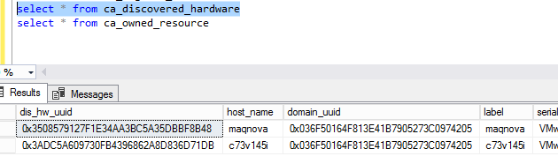

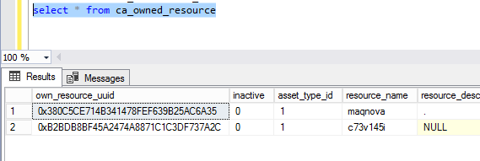

But to MDR button I have to fill Federated CI Mapping

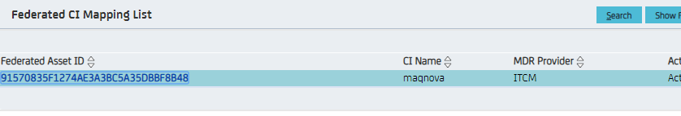

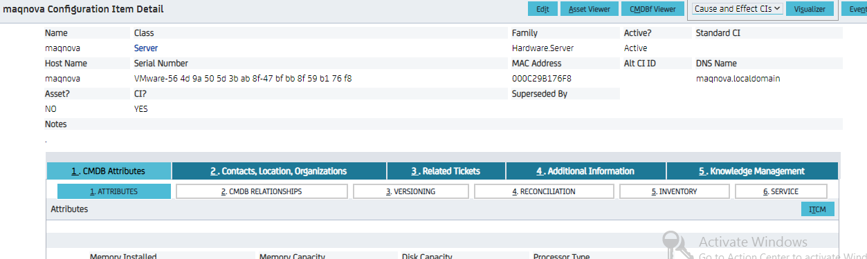
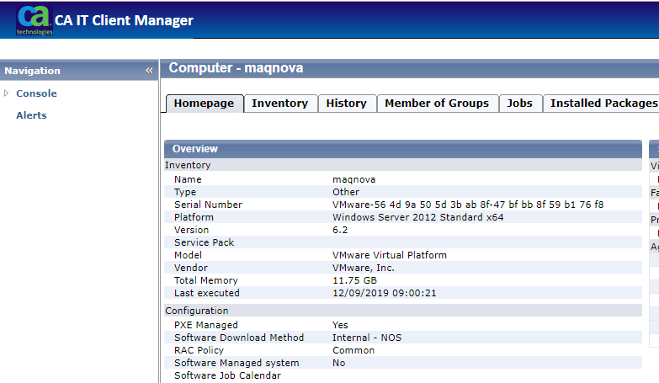

If I don’t fill the Federated CI Mapping I have this screen
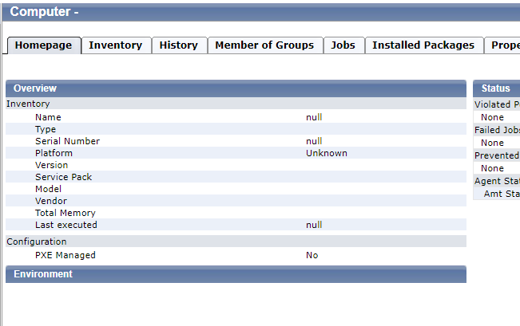
But to find out the correct uuid I have to capturing the url I don´t know which table stores this information

