Create New Firewall Rule Policy Block VLC Player

- Click on firewall Policies.

- Right Click and Select ADD.

- Give the Policy Name.

- Select the Rule and ADD Rule.
- Click on Next.
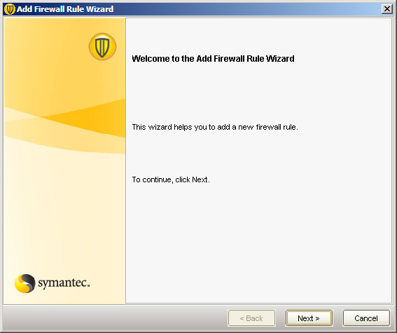

- Select Rule Type and Next.

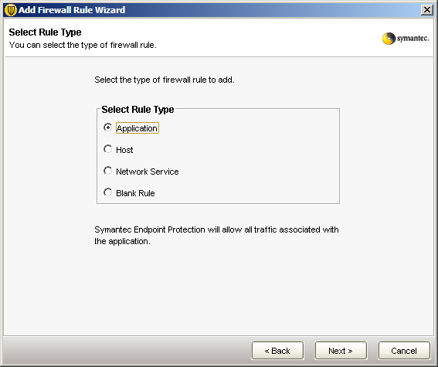

- Select Application Information.

- Select Define an application and next.

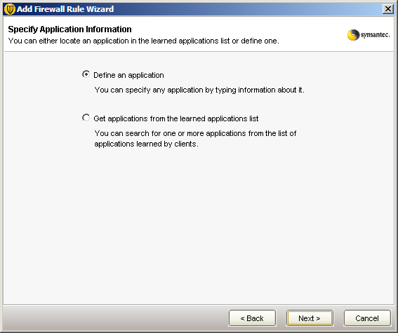

- Give the Specify application details and next.
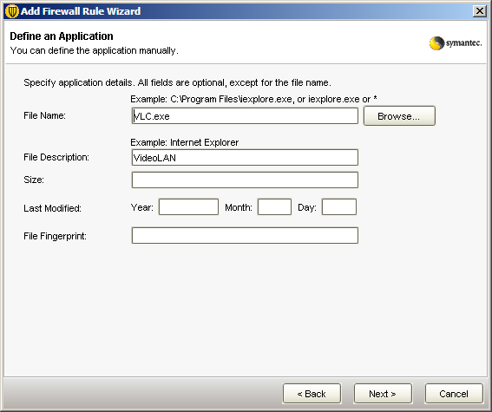

- You can add more application in ADD More TAB.

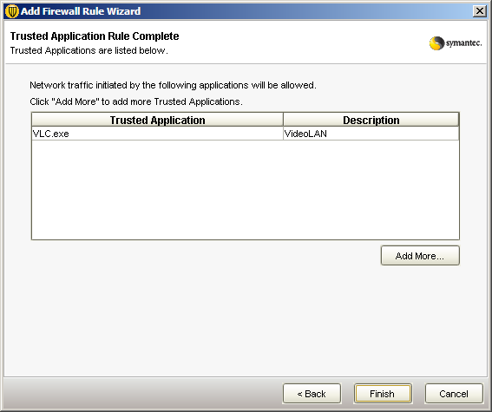

- Select the Action Tab.

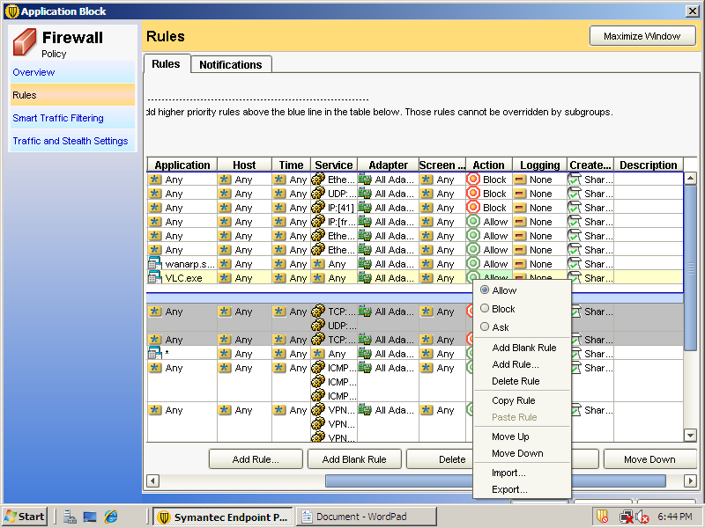

- Block the Application.

- Finish and Assign this policy to group.

