You can use the EEM safex command to export and import EEM policies via Command Line. Within the EEMr12_Export_Import_v4.zip file, under the Docs directory, there is a guide with instructions on how to complete this process. Place this zip file onto the server where EEM is installed.
NOTE: If you are NOT using CA Process Automation (formerly known as CA IT Process Automation or CA IT PAM), skip pages 7-8 in the guide.
Tips for using the EEM Safex Command for Workload Control Center and Workload Automation AE EEM Policies
- Extract the contents of the EEMr12_Export_Import_v4.zip into your %EIAM_HOME%\bin directory
- It is recommended to name your export file – if you don’t, each time you export an application it will use the same default file name. Your previous exports will constantly be overwritten.
- Below is an example of a Workload Control Center export with a specified file name.
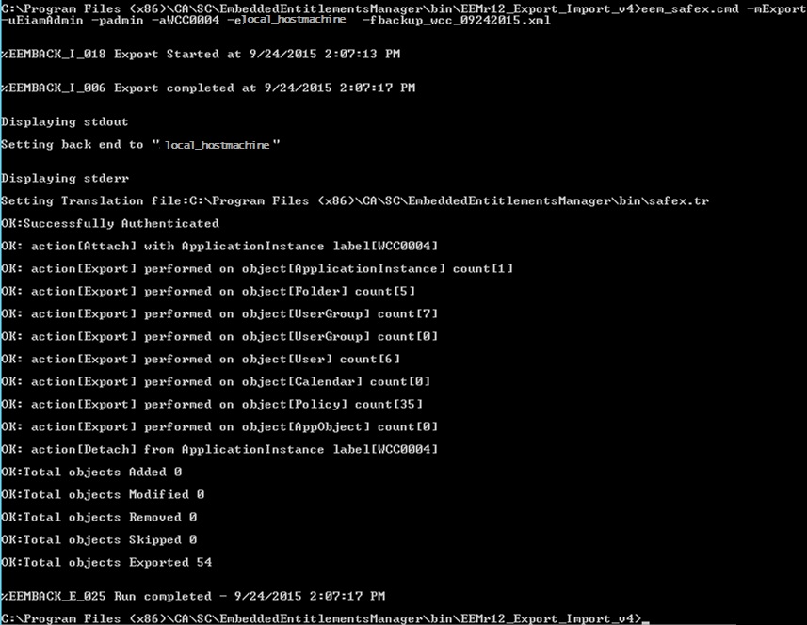
NOTE: There should be NO SPACE between the switch parameter and input (i.e. –u{username} should read as -uEiamAdmin)

- Below is an example of a WorkloadAutomationAE export with a specified file name.
NOTE: There should be NO SPACE between the switch parameter and input (i.e. –u{username} should read as -uEiamAdmin)

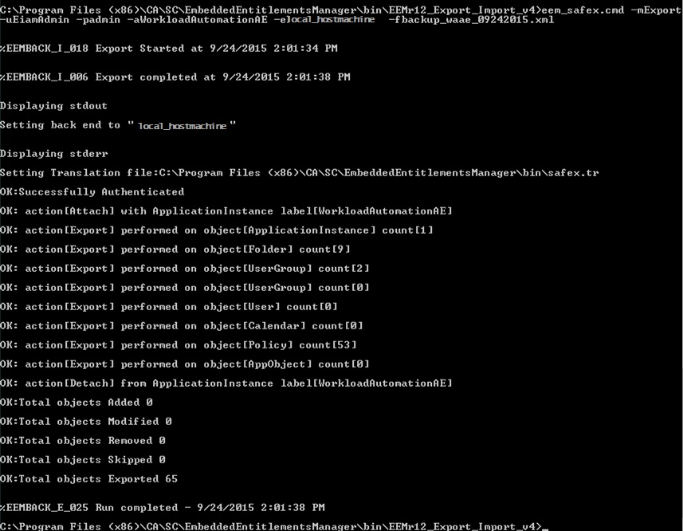
- You will find your exported policies in the EEMr12_Export_Import_v4\XML directory

- If you want to import your WCC or WorkloadAutomationAE policies into a different EEM instance, use the Import parameter and XML file.
NOTE: This command will REGISTER the application to EEM, as well as import the EEM policies. You do NOT need to register WCC or WorkloadAutomationAE prior to running this command. If you have either application registered to EEM, this command will (1) unregister the application from EEM, (2) register the application with EEM, and (3) import the EEM policies.
- Below is an example of a WorkloadAutomationAE import that (1) unregister the application from EEM, (2) register the application with EEM, and (3) import the EEM policies. [There are 3 Autosys instances.]
NOTE: There should be NO SPACE between the switch parameter and input (i.e. –u{username} should read as -uEiamAdmin)
