Hi,
Currently, I am working with the CA Service Desk 17 and CABI 4.1 SP 5 Integration.
The Integration is working without problem. But I noticed a inconsistency in a new field “field z”
This custom field was added, when the derived universe was created.
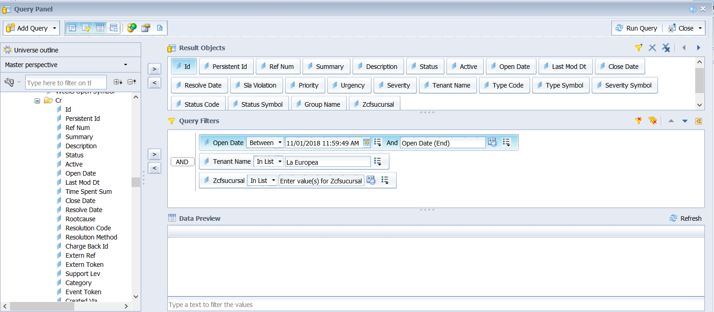
When run the report, The data is mixed, with other customers using the same custom field

*****************************************************************************
This field is called “zsucursal” and is SREL type
The relation is a “loc” Object

Field z
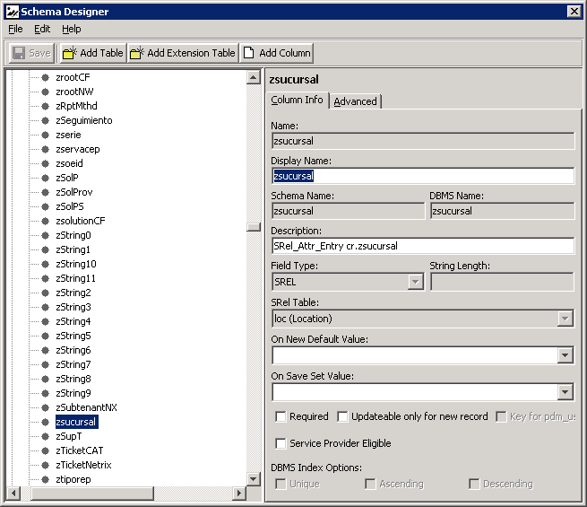

Loc Object: I notice that the loc object has a radio button in “tenant optional “
And all my records have a tenant
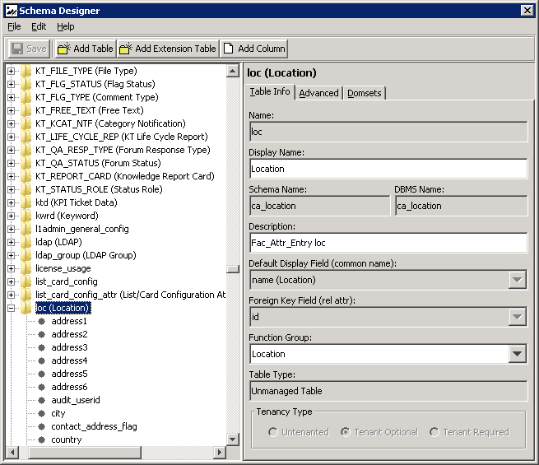

For my custom field to appear in my CABI, I added the Attribute in CA SDM

