How to work with single CEM Gateway in Hierarchy for CEM endpoints
How to avoid unnecessary setup of CEM policies on Child Servers in hierarchy and just use Parent Server to deploy CEM policy in case if environment works with single CEM gateway?

1. Create CEM Web Site on Parent and Child Servers
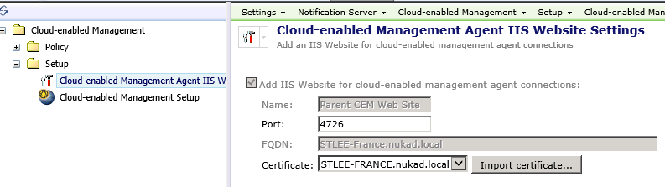
2. Open Installed CEM Gateway and add Parent and Child SMP Servers
For example:
I have 2 SMP Servers, where "Stlee-france" is a Parent and "Stlee-germ-8r2" is a Child Server
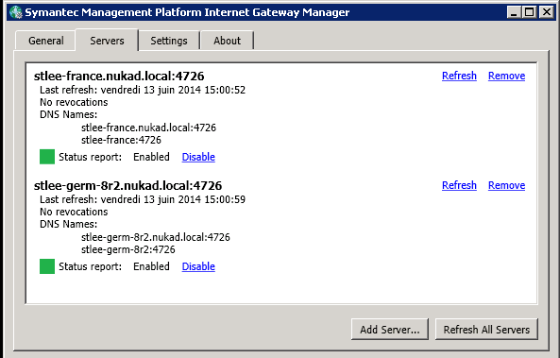
3. Open SMP Console on Parent server and clone default "Cloud-enabled Management Settings" policy.
- Set appropriate settings there for CEM gateway
- Set appropriate resource target
- Save changes
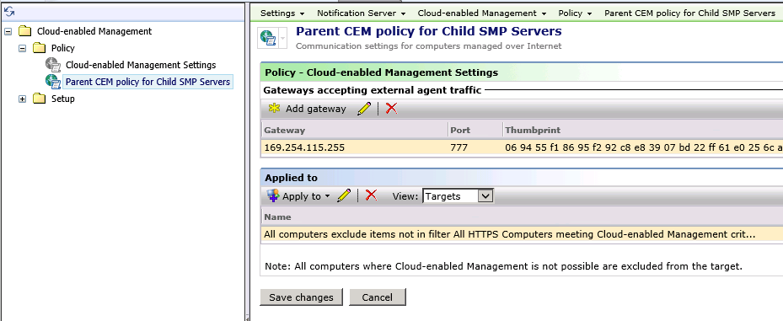
Note: If you have already performed replication UP and DOWN, then Parent Server will knows about managed endpoints from Child Servers and you will be able to create another resource targets which will include all appropriate client computers.
In my case I've used "All HTTPS Computers meeting Cloud-enabled Management criteria" filter as "Resource Target" for CEM policy.
4. Now you can perform manual replication of this CEM policy to all your Child SMP Servers from Parent Server via mouse right click menu. Check properties and set appropriate settings.
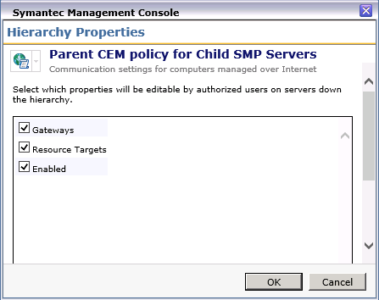

Then perform "Replication Now"
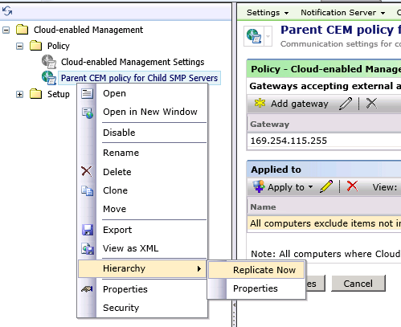
- SMP Child servers will receive this CEM policy and all appropriate client computers will receive it and when client will be in internet, then it will switch to CEM and work with its Child SMP Server through gateway.
