Product and Solution Download

To download the product, you must be registered as an enterprise user with CA support portal.
If you have trouble registering, please contact CA Customer Care Team and a Customer Care Representative will be happy to assist you.

- Go to CA support portal: casupport.broadcom.com, click on the sign in button; Sign in with your log in credentials as shown below,
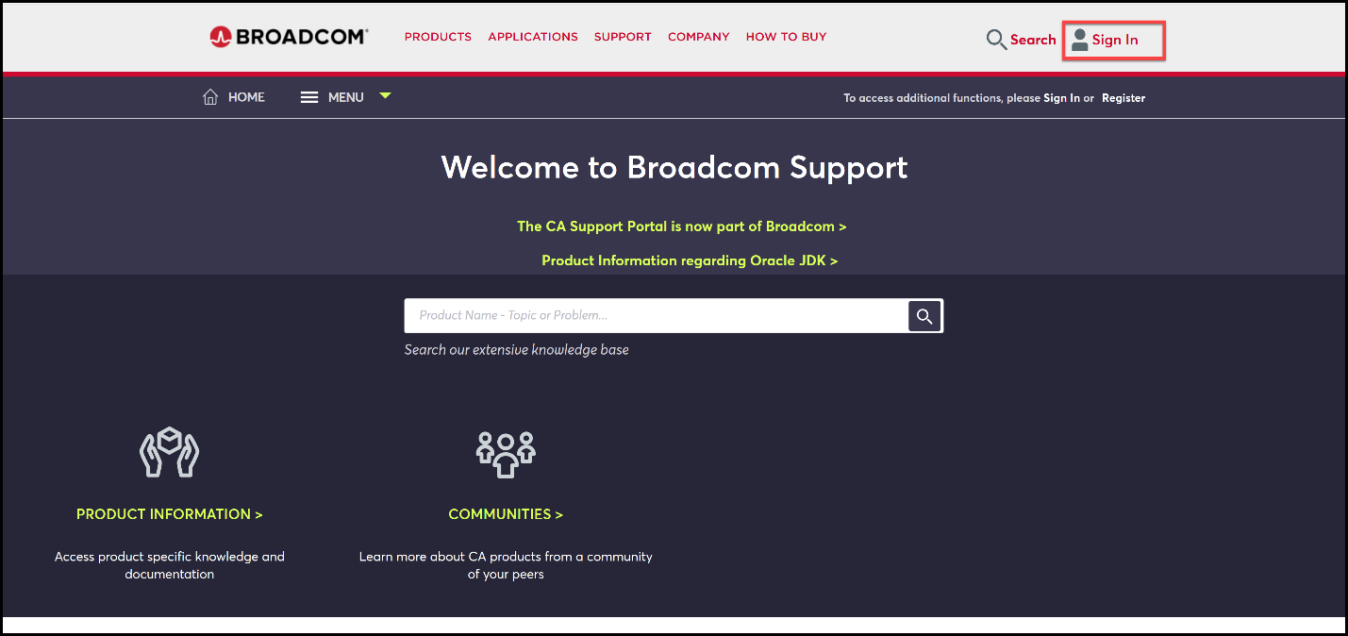
- After logged in, it will enable the download management feature for enterprise users. Click on the download management to access the download center.
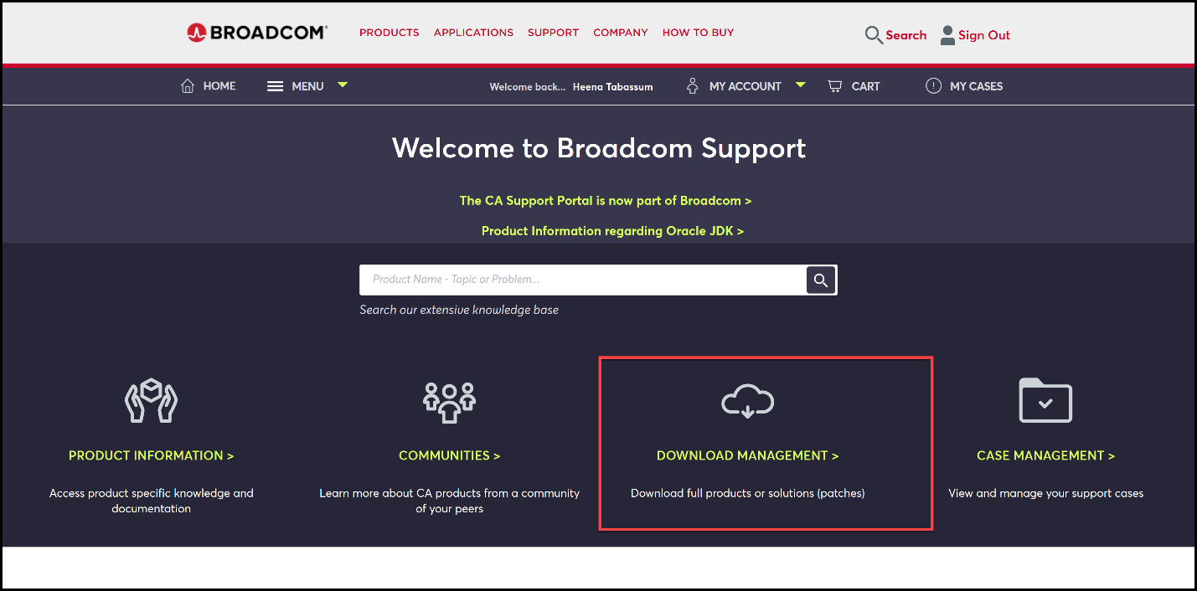
- In the download center, it will populate the products that associate to your account has valid maintenance. Or you can search the product by name.
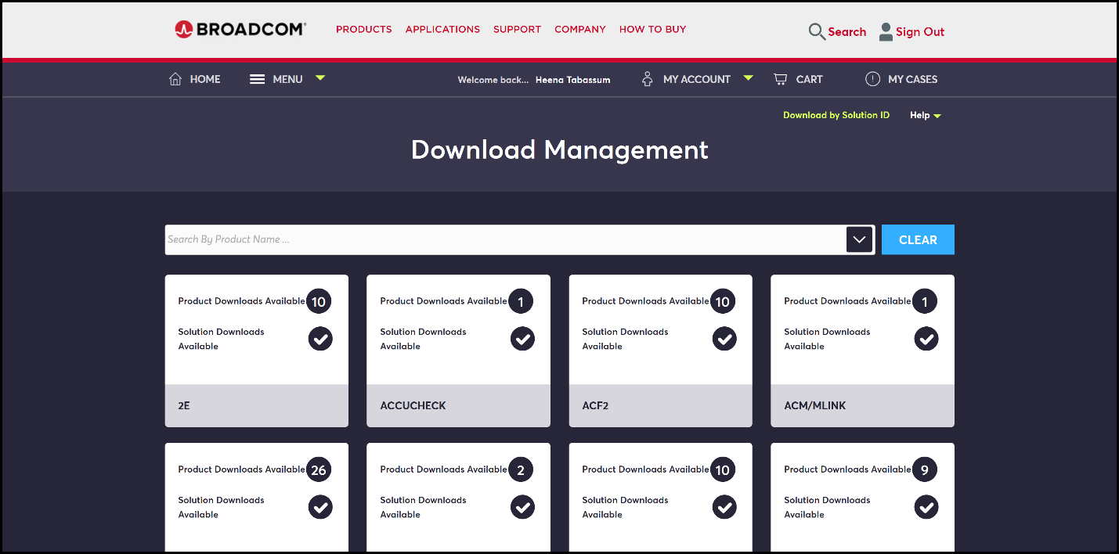
- After choosing a CA Product Card, a list with two tabs is displayed “Product Download” and “Solution Downloads”
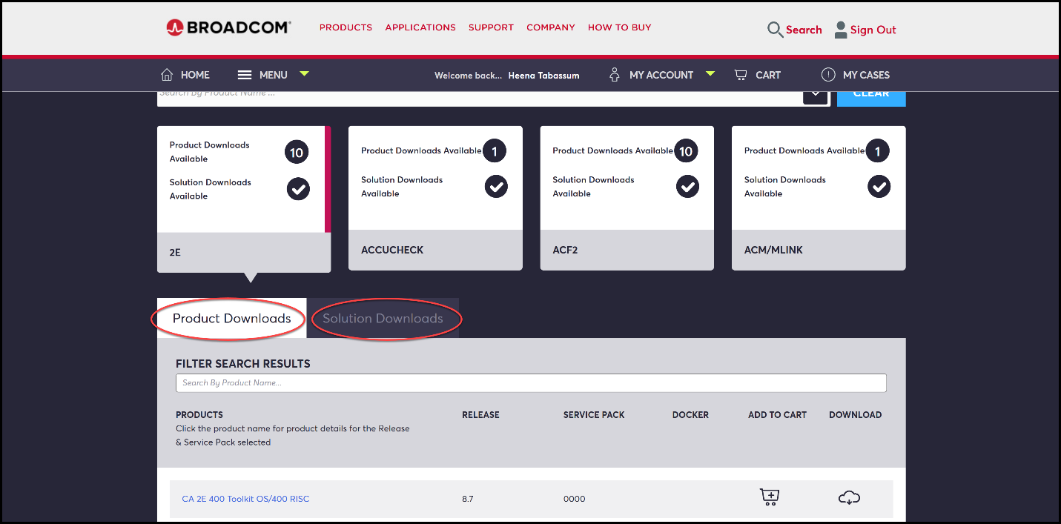
- To download the product or solution (Fix), select the component(s) from product or solution tab and add it to the shopping cart, click on “CART” from the top of the screen when finished.
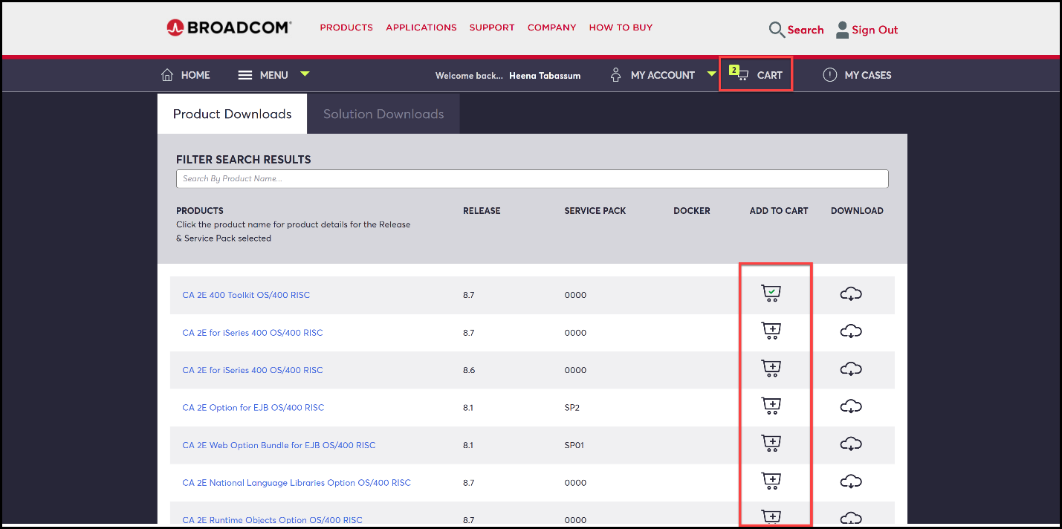

- Verify the component(s) in the CART and checkout to complete the download process.
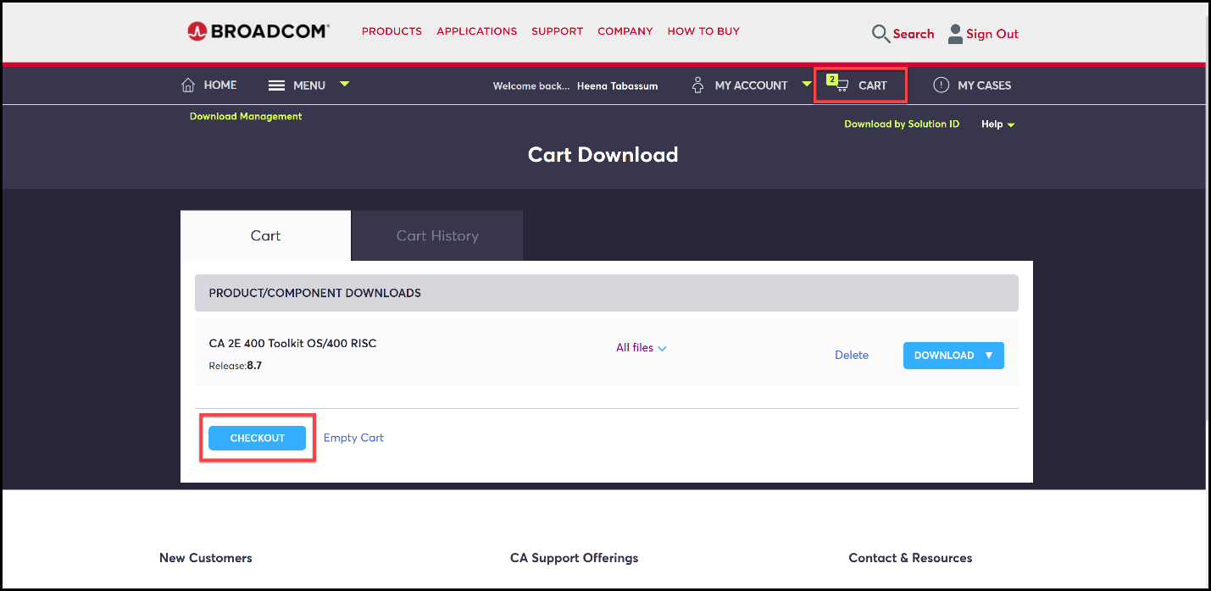
- Download the software using FTP and HTTP Browsers listed in the cart.

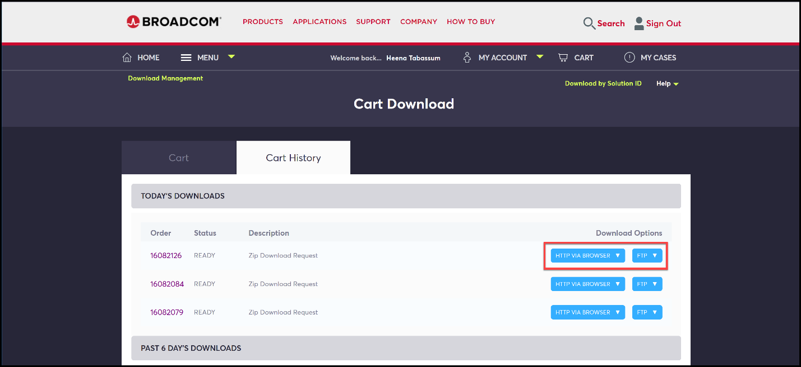

Note:
FTP can be used for individual downloads as well as orders and zipped files.
HTTP Browser can be used only for individual item downloads.
The HTTP Browser option will not be available for downloading orders and zipped files.

If you need help with any of these steps, please contact a CA Customer Care Representative by opening a ticket online, or by calling your local contact number.
Call a Customer Care Representative: CA Contact
Open a Customer Care ticket: Customer Care Request Form

