requester logged in to identity portal
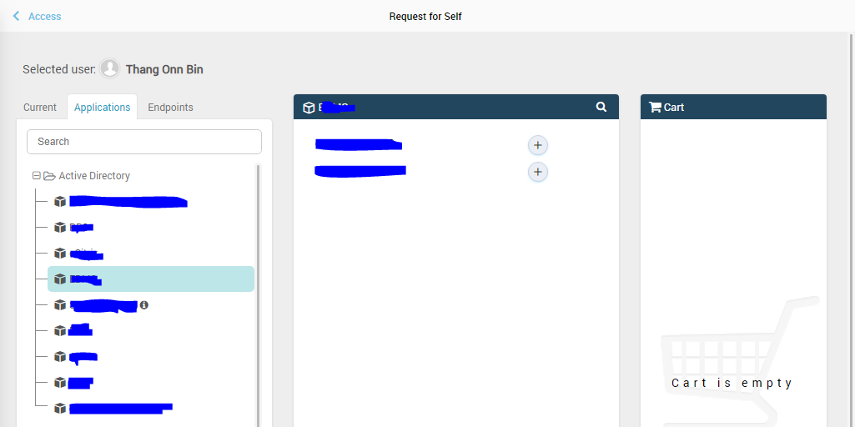
Requester make a request
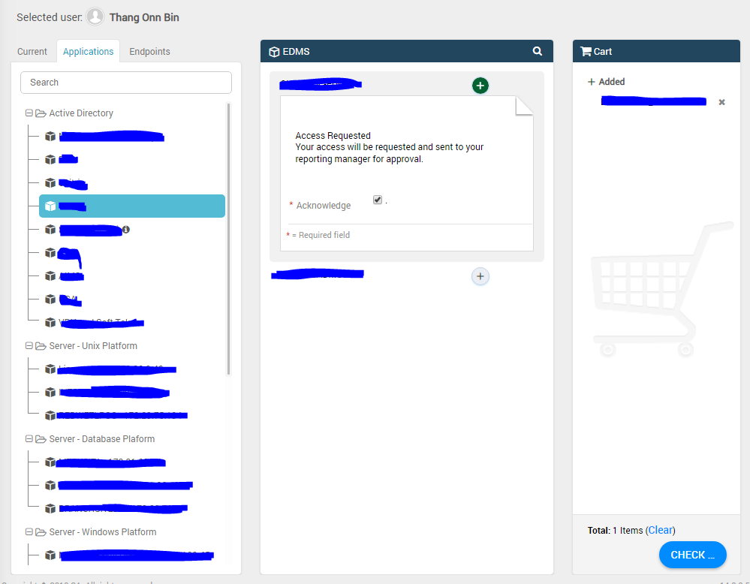
Request Submitted
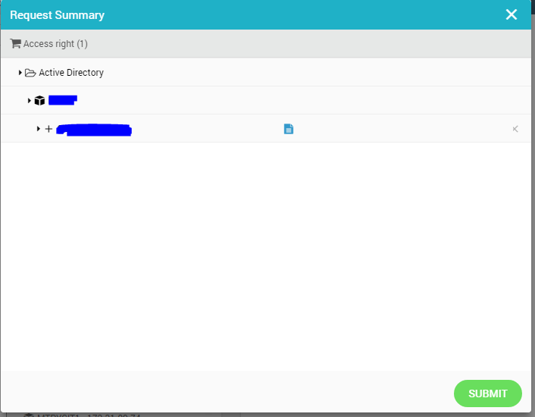
Request ID received
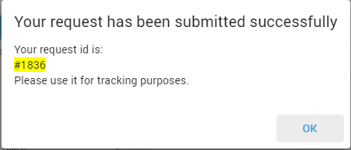
Open up the private browsing mode and login as the approval and leave it first. Approval able to saw the request updated in “task” section
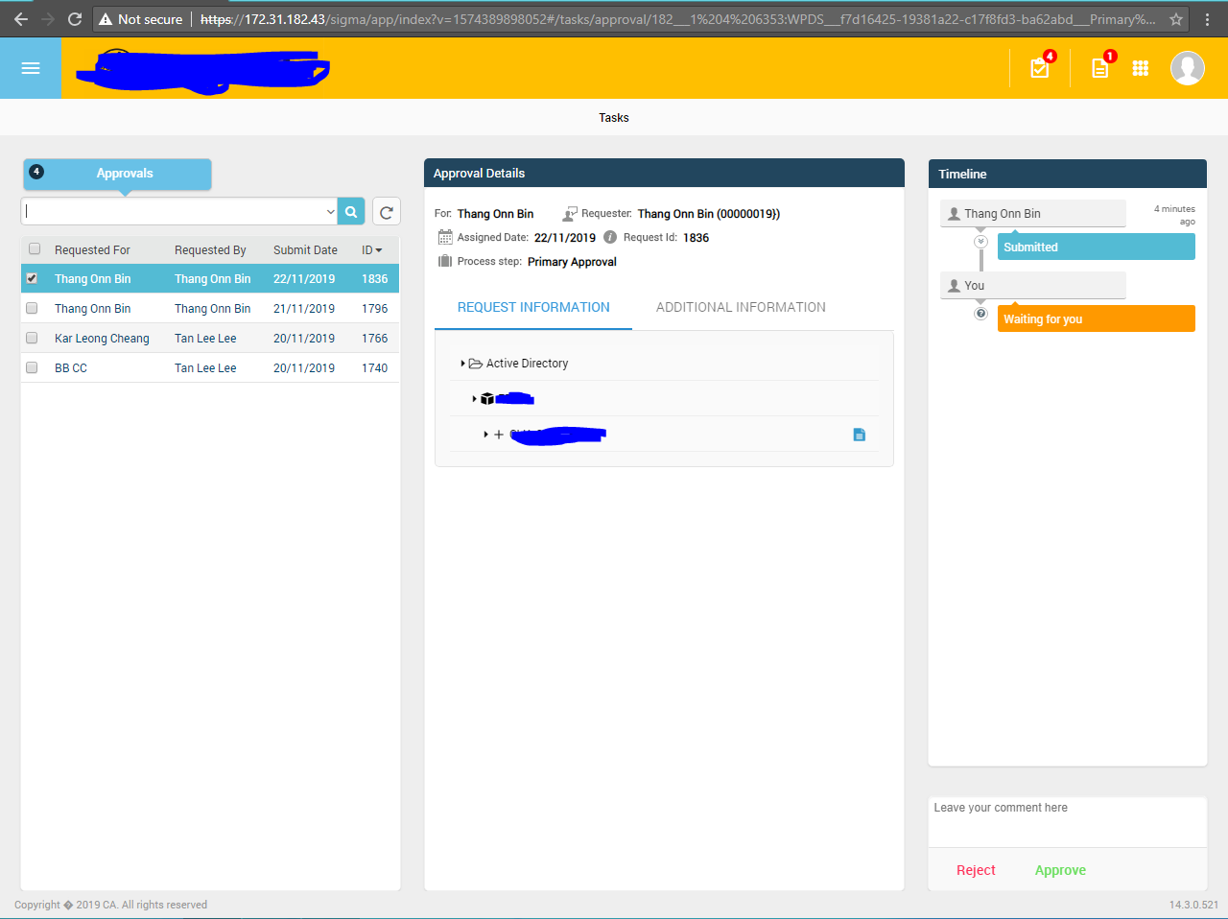
Go back to the requester web browser and cancel the request
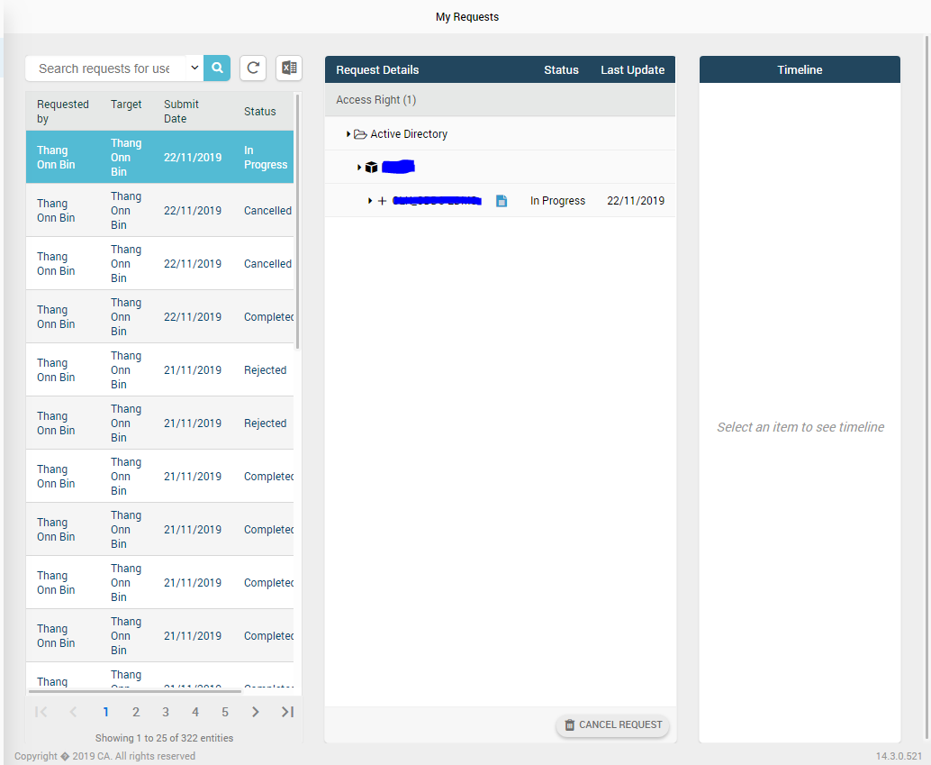
Request canceled by requester
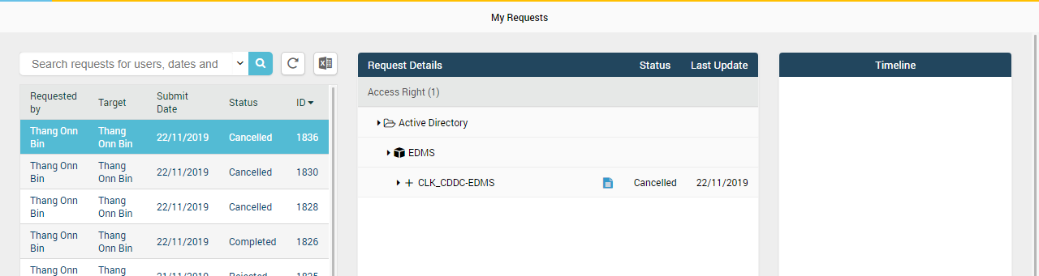
Go back to the private browsing for the approval and approve the request without refreshing the browser
