Copying Feature and Sub Levels from I3006 (Large Project Template)

Ensure you have “Portfolio Item Copy” App on your Dashboard

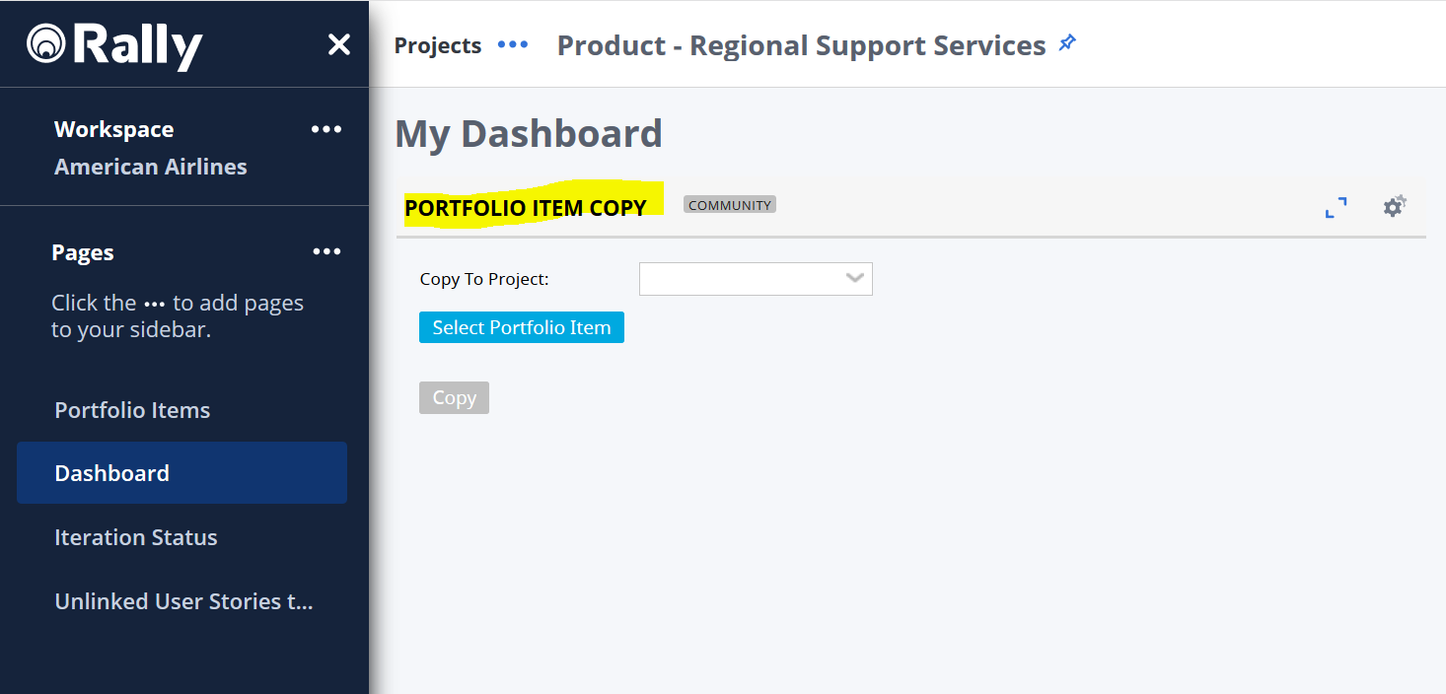

If you do not have it, please add to your dashboard

Click the “Gear” icon and select “Add App

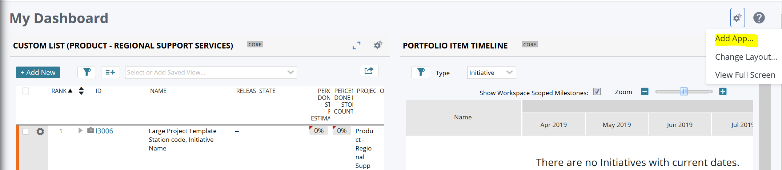

Search for “Portfolio Item Copy” and click “Add” Blue button at the bottom left

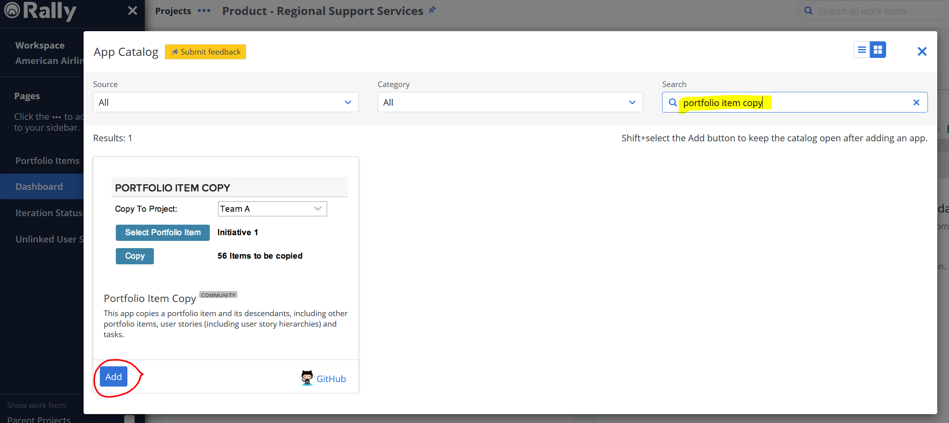

You will now see it on your Dashboard (as in the first screenshot above)
To copy a Feature (and Sub levels) from I3006 (In this example, F32377, which as 1 Team Feature below it and 4 User Stories

Select the approriate Squad Name at the “Copy To Project” drop down

Click on Select Portfolio Item and then type in the Feature Number to be copied (F32377)

Press “Done” at the bottom

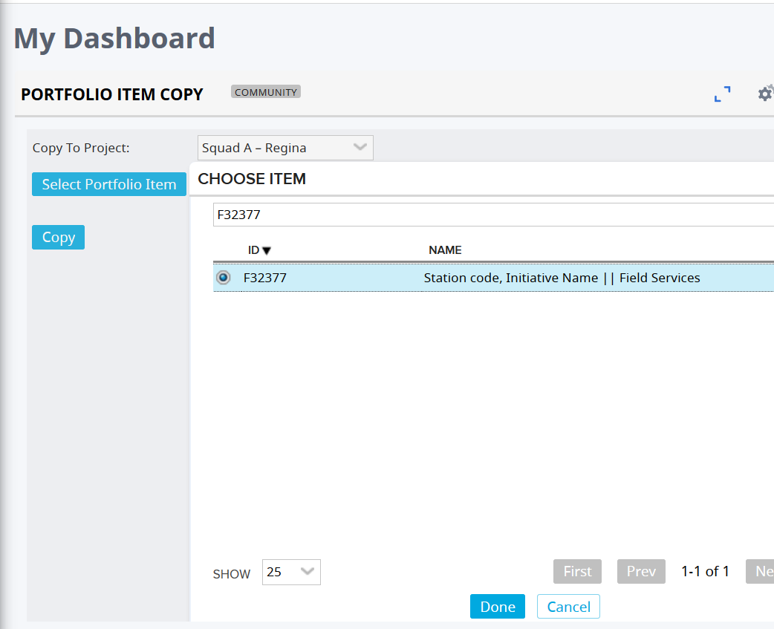

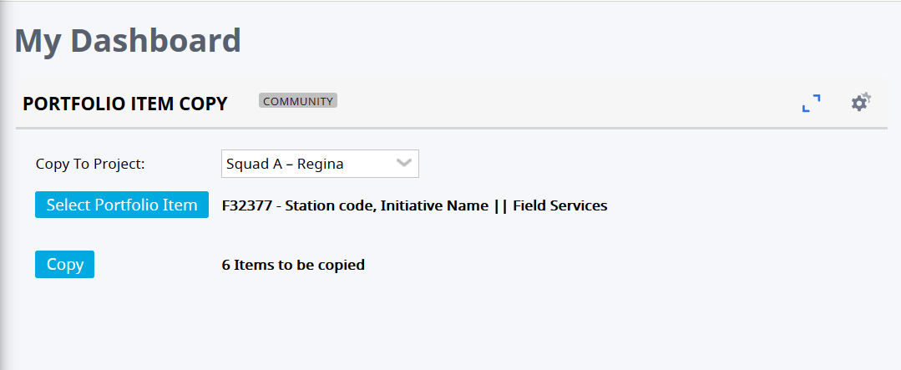

Before anything is copied, you will see the above ie You are about to copy F32377 plus 5 sub levels

As per our example above, 1 Feature, 1 Team Feature and 4 User Stories, a total of 6 Items

Pressing Copy will Copy and you will see the new Feature Number allocated

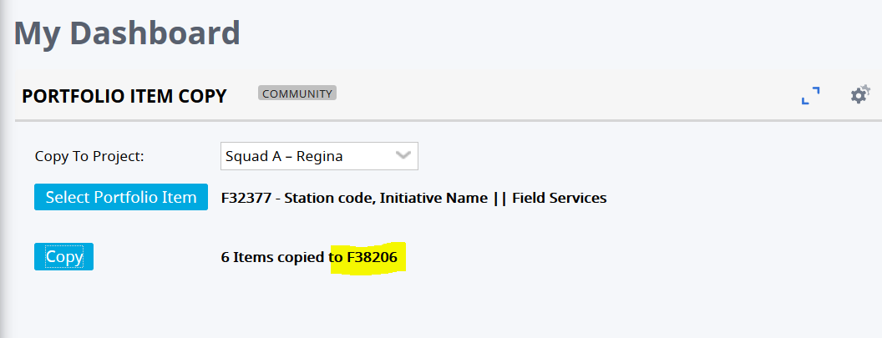

Make a note of the new Feature F28206

Next Step is to associate this new Hierarchy to the Initiative you want to copy it to

In this case for MEX Cargo I3695

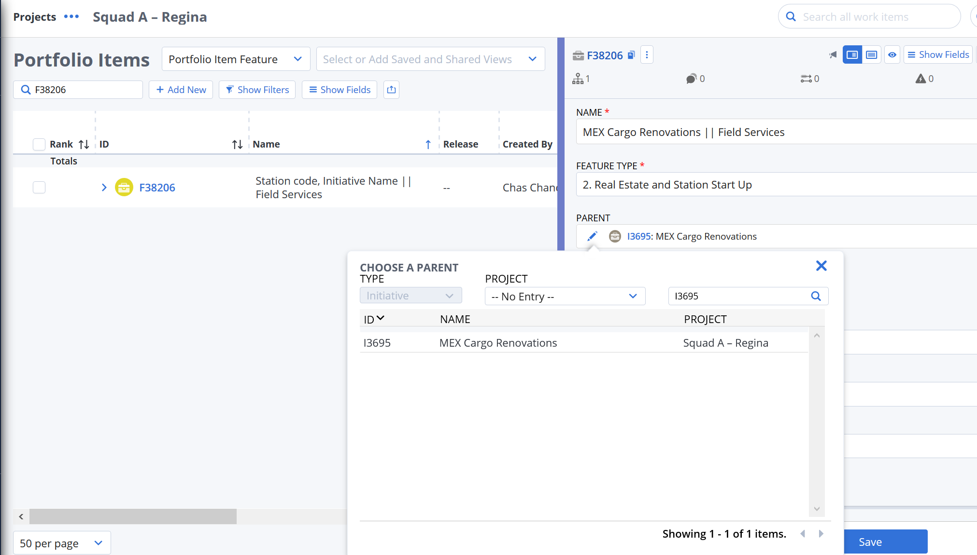

Select the appropriate Parent (I3695) and Save

Once the Initiative has been associated, the remainder of the sub items have the correct PARENT

Depending on how you have set up your View, most of the Fields can be updated “On Screen” rather than go into each item

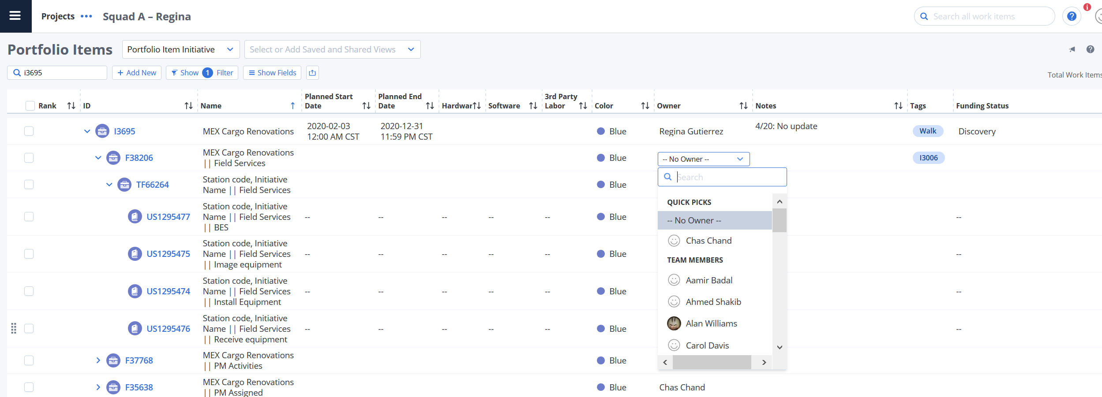

This is ONLY another way of doing things, if you prefer copying from the Template, that is good too. – How you do it is a personal preference

