- Click on Start button -> Run -> Smc –stop Than Press Enter
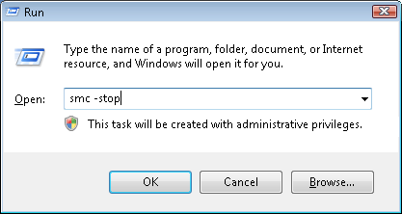

- Enter the Password (*****) to stop the Service
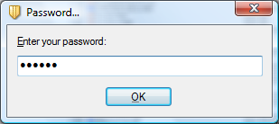

- Go to Below Registry path and delete the entry of “HardwareID”
Path - HKLM\SOFTWARE\Symantec\Symantec Endpoint Protection\SMC\SYLINK\SyLink\HardwareID.
4. Delete the “sephwid.xml” file from below path
Path - C:\Program Files\Common Files\Symantec Shared\HWID
NOTE: The registry value HKLM\SOFTWARE\Symantec\Symantec Endpoint Protection\SMC\SYLINK\SyLink\SySoftk may also need to be deleted if present.
Once the image is applied to a new system, the client will generate a unique id value, check in with its SEPM and register. During the registration process the SEPM will register all necessary client information into the database.
This value will regenerate automatically when the next time client loads.

