FAQ: Ideation for CA Gen
From your CA Gen Product Owner, Kim Peelman 3/4/2020

What is “Ideation”?
Ideation is a forum in the Broadcom communities where customers can post ideas, vote, or leave comments. The product teams monitor the Ideation board for future development plans. They assess a variety of factors, like votes and comments, alignment to product vision, development investment vs customer value.

Where is “Ideation”?
A link to the Ideation forum is in the top menu of the Broadcom community. Click HERE to check it out.
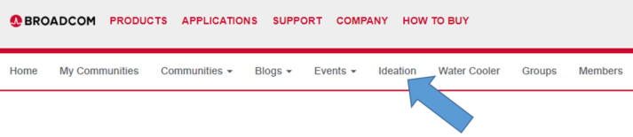

How do I use “Ideation”?
First, search to see if your idea has already been posted. If it has, see if it has already been assessed, and add a vote/comment to show your product team this feature is in demand. Tips for searching: Select “CA Gen” in the Category filter and click “Apply Filters”.
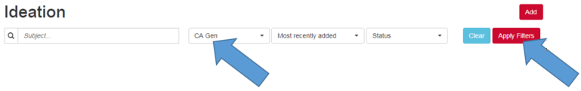
Second, if you have a new idea, post it! Click “Add”, type a catchy, descriptive title, describe the business value and the technical need, select “CA Gen” as the category, and “Save”.

How do I vote for an idea?
To vote, click the thumbs up icon. When you have voted, the icon will turn blue.
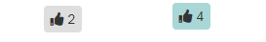

Can I post ideas in the CA Gen community?
The CA Gen community is a good place to start a conversation, like if you want to share a best practice for using a feature or have an implementation question. However, if you have an idea for a new feature, we recommend putting it in Ideation.

How can I gain visibility to CA Gen Ideations?
I realize having a second place to find information ( CA Gen EDGE Community and Ideation) can be challenging. To help, I’m going to start posting links on the CA Gen EDGE Community to new CA Gen Ideations when they are posted.

What does each ‘status’ mean?
To be completely honest, I’m still figuring that out. Here’s what I think they mean. I’m going to review previously submitted ideas to see if that status still makes sense.

- Wish-Listed: This status disabled voting, so we won’t use it.
- Delivered: DONE
- Currently Planned: This idea has been approved and is in the pipeline.
- Under Review: This will most commonly be for items that have at least 10 votes. I’ll review the idea with the CA Gen team and we’ll do research as-needed.
- New: “New” and “Submitted” are pretty much the same thing, but I’ll change a status to “New” to help me keep track of those I’ve read and those I haven’t.
- Not Planned: We’ve reviewed the idea and have concluded it’s not viable for some reason. Those reasons usually include the number of customers interested, the overall customer value, and the feasibility of the request.
- Submitted: This idea was recently submitted, and I haven’t had a chance to look at it yet.
- Duplicate: This idea matched another idea already in Ideation. The Product Owner will put a link referencing the original idea so others can vote and comment all in the original post.

How fast will my idea be implemented?
That’s really a loaded question, but it’s sure to come up, so let’s talk about the elephant in the room… Our organization is a lot like yours. Tons to do and never enough time to do it all. I can’t promise delivery dates. I can promise to be transparent. For example, we commit to engineering work on a quarterly basis. I can tell you when your feature has been added to the commitment for that quarter, and I can update you as we make progress. We make decisions based on priority and resources. We set priorities based on customer impact, so if your idea is going to impact 20% of customers, and something else in the queue will impact 40% of customers, the other idea will probably be worked on first. Of course there are dozens of other factors that feed into that decision making. You know that; you have the same balancing act in your organization. The best I can do is communicate. I will advocate for you. I will ask you to help me build the business case and validate our work as we progress.

How long will my idea stay on the ‘wish list’?
That’s another loaded question, but I want to be frank. I am going to push to move things from ‘wish-listed’ to ‘ currently planned’, and I’ll push for things to move from ‘currently planned’ to ‘delivered’. If I see a feature constantly being deprioritized, I’ll recommend moving it to ‘not planned’. There’s no reason to set unrealistic expectations.

Having said that, our organization works under Agile principles. That means we value individuals and interactions over processes and tools. We value customer collaboration over contract negotiation. We value responding to change over following a plan. I’m always willing to have a phone call to discuss your ideas and needs.

My idea is marked as ‘not planned’. Can that be reconsidered?
Technology and needs are constantly changing. An idea might not have been viable or impactful five years ago, yet today it’s simpler and super valuable (high ROI), so YES a status can be reconsidered. How? Start a conversation in the CA Gen EDGE Community. Get others to support the idea. Create some buzz.

