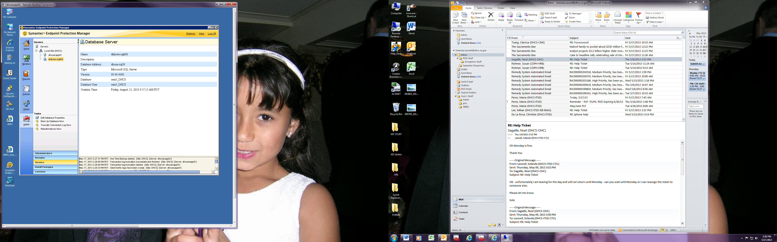

How do I change the Database Address to my new location name?