Hi Kathryn Ellis,

I had the same issue and I have followed the steps but I didn’t get the expected result. Could you please help me out.
Thankyou in Advance.
- I have created a 'Role-Location' Rate Matrix that has the 'Role' and 'Location' columns with different rates.
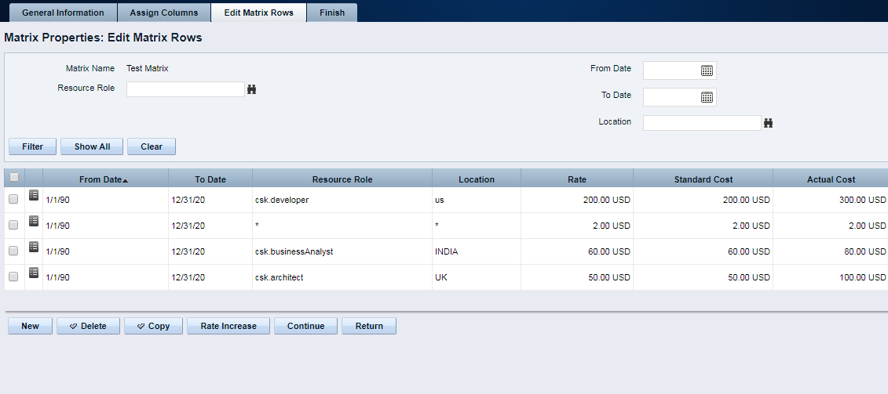
- I have configured the Project, Team List View to include the 'Staff OBS Unit' field and added two Roles to the Project Team.
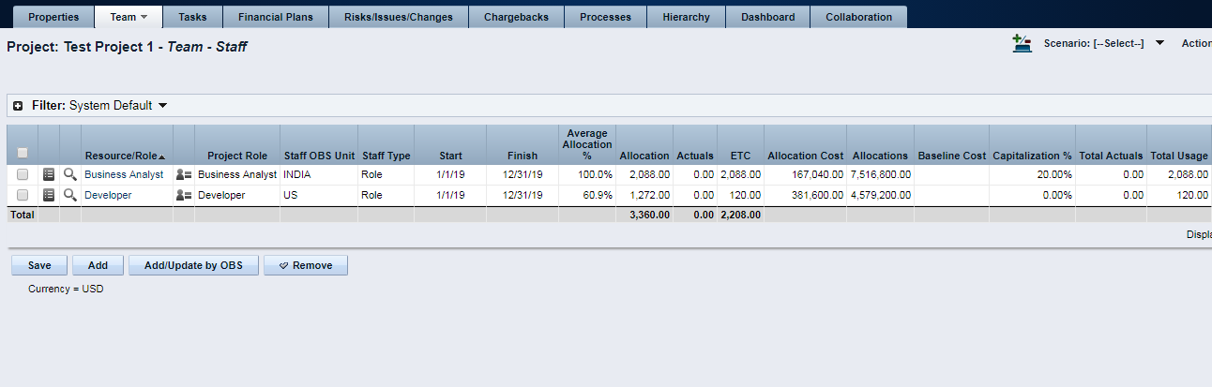
- I have created a new cost plan using 'New From Investment Team', Group By Role, Location.
- But I didn’t get cost values grouped by Roles based on the Location OBS Unit.
