Proxy Application

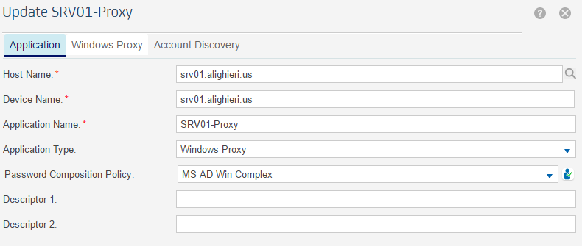

Proxy Application – Proxy Tab

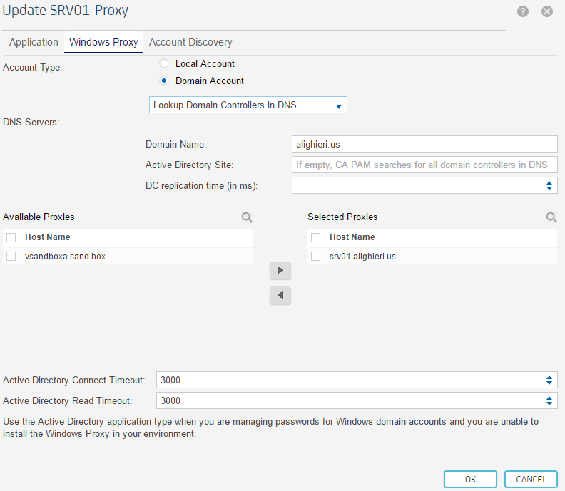

Proxy Application – Account Discovery

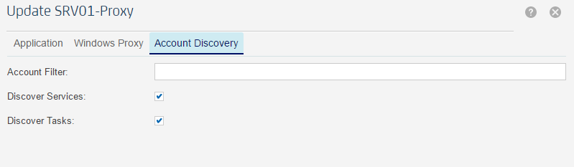

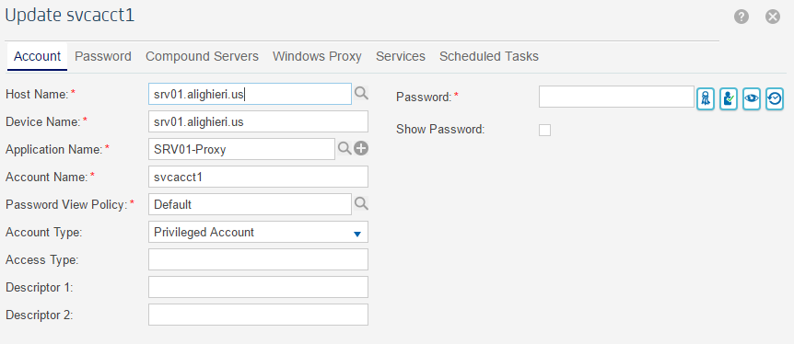Proxy Account – Properties

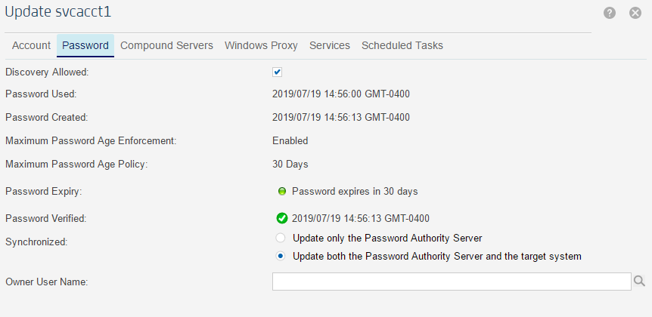

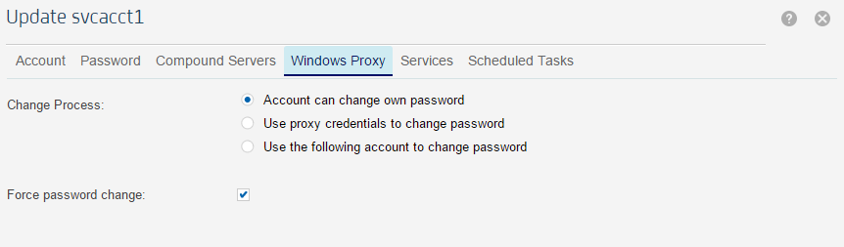

Discovery Profile – Windows Proxy is not listed in the Available Servers List.

