ARD 2.7 LICENSING

Contents
LICENSE ACTIVATION WIZARD 1
ONLINE ACTIVATION 2
OFFLINE MODE 4

LICENSE ACTIVATION WIZARD
- On ARD 2.7, a license activation wizard opens automatically when software is launched for the first time.
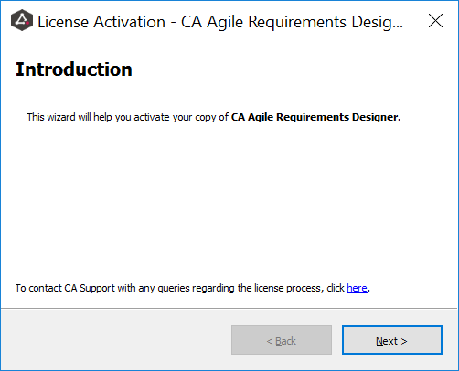

- Click Next and the licensing wizard will show the following 4 options: Trial, Viewer, Named, Concurrent.
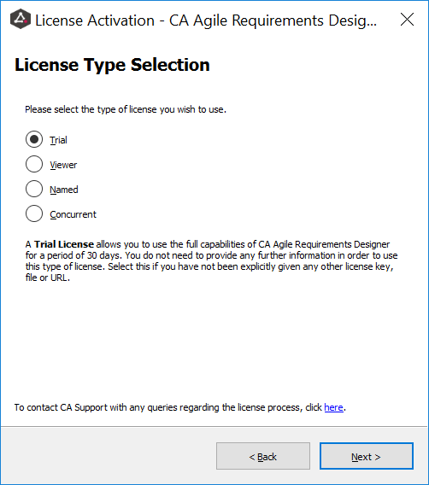

- If Trial or Viewer is selected, a license may not be needed from the CA Licensing Team:
- For Trials, a 30-day key is embedded within the software and it can be used with all functionalities from the moment the trial option is activated.
- The Viewer licensing option does not need a license. By selecting this option, you will be able to use ARD in a limited capacity. Viewer license is permanent.

- If Named or Concurrent is selected, the system will prompt for a license:
- For Concurrent, first set up the remote server by adding the IP address or server name. After that, Concurrent licensing works exactly as Named licensing.

- After choosing Named or Concurrent licensing options, select the Activation Method: Online or Offline.
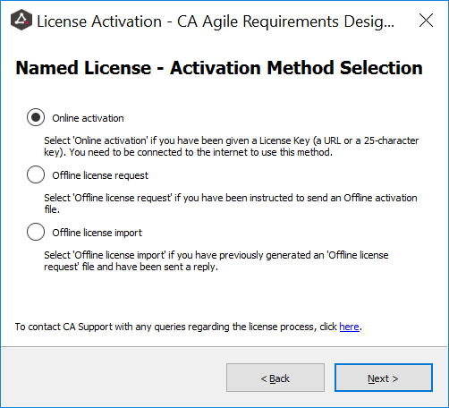

ONLINE ACTIVATION

- Online activation means that the machine where ARD is installed has an internet connection. A 25-digit license code is needed from the CA Licensing Team.
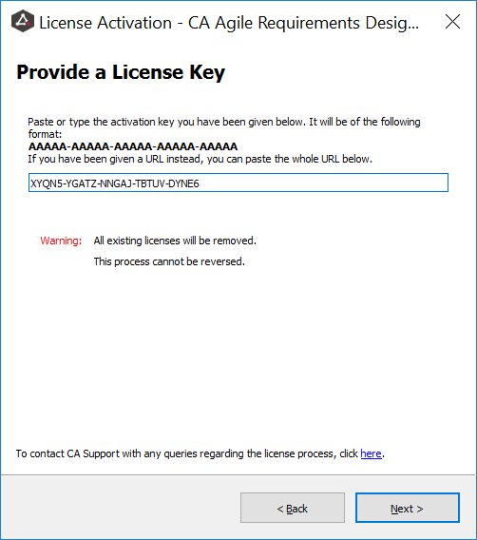

After entering the code and clicking next, the wizard confirms the license was correctly activated and shows the start and end dates in case it is a subscription license or Perpetual if the license is permanent.
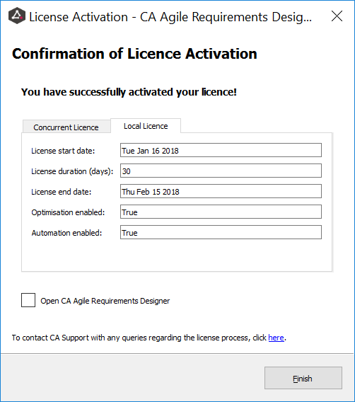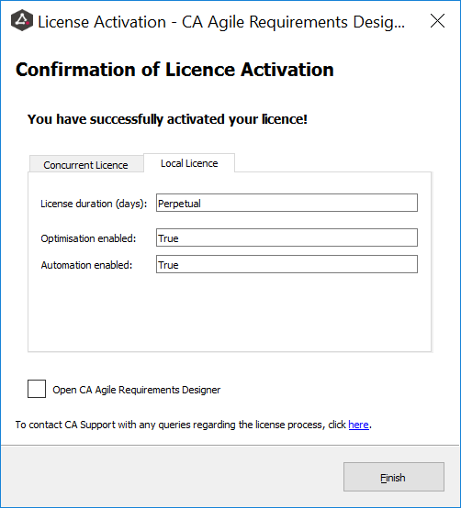

- The software is now licensed and available for use.

OFFLINE MODE
- Offline means that the machine where ARD is installed does not have an internet connection. An offline license request file (RAC file) will need to be generated and provided to the CA Licensing Team in order for a license to be created.
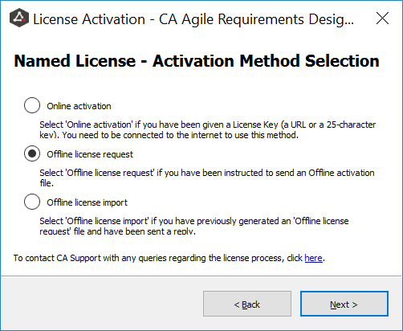

- After clicking next, the License Request File creation begins by choosing the location where the RAC file is to be created.
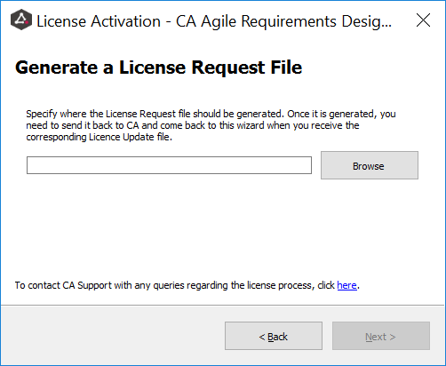

- Choose any location within the server or PC, name the file and click save.
NOTE: Do not change the file extension (WibuCmRac).
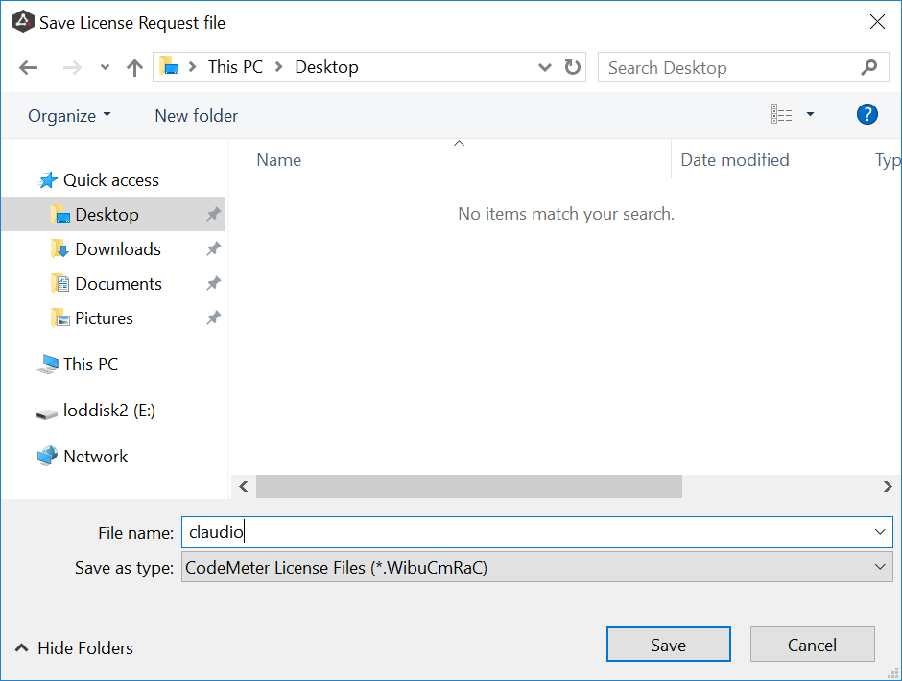

- The wizard will now show the path where the file will be created. Click next.
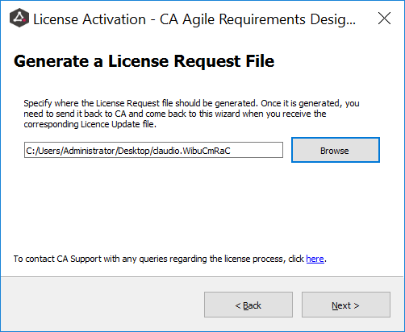

- The instructions on the following page will prompt you to create a licensing request.
(RAC file must be attached to the request)
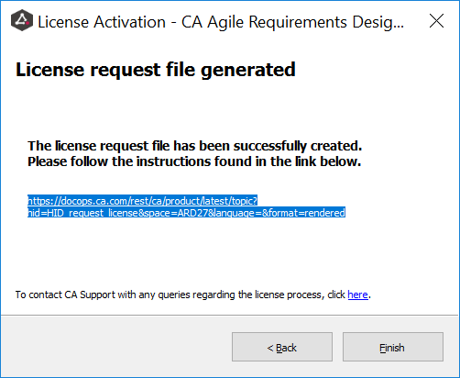
- CA Licensing Team will then provide a license file with the extension WibuCmRau. Save the file to your local machine.

- Open wizard, select “Offline license import” and click next.
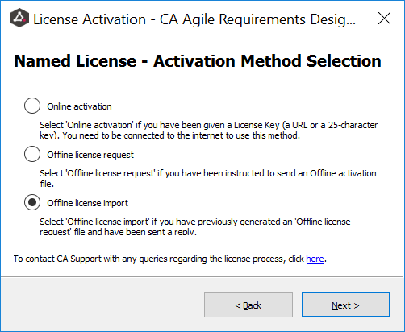

- Locate the license file and click next.
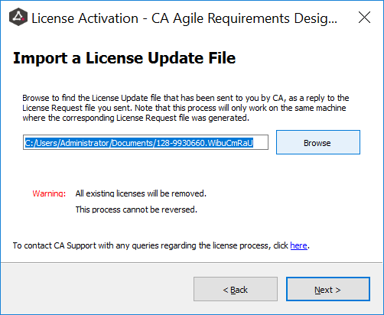

- The License Activation confirmation window will appear, showing the license duration and the end date, or if it is perpetual.

