This running through the directory ( db_1) where opatch.old is located, opatch version is 1.9
But OUI version is 1.0 that should be on 3.0 as you can see screenshot

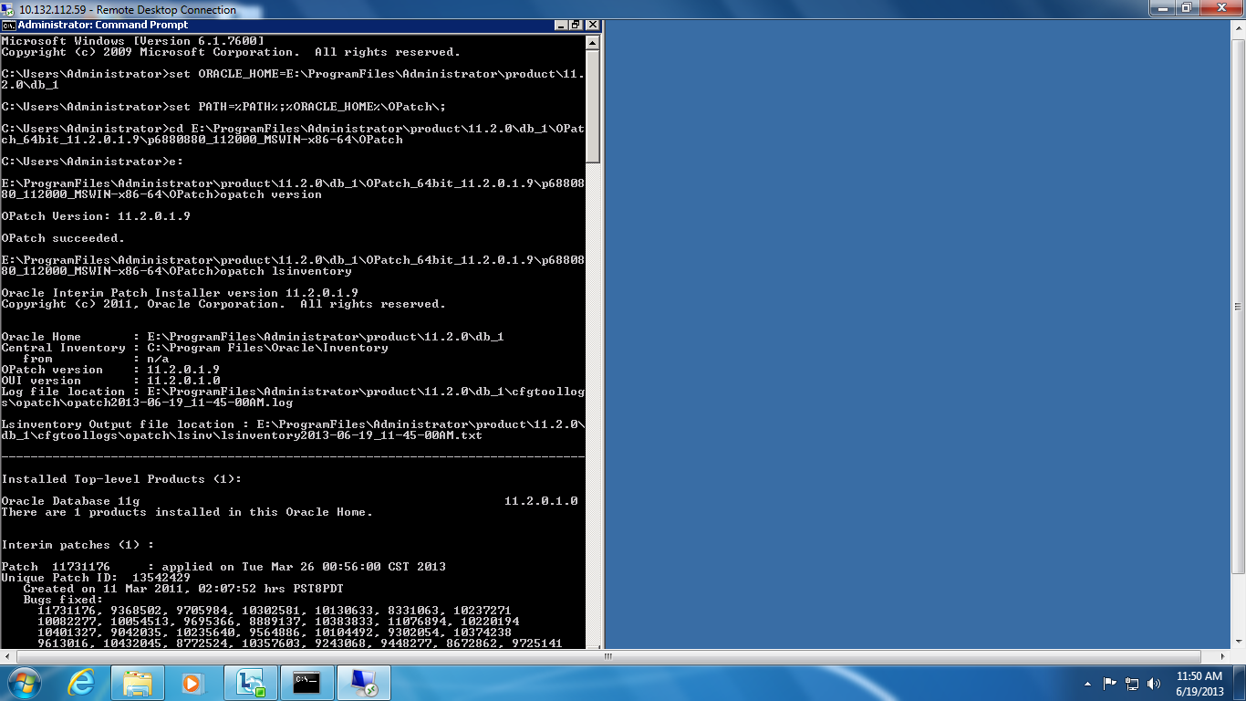
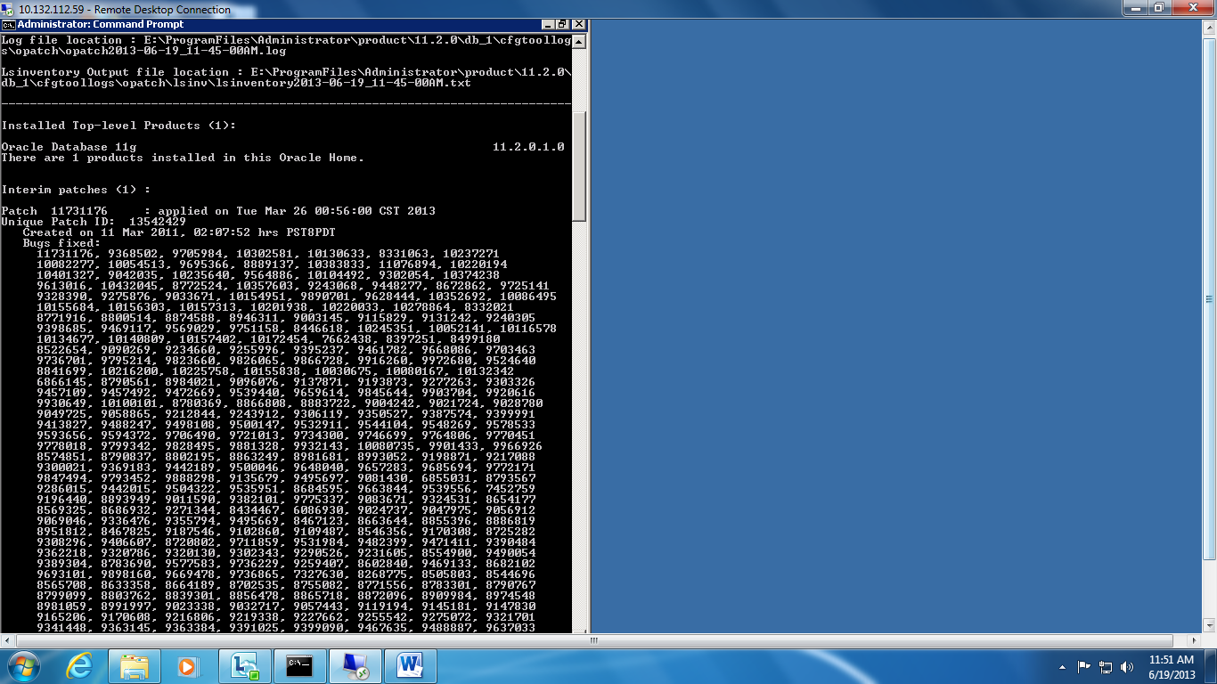
Here is the path where new opatch is located.
Opatch version :1.9
OUI Version: 3.0

This is a correct versions I need.
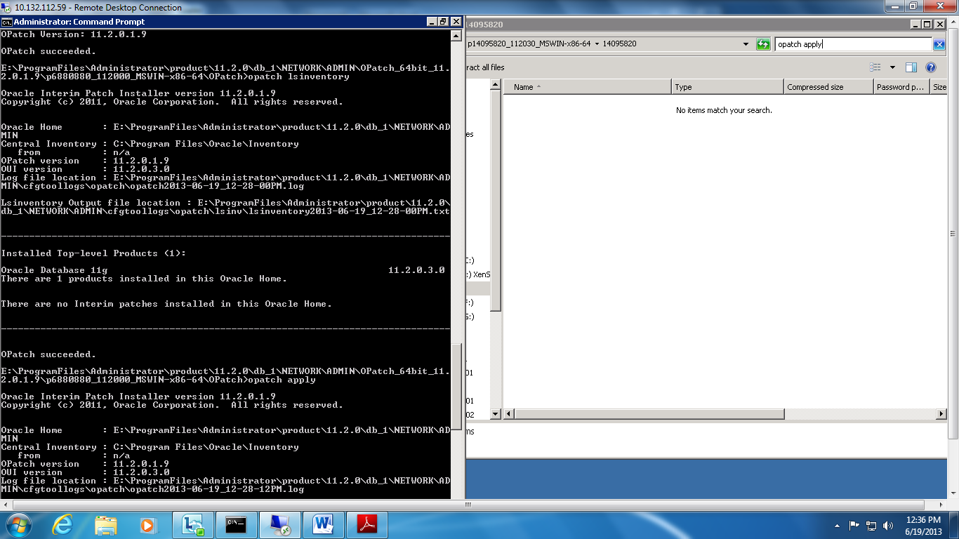
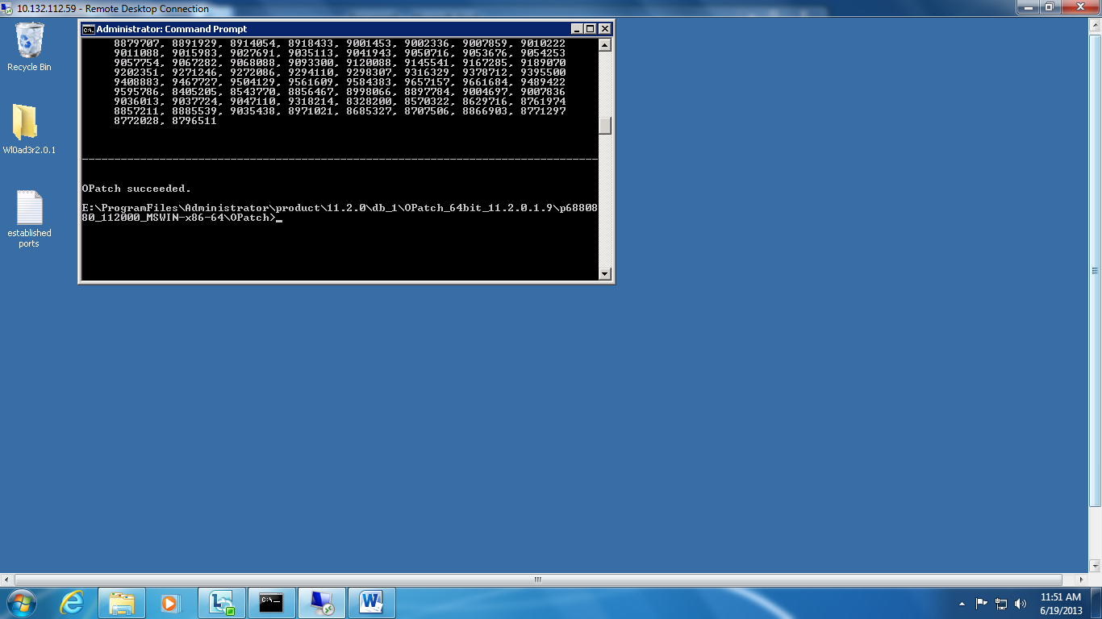
Here’s when running opatch apply through command prompt. It does not recognized.
