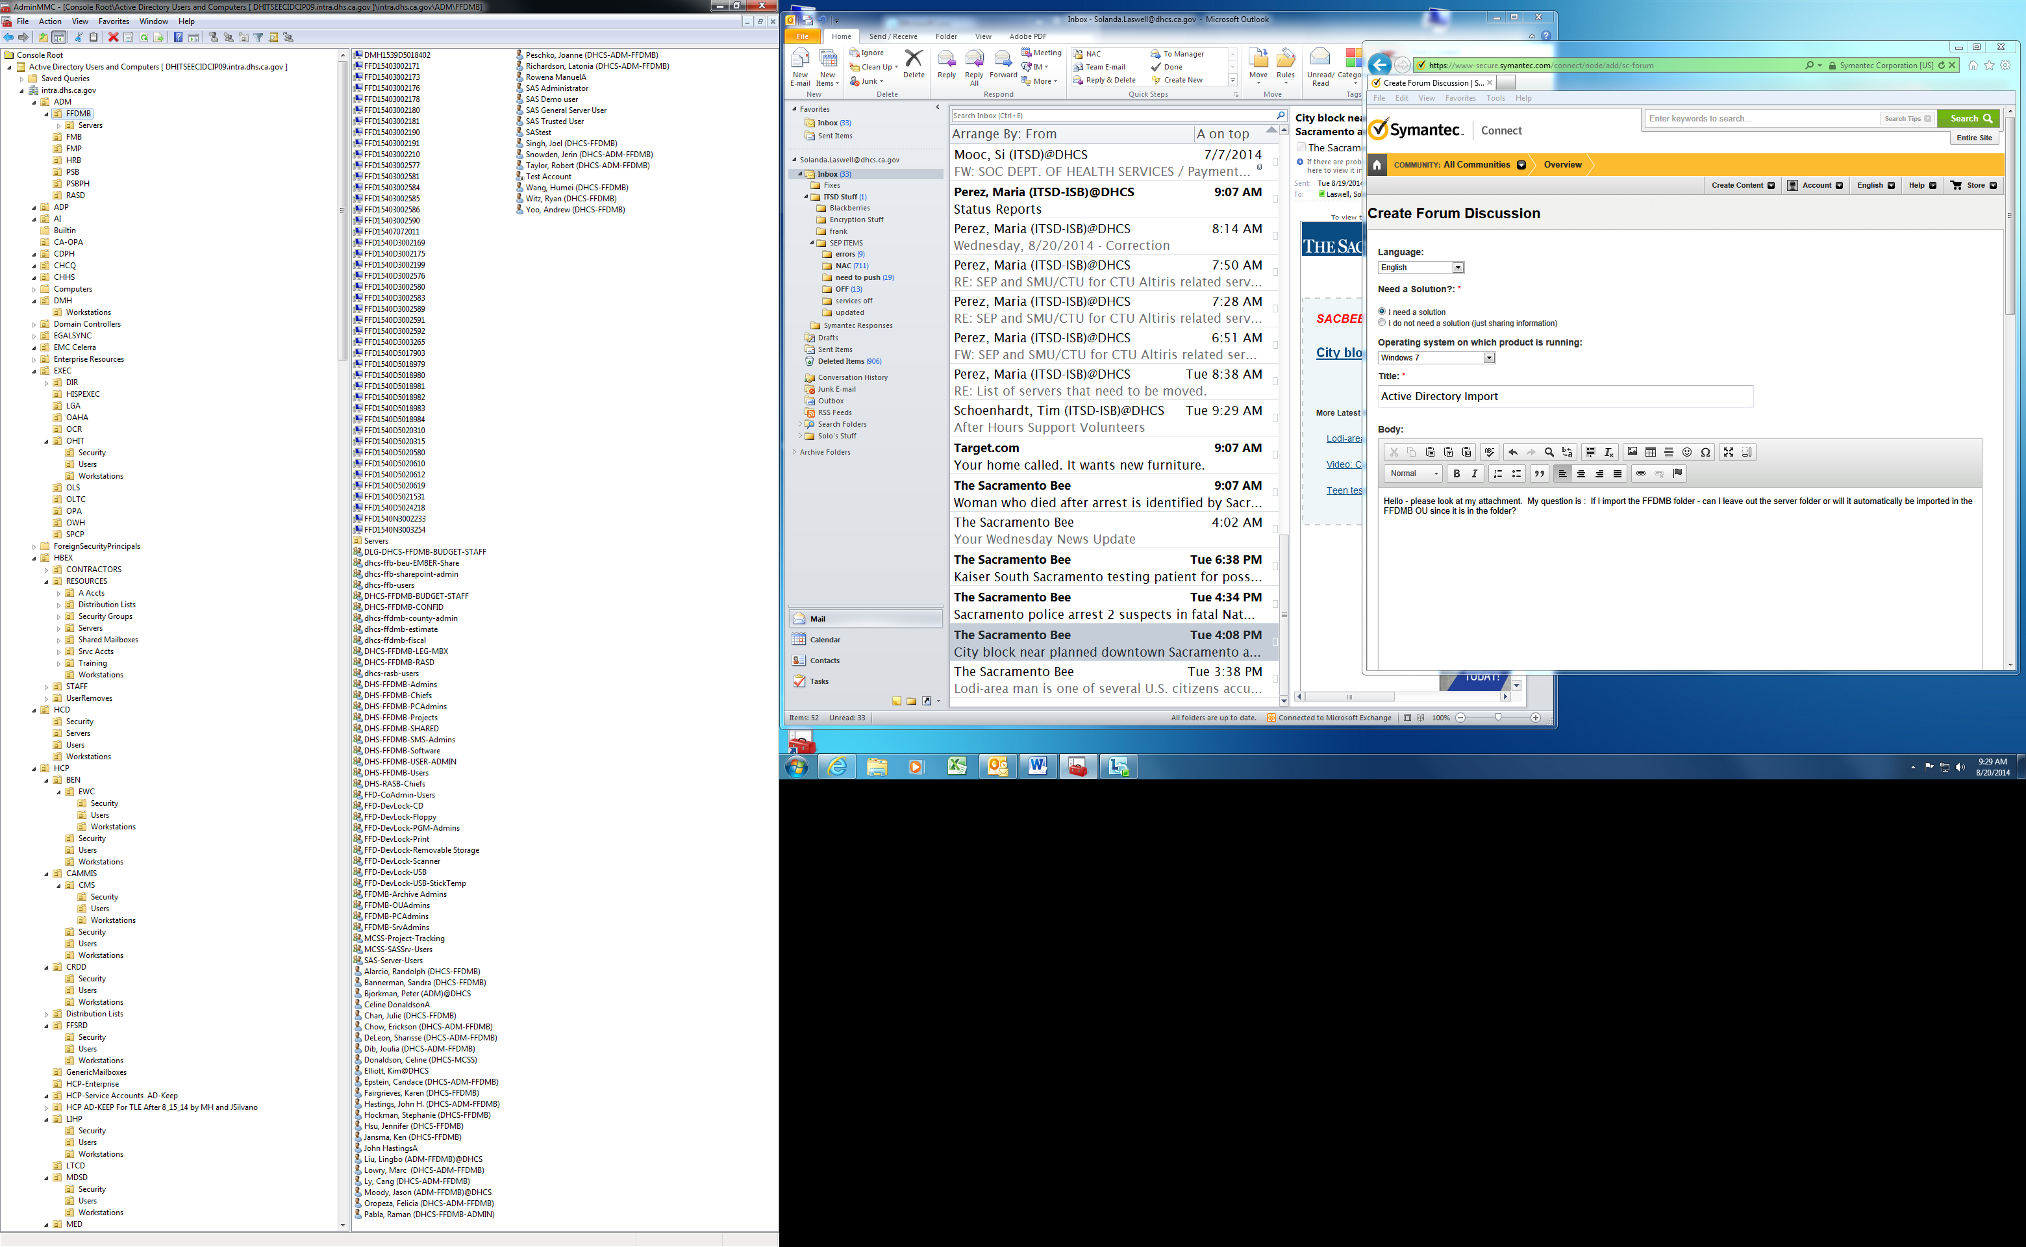

Can I import just the FFDMB folder and not the Server folder?