Automic uses MS-SQL as its native data store. SQL jobs that read its data use MS-SQL constructs.

SQL Jobs:
- Duplicate a SQL report job and save it as the name you desire.
- Modify the job Title and the Archive Key 1.
These are used to generate the output in their proper folders.

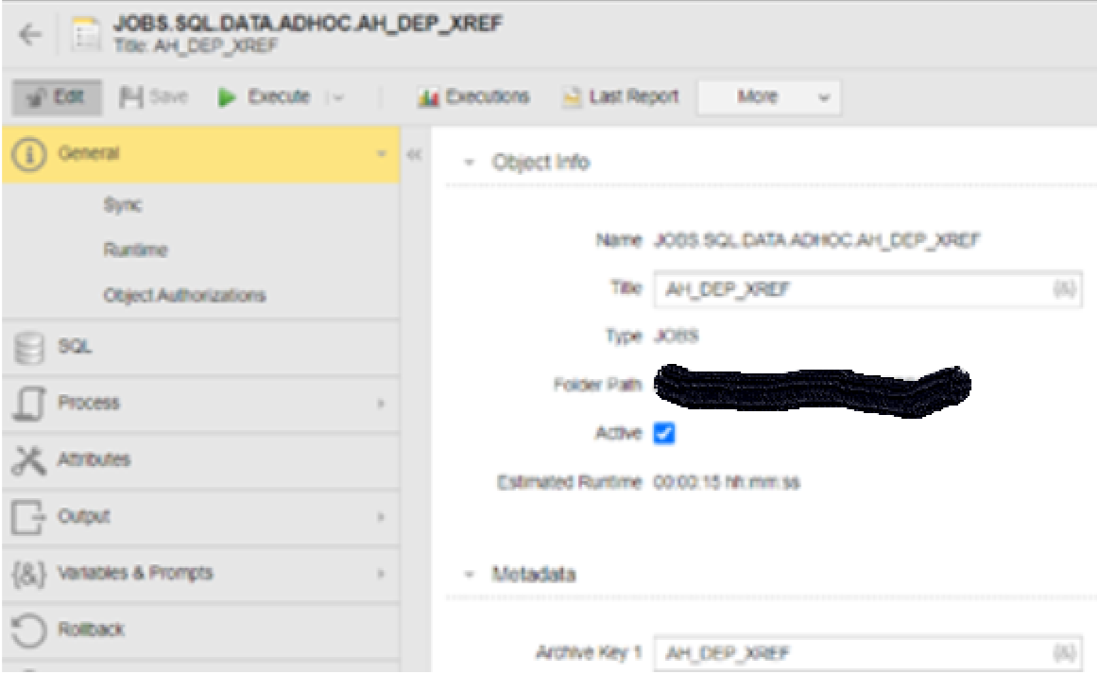
- Validate the SQL connection and settings
This connects and authenticates to the SQL correct data source.
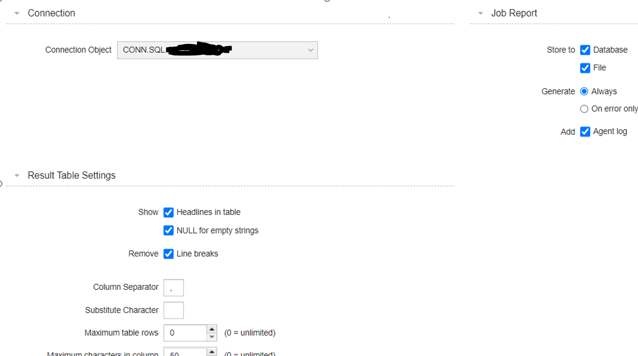

Standard External Output File is specified as:
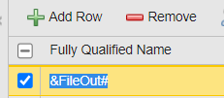

Pre-Process:
Include a JOBI that sets up the output folder. In this example the output folder and file format are specified to match the naming convention of the job title. This targets the output foler name.
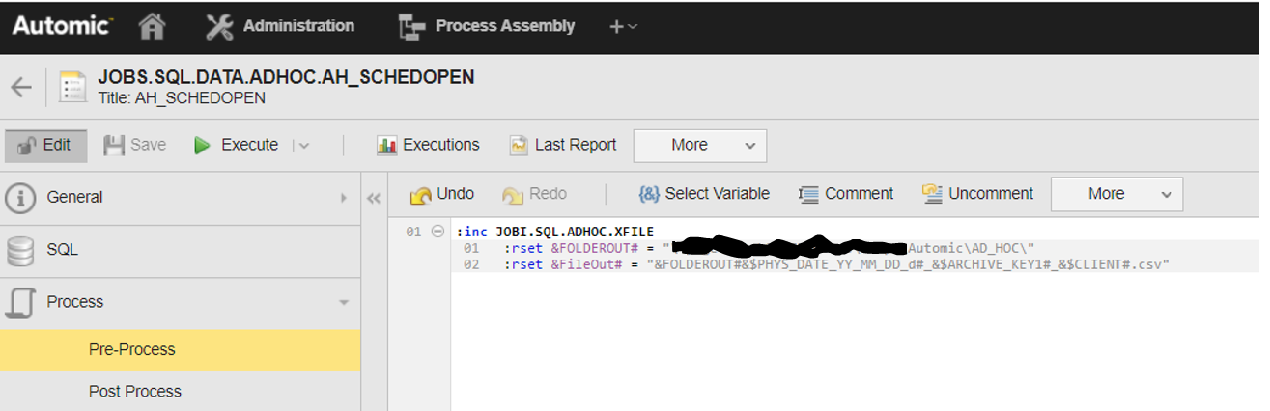

Prost-Process:
Include the standard JOBI ‘JOBI.SQL.CSV2XLSX’ that copies and transforms the CSV data to the output file and folder specified in the Pre-Process include.
