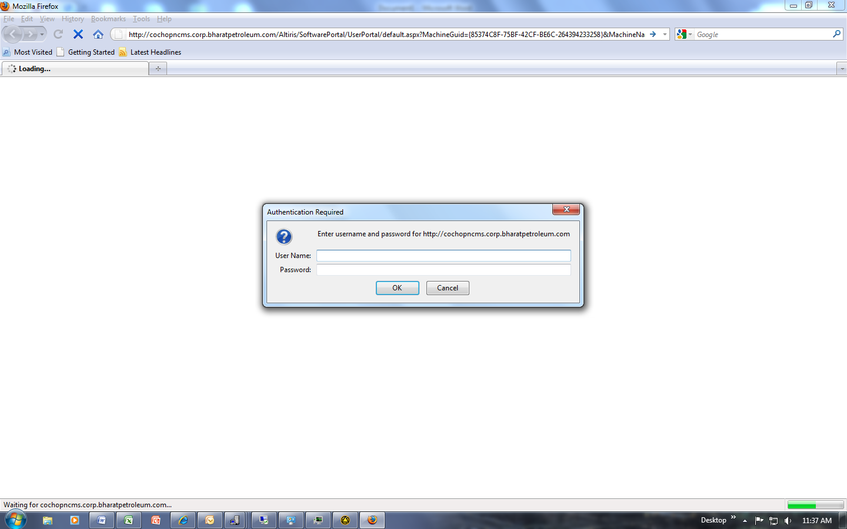

This is the pop-up I get when I click on the Portal.