Management Console:

Define a logical attribute:

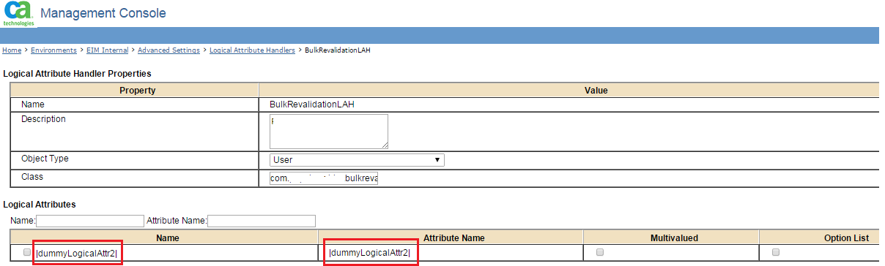

Admin Task:

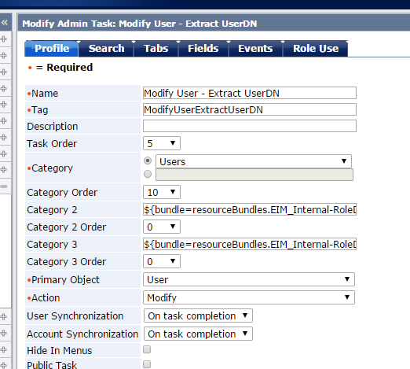

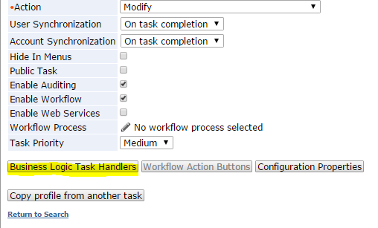

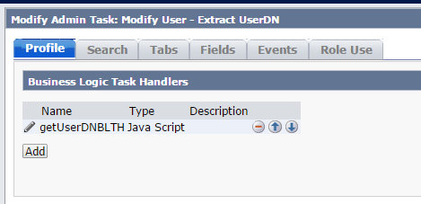

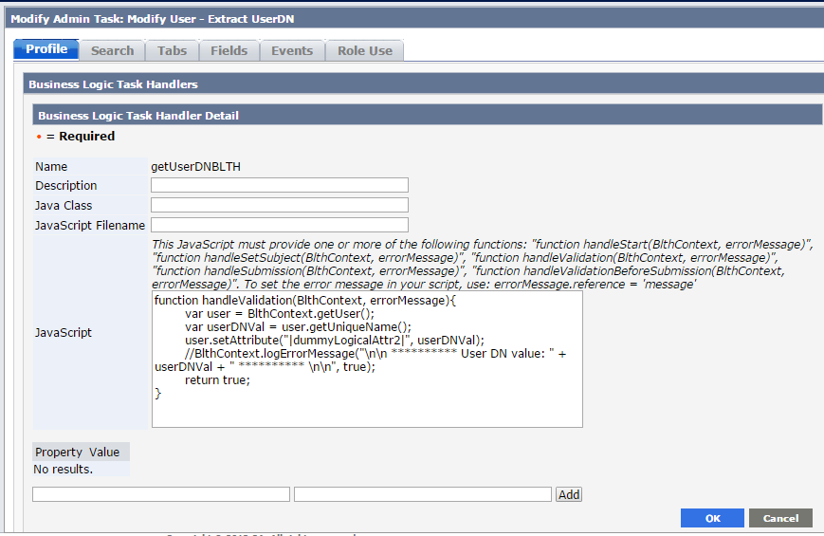

BLTH Code to attached with Admin Task:

function handleValidation(BlthContext, errorMessage){

var user = BlthContext.getUser();

var userDNVal = user.getUniqueName();

user.setAttribute("|dummyLogicalAttr2|", userDNVal);

//BlthContext.logErrorMessage("\n\n \*\*\*\*\*\*\*\*\*\* User DN value: " + userDNVal + " \*\*\*\*\*\*\*\*\*\* \n\n", true);

return true;

}

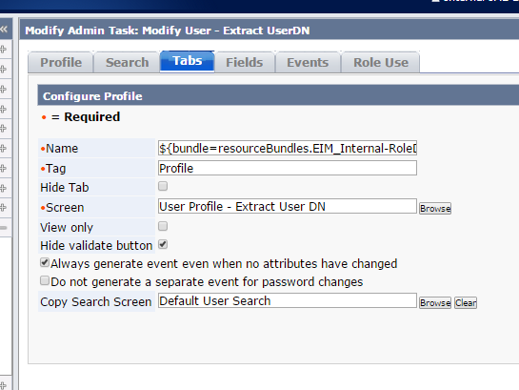

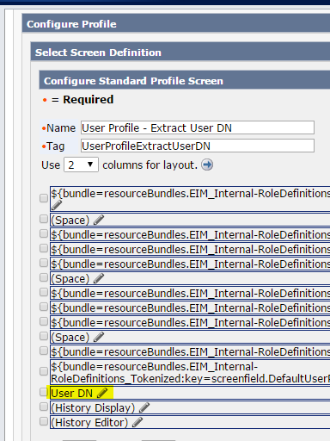

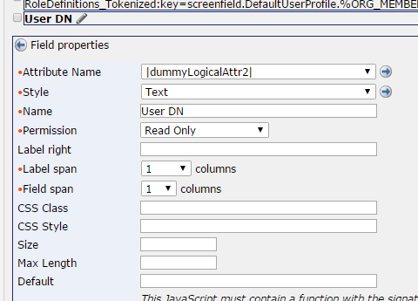

PX:

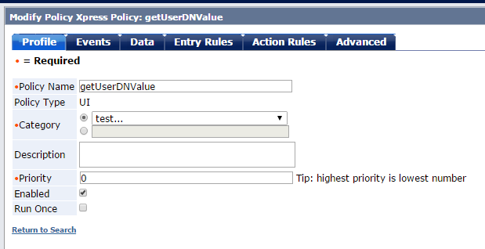

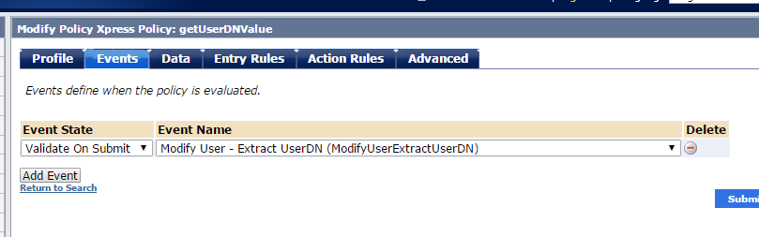

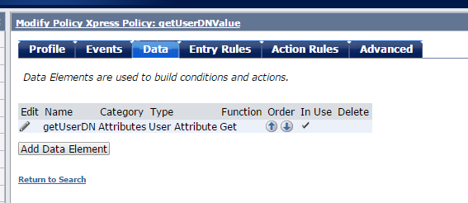

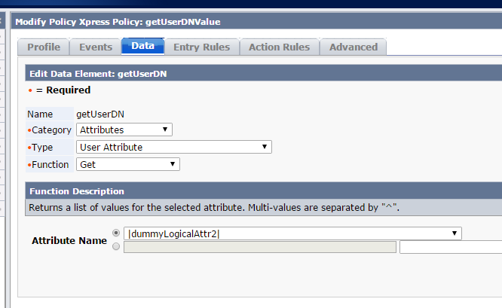

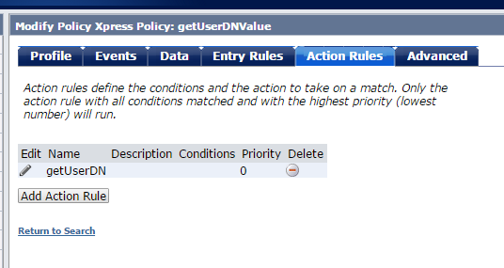

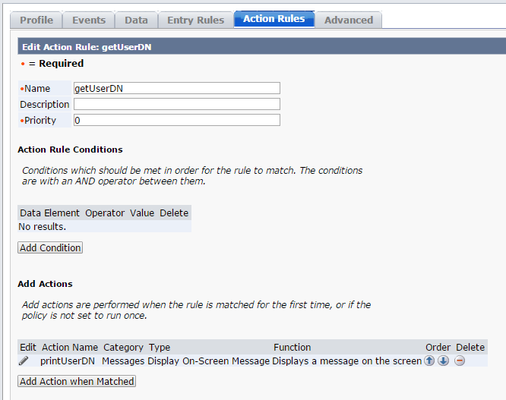

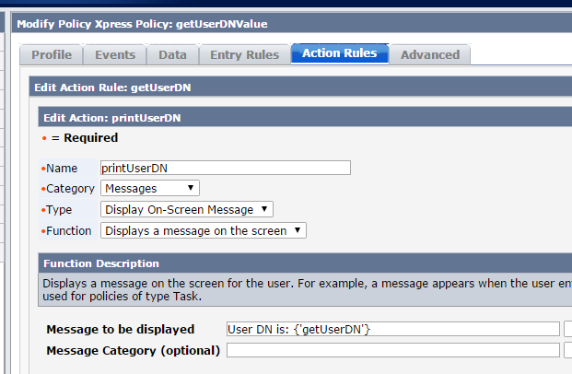

Output:

