Here is the results of my testing.  I set up two folders on our network shared drive.  I copied an unencrypted .pst file that I know to be readable from my laptop into folder #1.  For the second folder, I initially left the folder empty.  I then encrypted both folders individually using File Share Encryption, making myself the admin and another key user.  I then copied the same .pst file from my laptop into folder #2, causing it to be automatically encrypted as it was copied into the folder.

cid:image001.png@01D1F46A.61B68F80

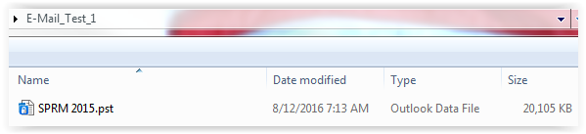

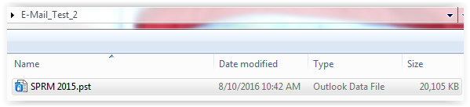

I then tried to open the Outlook Data File in folder #1 and Outlook immediately failed with the following error message:

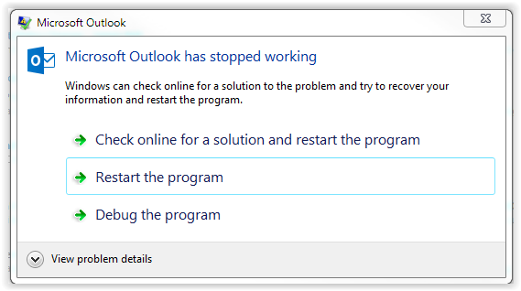

**Here are the details of the crash from the Microsoft Windows Application Log (two messages):**

Log Name:      Application

Source:        Application Error

Date:          8/12/2016 7:28:01 AM

Event ID:      1000

Task Category: (100)

Level:         Error

Keywords:      Classic

User:          N/A

Computer:      NAME.nnncorp.org

Description:

Faulting application name: OUTLOOK.EXE, version: 16.0.4405.1000, time stamp: 0x57601686

Faulting module name: KERNELBASE.dll, version: 6.1.7601.23455, time stamp: 0x573a5509

Exception code: 0x4000001f

Fault offset: 0x0001338d

Faulting process id: 0x1c0c

Faulting application start time: 0x01d1f4929916935f

Faulting application path: C:\Program Files (x86)\Microsoft Office\Office16\OUTLOOK.EXE

Faulting module path: C:\Windows\syswow64\KERNELBASE.dll

Report Id: 352d4e28-6088-11e6-b831-a08cfda524a2

Event Xml:

<Event xmlns="<http://schemas.microsoft.com/win/2004/08/events/event>">

  <System>

    <Provider Name="Application Error" />

    <EventID Qualifiers="0">1000</EventID>

    <Level>2</Level>

    <Task>100</Task>

    <Keywords>0x80000000000000</Keywords>

    <TimeCreated SystemTime="2016-08-12T12:28:01.000000000Z" />

    <EventRecordID>54943</EventRecordID>

    <Channel>Application</Channel>

    <Computer>NAME.nnncorp.org</Computer>

    <Security />

  </System>

  <EventData>

    <Data>OUTLOOK.EXE</Data>

    <Data>16.0.4405.1000</Data>

    <Data>57601686</Data>

    <Data>KERNELBASE.dll</Data>

    <Data>6.1.7601.23455</Data>

    <Data>573a5509</Data>

    <Data>4000001f</Data>

    <Data>0001338d</Data>

    <Data>1c0c</Data>

    <Data>01d1f4929916935f</Data>

    <Data>C:\Program Files (x86)\Microsoft Office\Office16\OUTLOOK.EXE</Data>

    <Data>C:\Windows\syswow64\KERNELBASE.dll</Data>

    <Data>352d4e28-6088-11e6-b831-a08cfda524a2</Data>

  </EventData>

</Event>

Log Name:      Application

Source:        Windows Error Reporting

Date:          8/12/2016 7:28:36 AM

Event ID:      1001

Task Category: None

Level:         Information

Keywords:      Classic

User:          N/A

Computer:      NAME.nnncorp.org

Description:

Fault bucket , type 0

Event Name: APPCRASH

Response: Not available

Cab Id: 0

Problem signature:

P1: OUTLOOK.EXE

P2: 16.0.4405.1000

P3: 57601686

P4: KERNELBASE.dll

P5: 6.1.7601.23455

P6: 573a5509

P7: 4000001f

P8: 0001338d

P9:

P10:

Attached files:

C:\Users\kbp1090\AppData\Local\Temp\{5DDC3D19-6F88-4CEA-BA4F-07A6C7F16523} - OProcSessId.dat

These files may be available here:

C:\Users\kbp1090\AppData\Local\Microsoft\Windows\WER\ReportArchive\AppCrash_OUTLOOK.EXE_cd8d36cf96d7f298840f3deff52ea112387682_15021a54

Analysis symbol:

Rechecking for solution: 0

Report Id: 352d4e28-6088-11e6-b831-a08cfda524a2

Report Status: 0

Event Xml:

<Event xmlns="<http://schemas.microsoft.com/win/2004/08/events/event>">

  <System>

    <Provider Name="Windows Error Reporting" />

    <EventID Qualifiers="0">1001</EventID>

    <Level>4</Level>

    <Task>0</Task>

    <Keywords>0x80000000000000</Keywords>

    <TimeCreated SystemTime="2016-08-12T12:28:36.000000000Z" />

    <EventRecordID>54944</EventRecordID>

    <Channel>Application</Channel>

    <Computer>NAME.nnncorp.org</Computer>

    <Security />

  </System>

  <EventData>

    <Data>

    </Data>

    <Data>0</Data>

    <Data>APPCRASH</Data>

    <Data>Not available</Data>

    <Data>0</Data>

    <Data>OUTLOOK.EXE</Data>

    <Data>16.0.4405.1000</Data>

    <Data>57601686</Data>

    <Data>KERNELBASE.dll</Data>

    <Data>6.1.7601.23455</Data>

    <Data>573a5509</Data>

    <Data>4000001f</Data>

    <Data>0001338d</Data>

    <Data>

    </Data>

    <Data>

    </Data>

    <Data>

C:\Users\kbp1090\AppData\Local\Temp\{5DDC3D19-6F88-4CEA-BA4F-07A6C7F16523} - OProcSessId.dat</Data>

    <Data>C:\Users\kbp1090\AppData\Local\Microsoft\Windows\WER\ReportArchive\AppCrash_OUTLOOK.EXE_cd8d36cf96d7f298840f3deff52ea112387682_15021a54</Data>

    <Data>

    </Data>

    <Data>0</Data>

    <Data>352d4e28-6088-11e6-b831-a08cfda524a2</Data>

    <Data>0</Data>

  </EventData>

</Event>

**I restarted Outlook and received the following error message:**

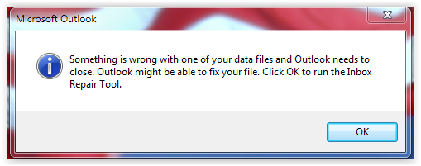

I clicked on OK and performed the repair process:

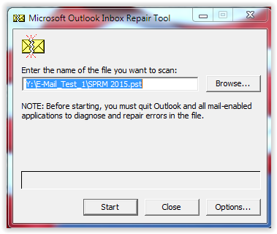

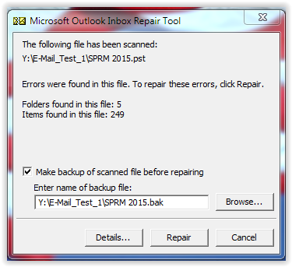

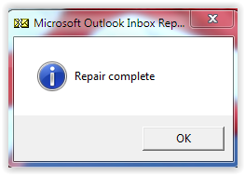

**The log from the repair follows:**

Microsoft (R) Inbox Repair Tool

© 2016 Microsoft Corporation.  All rights reserved.

Version 16.0.4405.1000

**Beginning NDB recovery

  **Attempting to open database

  **Attempting to validate header

  **Attempting to validate AMap

  **Attempting to validate BBT

    !!Invalid block (bid=1C, ib=20992, cb=92, cRef=2):

      CRC mismatch (read C66A1478, computed AA86800C)

      Sig mismatch (read 7D27, computed 521C)

      cb mismatch (read 3828, expected 92)

      BID mismatch (read EC33832FE4DBED22, expected 1C)

    !!Invalid block (bid=30, ib=21120, cb=114, cRef=2):

      CRC mismatch (read A1436219, computed 701AE7E0)

      Sig mismatch (read F46F, computed 52B0)

      cb mismatch (read 7870, expected 114)

      BID mismatch (read DF56D408D6F2DD81, expected 30)

    !!Invalid block (bid=48, ib=21440, cb=34, cRef=2):

      CRC mismatch (read 4A964442, computed D5B78764)

      Sig mismatch (read EF5E, computed 5388)

      cb mismatch (read 57613, expected 34)

      BID mismatch (read D57C9F01DDC892E3, expected 48)

    !!Invalid block (bid=68, ib=21312, cb=86, cRef=2):

      CRC mismatch (read 48AE7E7F, computed D8B14D69)

      Sig mismatch (read F1C5, computed 5328)

      cb mismatch (read 15317, expected 86)

      BID mismatch (read 554D1E788491FEA6, expected 68)

    !!Invalid block (bid=8004, ib=19318272, cb=8176, cRef=2):

      CRC mismatch (read 1688061B, computed F45638EA)

    !!Invalid block (bid=9410, ib=19572224, cb=6474, cRef=2):

      CRC mismatch (read C84D8FD6, computed ECF1F20F)

  **Attempting to rebuild BBT

    **Attempting to scavenge for blocks

  **Attempting to validate NBT

    !!Invalid node (nid=62B, bidData=3000000000, bidSub=0, nidParent=0):

      Data block (bid=30) not found in BBT

    !!Invalid node (nid=64C, bidData=1C00000000, bidSub=0, nidParent=0):

      Data block (bid=1C) not found in BBT

    !!Invalid node (nid=C01, bidData=4800000000, bidSub=0, nidParent=0):

      Data block (bid=48) not found in BBT

    !!Invalid node (nid=8042, bidData=6800000000, bidSub=0, nidParent=0):

      Data block (bid=68) not found in BBT

    !!Invalid node (nid=808E, bidData=943200000000, bidSub=940A00000000, nidParent=0):

      Data block (bid=9410) not found in BBT

    !!Invalid node (nid=2023C4, bidData=805000000000, bidSub=804E00000000, nidParent=0):

      Data block (bid=8004) not found in BBT

  **Attempting to rebuild NBT

    **Attempting to scavenge for nodes

    !!Invalid node (nid=62B, bidData=3000000000, bidSub=0, nidParent=0):

      Data block (bid=30) not found in BBT

    !!Invalid node (nid=64C, bidData=1C00000000, bidSub=0, nidParent=0):

      Data block (bid=1C) not found in BBT

    !!Invalid node (nid=C01, bidData=4800000000, bidSub=0, nidParent=0):

      Data block (bid=48) not found in BBT

    !!Invalid node (nid=8042, bidData=6800000000, bidSub=0, nidParent=0):

      Data block (bid=68) not found in BBT

    !!Invalid node (nid=808E, bidData=12400000000, bidSub=0, nidParent=0):

      Data block (bid=124) not found in BBT

    !!Invalid node (nid=62B, bidData=3000000000, bidSub=0, nidParent=0):

      Data block (bid=30) not found in BBT

    !!Invalid node (nid=64C, bidData=1C00000000, bidSub=0, nidParent=0):

      Data block (bid=1C) not found in BBT

    !!Invalid node (nid=C01, bidData=4800000000, bidSub=0, nidParent=0):

      Data block (bid=48) not found in BBT

    !!Invalid node (nid=62B, bidData=3000000000, bidSub=0, nidParent=0):

      Data block (bid=30) not found in BBT

    !!Invalid node (nid=64C, bidData=1C00000000, bidSub=0, nidParent=0):

      Data block (bid=1C) not found in BBT

    !!Invalid node (nid=8042, bidData=6800000000, bidSub=0, nidParent=0):

      Data block (bid=68) not found in BBT

    !!Invalid node (nid=808E, bidData=816200000000, bidSub=862E00000000, nidParent=0):

      Data block (bid=8162) not found in BBT

    !!Invalid node (nid=62B, bidData=3000000000, bidSub=0, nidParent=0):

   Data block (bid=30) not found in BBT

    !!Invalid node (nid=64C, bidData=1C00000000, bidSub=0, nidParent=0):

      Data block (bid=1C) not found in BBT

    !!Invalid node (nid=8042, bidData=6800000000, bidSub=0, nidParent=0):

      Data block (bid=68) not found in BBT

    !!Invalid node (nid=2023C4, bidData=805000000000, bidSub=804E00000000, nidParent=0):

      Data block (bid=8004) not found in BBT

    !!Invalid node (nid=C01, bidData=4800000000, bidSub=0, nidParent=0):

      Data block (bid=48) not found in BBT

    !!Invalid node (nid=808E, bidData=943200000000, bidSub=940A00000000, nidParent=0):

      Data block (bid=9410) not found in BBT

    !!Invalid node (nid=8042, bidData=6800000000, bidSub=0, nidParent=0):

      Data block (bid=68) not found in BBT

    !!Invalid node (nid=62B, bidData=3000000000, bidSub=0, nidParent=0):

      Data block (bid=30) not found in BBT

    !!Invalid node (nid=64C, bidData=1C00000000, bidSub=0, nidParent=0):

      Data block (bid=1C) not found in BBT

    !!Invalid node (nid=C01, bidData=4800000000, bidSub=0, nidParent=0):

      Data block (bid=48) not found in BBT

  **Attempting to validate BBT refcounts

    ??Couldn't find BBT entry in the RBT (2660)

    ??Couldn't find BBT entry in the RBT (2764)

    ??Couldn't find BBT entry in the RBT (33C4)

    ??Couldn't find BBT entry in the RBT (3772)

    ??Couldn't find BBT entry in the RBT (3948)

    ??Couldn't find BBT entry in the RBT (42C8)

    ??Couldn't find BBT entry in the RBT (4672)

 ??Couldn't find BBT entry in the RBT (4D54)

    ??Couldn't find BBT entry in the RBT (5444)

    ??Couldn't find BBT entry in the RBT (6614)

    ??Couldn't find BBT entry in the RBT (6F70)

    ??Couldn't find BBT entry in the RBT (7A4C)

    ??Couldn't find BBT entry in the RBT (7E7E)

    ??Couldn't find BBT entry in the RBT (7FE4)

    ??Couldn't find BBT entry in the RBT (7FFE)

    ??Couldn't find BBT entry in the RBT (8000)

    ??Couldn't find BBT entry in the RBT (8008)

    ??Couldn't find BBT entry in the RBT (800C)

    ??Couldn't find BBT entry in the RBT (8010)

    ??Couldn't find BBT entry in the RBT (8014)

    ??Couldn't find BBT entry in the RBT (8018)

    ??Couldn't find BBT entry in the RBT (801C)

    ??Couldn't find BBT entry in the RBT (8020)

    ??Couldn't find BBT entry in the RBT (8024)

    ??Couldn't find BBT entry in the RBT (802E)

    ??Couldn't find BBT entry in the RBT (8034)

    ??Couldn't find BBT entry in the RBT (8038)

    ??Couldn't find BBT entry in the RBT (8048)

    ??Couldn't find BBT entry in the RBT (804E)

    ??Couldn't find BBT entry in the RBT (8050)

    ??Couldn't find BBT entry in the RBT (8164)

    ??Couldn't find BBT entry in the RBT (8170)

    ??Couldn't find BBT entry in the RBT (8174)

    ??Couldn't find BBT entry in the RBT (8642)

    ??Couldn't find BBT entry in the RBT (940A)

    ??Couldn't find BBT entry in the RBT (940E)

    ??Couldn't find BBT entry in the RBT (9414)

    ??Couldn't find BBT entry in the RBT (9418)

    ??Couldn't find BBT entry in the RBT (941C)

    ??Couldn't find BBT entry in the RBT (9420)

    ??Couldn't find BBT entry in the RBT (9424)

    ??Couldn't find BBT entry in the RBT (9428)

    ??Couldn't find BBT entry in the RBT (942C)

    ??Couldn't find BBT entry in the RBT (9432)

    ??Couldn't find BBT entry in the RBT (9434)

    ??Couldn't find BBT entry in the RBT (9438)

  **Attempting to validate header NID high-water marks

**Beginning PST/OST recovery

  **Attempting to recover all top-level objects

    **Store created by build: 16.4405

      !!Receive folder table missing

      !!Receive folder table missing default message class

      !!Missing the outgoing queue

  !!HMP not found - creating

  **Attempting to walk all folders

      !!Hierarchy Table for 122, sub-object not found:

        irow = 1, RowID = 8042

      !!Folder ("SPRM", nid=8082):

        Invalid PR_CONTENT_COUNT (computed=0, actual=250)

  **Attempting to locate any orphaned folders/messages

    !!Adding message (nid=200024) back to the database

    !!Adding message (nid=200044) back to the database

    !!Adding message (nid=200064) back to the database

    !!Adding message (nid=200084) back to the database

    !!Adding message (nid=2000A4) back to the database

    !!Adding message (nid=2000C4) back to the database

    !!Adding message (nid=2000E4) back to the database

    !!Adding message (nid=200104) back to the database

    !!Adding message (nid=200124) back to the database

    !!Adding message (nid=200144) back to the database

    !!Adding message (nid=200164) back to the database

    !!Adding message (nid=200184) back to the database

   !!Adding message (nid=2001A4) back to the database

    !!Adding message (nid=2001C4) back to the database

    !!Adding message (nid=200204) back to the database

    !!Adding message (nid=200244) back to the database

    !!Adding message (nid=200284) back to the database

    !!Adding message (nid=2002C4) back to the database

    !!Adding message (nid=200304) back to the database

    !!Adding message (nid=200344) back to the database

    !!Adding message (nid=200384) back to the database

    !!Adding message (nid=2003C4) back to the database

    !!Adding message (nid=2003E4) back to the database

 !!Adding message (nid=200424) back to the database

    !!Adding message (nid=200464) back to the database

    !!Adding message (nid=2004A4) back to the database

    !!Adding message (nid=2004E4) back to the database

    !!Adding message (nid=200504) back to the database

    !!Adding message (nid=200544) back to the database

    !!Adding message (nid=200564) back to the database

    !!Adding message (nid=2005A4) back to the database

    !!Adding message (nid=2005C4) back to the database

    !!Adding message (nid=2005E4) back to the database

    !!Adding message (nid=200604) back to the database

    !!Adding message (nid=200624) back to the database

    !!Adding message (nid=200644) back to the database

    !!Adding message (nid=200664) back to the database

    !!Adding message (nid=200684) back to the database

    !!Adding message (nid=2006A4) back to the database

   !!Adding message (nid=2006C4) back to the database

    !!Adding message (nid=2006E4) back to the database

    !!Adding message (nid=200704) back to the database

    !!Adding message (nid=200724) back to the database

    !!Adding message (nid=200744) back to the database

    !!Adding message (nid=200764) back to the database

    !!Adding message (nid=200784) back to the database

    !!Adding message (nid=2007A4) back to the database

    !!Adding message (nid=2007C4) back to the database

    !!Adding message (nid=2007E4) back to the database

    !!Adding message (nid=200804) back to the database

 !!Adding message (nid=200824) back to the database

    !!Adding message (nid=200844) back to the database

    !!Adding message (nid=200864) back to the database

    !!Adding message (nid=200884) back to the database

    !!Adding message (nid=2008A4) back to the database

    !!Adding message (nid=2008C4) back to the database

    !!Adding message (nid=2008E4) back to the database

    !!Adding message (nid=200904) back to the database

    !!Adding message (nid=200924) back to the database

    !!Adding message (nid=200944) back to the database

    !!Adding message (nid=200964) back to the database

    !!Adding message (nid=200984) back to the database

    !!Adding message (nid=2009A4) back to the database

    !!Adding message (nid=2009C4) back to the database

    !!Adding message (nid=2009E4) back to the database

    !!Adding message (nid=200A04) back to the database

    !!Adding message (nid=200A24) back to the database

    !!Adding message (nid=200A44) back to the database

    !!Adding message (nid=200A64) back to the database

    !!Adding message (nid=200A84) back to the database

    !!Adding message (nid=200AA4) back to the database

    !!Adding message (nid=200AC4) back to the database

    !!Adding message (nid=200AE4) back to the database

    !!Adding message (nid=200B04) back to the database

    !!Adding message (nid=200B24) back to the database

    !!Adding message (nid=200B44) back to the database

    !!Adding message (nid=200B64) back to the database

    !!Adding message (nid=200B84) back to the database

    !!Adding message (nid=200BA4) back to the database

    !!Adding message (nid=200BC4) back to the database

    !!Adding message (nid=200BE4) back to the database

    !!Adding message (nid=200C04) back to the database

    !!Adding message (nid=200C24) back to the database

    !!Adding message (nid=200C44) back to the database

    !!Adding message (nid=200C64) back to the database

    !!Adding message (nid=200C84) back to the database

    !!Adding message (nid=200CA4) back to the database

    !!Adding message (nid=200CC4) back to the database

    !!Adding message (nid=200CE4) back to the database

    !!Adding message (nid=200D04) back to the database

    !!Adding message (nid=200D24) back to the database

    !!Adding message (nid=200D44) back to the database

    !!Adding message (nid=200D64) back to the database

    !!Adding message (nid=200D84) back to the database

    !!Adding message (nid=200DA4) back to the database

 !!Adding message (nid=200DC4) back to the database

    !!Adding message (nid=200DE4) back to the database

    !!Adding message (nid=200E04) back to the database

    !!Adding message (nid=200E24) back to the database

    !!Adding message (nid=200E44) back to the database

    !!Adding message (nid=200E64) back to the database

    !!Adding message (nid=200E84) back to the database

    !!Adding message (nid=200EA4) back to the database

    !!Adding message (nid=200EC4) back to the database

    !!Adding message (nid=200EE4) back to the database

    !!Adding message (nid=200F04) back to the database

    !!Adding message (nid=200F24) back to the database

    !!Adding message (nid=200F44) back to the database

    !!Adding message (nid=200F84) back to the database

    !!Adding message (nid=200FA4) back to the database

    !!Adding message (nid=200FC4) back to the database

    !!Adding message (nid=200FE4) back to the database

    !!Adding message (nid=201004) back to the database

    !!Adding message (nid=201044) back to the database

    !!Adding message (nid=201064) back to the database

    !!Adding message (nid=2010A4) back to the database

    !!Adding message (nid=2010C4) back to the database

    !!Adding message (nid=2010E4) back to the database

    !!Adding message (nid=201104) back to the database

    !!Adding message (nid=201144) back to the database

    !!Adding message (nid=201164) back to the database

    !!Adding message (nid=201184) back to the database

 !!Adding message (nid=2011A4) back to the database

    !!Adding message (nid=2011C4) back to the database

    !!Adding message (nid=2011E4) back to the database

    !!Adding message (nid=201204) back to the database

    !!Adding message (nid=201224) back to the database

    !!Adding message (nid=201244) back to the database

    !!Adding message (nid=201264) back to the database

    !!Adding message (nid=201284) back to the database

    !!Adding message (nid=2012A4) back to the database

    !!Adding message (nid=2012C4) back to the database

    !!Adding message (nid=2012E4) back to the database

    !!Adding message (nid=201304) back to the database

    !!Adding message (nid=201324) back to the database

    !!Adding message (nid=201344) back to the database

    !!Adding message (nid=201364) back to the database

    !!Adding message (nid=201384) back to the database

    !!Adding message (nid=2013A4) back to the database

    !!Adding message (nid=2013C4) back to the database

 !!Adding message (nid=2013E4) back to the database

    !!Adding message (nid=201404) back to the database

    !!Adding message (nid=201424) back to the database

    !!Adding message (nid=201444) back to the database

    !!Adding message (nid=201464) back to the database

    !!Adding message (nid=201484) back to the database

    !!Adding message (nid=2014A4) back to the database

    !!Adding message (nid=2014C4) back to the database

    !!Adding message (nid=2014E4) back to the database

    !!Adding message (nid=201504) back to the database

    !!Adding message (nid=201524) back to the database

    !!Adding message (nid=201544) back to the database

    !!Adding message (nid=201564) back to the database

    !!Adding message (nid=2015A4) back to the database

    !!Adding message (nid=2015E4) back to the database

    !!Adding message (nid=201604) back to the database

    !!Adding message (nid=201644) back to the database

   !!Adding message (nid=201664) back to the database

    !!Adding message (nid=2016A4) back to the database

    !!Adding message (nid=2016E4) back to the database

    !!Adding message (nid=201704) back to the database

    !!Adding message (nid=201744) back to the database

    !!Adding message (nid=201784) back to the database

    !!Adding message (nid=2017C4) back to the database

    !!Adding message (nid=201804) back to the database

    !!Adding message (nid=201824) back to the database

    !!Adding message (nid=201844) back to the database

 !!Adding message (nid=201884) back to the database

    !!Adding message (nid=2018C4) back to the database

    !!Adding message (nid=201904) back to the database

    !!Adding message (nid=201944) back to the database

    !!Adding message (nid=201984) back to the database

    !!Adding message (nid=2019C4) back to the database

    !!Adding message (nid=2019E4) back to the database

    !!Adding message (nid=201A24) back to the database

    !!Adding message (nid=201A44) back to the database

    !!Adding message (nid=201A84) back to the database

    !!Adding message (nid=201AC4) back to the database

    !!Adding message (nid=201B04) back to the database

    !!Adding message (nid=201B44) back to the database

    !!Adding message (nid=201B64) back to the database

    !!Adding message (nid=201B84) back to the database

    !!Adding message (nid=201BA4) back to the database

    !!Adding message (nid=201BC4) back to the database

   !!Adding message (nid=201BE4) back to the database

    !!Adding message (nid=201C04) back to the database

    !!Adding message (nid=201C24) back to the database

    !!Adding message (nid=201C44) back to the database

    !!Adding message (nid=201C64) back to the database

    !!Adding message (nid=201C84) back to the database

    !!Adding message (nid=201CA4) back to the database

    !!Adding message (nid=201CC4) back to the database

    !!Adding message (nid=201CE4) back to the database

    !!Adding message (nid=201D04) back to the database

    !!Adding message (nid=201D24) back to the database

    !!Adding message (nid=201D44) back to the database

    !!Adding message (nid=201D64) back to the database

    !!Adding message (nid=201D84) back to the database

    !!Adding message (nid=201DA4) back to the database

    !!Adding message (nid=201DC4) back to the database

    !!Adding message (nid=201DE4) back to the database

    !!Adding message (nid=201E04) back to the database

    !!Adding message (nid=201E24) back to the database

    !!Adding message (nid=201E44) back to the database

    !!Adding message (nid=201E64) back to the database

    !!Adding message (nid=201E84) back to the database

    !!Adding message (nid=201EA4) back to the database

    !!Adding message (nid=201EC4) back to the database

    !!Adding message (nid=201EE4) back to the database

    !!Adding message (nid=201F04) back to the database

    !!Adding message (nid=201F24) back to the database

    !!Adding message (nid=201F44) back to the database

 !!Adding message (nid=201F64) back to the database

    !!Adding message (nid=201F84) back to the database

    !!Adding message (nid=201FA4) back to the database

    !!Adding message (nid=201FC4) back to the database

    !!Adding message (nid=201FE4) back to the database

    !!Adding message (nid=202004) back to the database

    !!Adding message (nid=202024) back to the database

    !!Adding message (nid=202044) back to the database

    !!Adding message (nid=202064) back to the database

    !!Adding message (nid=202084) back to the database

    !!Adding message (nid=2020A4) back to the database

    !!Adding message (nid=2020C4) back to the database

    !!Adding message (nid=2020E4) back to the database

    !!Adding message (nid=202104) back to the database

    !!Adding message (nid=202124) back to the database

    !!Adding message (nid=202144) back to the database

    !!Adding message (nid=202164) back to the database

   !!Adding message (nid=202184) back to the database

    !!Adding message (nid=2021A4) back to the database

    !!Adding message (nid=2021C4) back to the database

    !!Adding message (nid=2021E4) back to the database

    !!Adding message (nid=202204) back to the database

    !!Adding message (nid=202224) back to the database

    !!Adding message (nid=202244) back to the database

    !!Adding message (nid=202264) back to the database

    !!Adding message (nid=202284) back to the database

    !!Adding message (nid=2022A4) back to the database

 !!Adding message (nid=2022C4) back to the database

    !!Adding message (nid=2022E4) back to the database

    !!Adding message (nid=202304) back to the database

    !!Adding message (nid=202324) back to the database

    !!Adding message (nid=202344) back to the database

    !!Adding message (nid=202364) back to the database

    !!Adding message (nid=202384) back to the database

    !!Adding message (nid=2023A4) back to the database

    !!Adding message (nid=2023E4) back to the database

    !!Adding message (nid=202404) back to the database

  **Performing final HMP validation

  **Attempting to check top-level objects for consistency

      !!Special folder (35E70102) missing NID (8042)

      ??Deleting SDO

  **Updating folder hierarchy

 Updating hierarchy table for folder (nid=8022, RowID=8082)

**Attempting to fix original file

  **Attempting to copy back BBT

  **Attempting to copy back NBT

**I the restarted Outlook and it crashed again.**

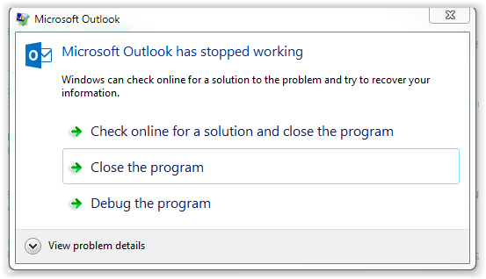

**The two applicable event log records are:**

Log Name:      Application

Source:        Application Error

Date:          8/12/2016 7:32:56 AM

Event ID:      1000

Task Category: (100)

Level:         Error

Keywords:      Classic

User:          N/A

Computer:      NAME.nnncorp.org

Description:

Faulting application name: OUTLOOK.EXE, version: 16.0.4405.1000, time stamp: 0x57601686

Faulting module name: KERNELBASE.dll, version: 6.1.7601.23455, time stamp: 0x573a5509

Exception code: 0x80000003

Fault offset: 0x0001338d

Faulting process id: 0x14e4

Faulting application start time: 0x01d1f49596e77c46

Faulting application path: C:\Program Files (x86)\Microsoft Office\Office16\OUTLOOK.EXE

Faulting module path: C:\Windows\syswow64\KERNELBASE.dll

Report Id: e50493f8-6088-11e6-b831-a08cfda524a2

Event Xml:

<Event xmlns="<http://schemas.microsoft.com/win/2004/08/events/event>">

  <System>

    <Provider Name="Application Error" />

    <EventID Qualifiers="0">1000</EventID>

    <Level>2</Level>

    <Task>100</Task>

    <Keywords>0x80000000000000</Keywords>

    <TimeCreated SystemTime="2016-08-12T12:32:56.000000000Z" />

    <EventRecordID>54952</EventRecordID>

    <Channel>Application</Channel>

    <Computer>NAME.nnncorp.org</Computer>

    <Security />

  </System>

  <EventData>

    <Data>OUTLOOK.EXE</Data>

    <Data>16.0.4405.1000</Data>

    <Data>57601686</Data>

    <Data>KERNELBASE.dll</Data>

    <Data>6.1.7601.23455</Data>

    <Data>573a5509</Data>

    <Data>80000003</Data>

    <Data>0001338d</Data>

    <Data>14e4</Data>

    <Data>01d1f49596e77c46</Data>

    <Data>C:\Program Files (x86)\Microsoft Office\Office16\OUTLOOK.EXE</Data>

    <Data>C:\Windows\syswow64\KERNELBASE.dll</Data>

    <Data>e50493f8-6088-11e6-b831-a08cfda524a2</Data>

  </EventData>

</Event>

Log Name:      Application

Source:        Windows Error Reporting

Date:          8/12/2016 7:33:51 AM

Event ID:      1001

Task Category: None

Level:         Information

Keywords:      Classic

User:          N/A

Computer:      NAME.nnncorp.org

Description:

Fault bucket , type 0

Event Name: APPCRASH

Response: Not available

Cab Id: 0

Problem signature:

P1: OUTLOOK.EXE

P2: 16.0.4405.1000

P3: 57601686

P4: KERNELBASE.dll

P5: 6.1.7601.23455

P6: 573a5509

P7: 80000003

P8: 0001338d

P9:

P10:

Attached files:

C:\Users\kbp1090\AppData\Local\Temp\{EFD2FC5F-451B-4F36-B598-448005AEF82F} - OProcSessId.dat

These files may be available here:

C:\Users\kbp1090\AppData\Local\Microsoft\Windows\WER\ReportArchive\AppCrash_OUTLOOK.EXE_9a2a63536ae98c2b94a9d3a599ffb7fc4c74d_21a6e86b

Analysis symbol:

Rechecking for solution: 0

Report Id: e50493f8-6088-11e6-b831-a08cfda524a2

Report Status: 0

Event Xml:

<Event xmlns="<http://schemas.microsoft.com/win/2004/08/events/event>">

  <System>

    <Provider Name="Windows Error Reporting" />

    <EventID Qualifiers="0">1001</EventID>

    <Level>4</Level>

    <Task>0</Task>

    <Keywords>0x80000000000000</Keywords>

    <TimeCreated SystemTime="2016-08-12T12:33:51.000000000Z" />

    <EventRecordID>54953</EventRecordID>

    <Channel>Application</Channel>

    <Computer>NAME.nnncorp.org</Computer>

    <Security />

  </System>

  <EventData>

    <Data>

    </Data>

    <Data>0</Data>

    <Data>APPCRASH</Data>

    <Data>Not available</Data>

    <Data>0</Data>

    <Data>OUTLOOK.EXE</Data>

    <Data>16.0.4405.1000</Data>

    <Data>57601686</Data>

    <Data>KERNELBASE.dll</Data>

    <Data>6.1.7601.23455</Data>

    <Data>573a5509</Data>

    <Data>80000003</Data>

    <Data>0001338d</Data>

    <Data>

    </Data>

    <Data>

    </Data>

    <Data>

C:\Users\kbp1090\AppData\Local\Temp\{EFD2FC5F-451B-4F36-B598-448005AEF82F} - OProcSessId.dat</Data>

    <Data>C:\Users\kbp1090\AppData\Local\Microsoft\Windows\WER\ReportArchive\AppCrash_OUTLOOK.EXE_9a2a63536ae98c2b94a9d3a599ffb7fc4c74d_21a6e86b</Data>

    <Data>

    </Data>

    <Data>0</Data>

    <Data>e50493f8-6088-11e6-b831-a08cfda524a2</Data>

    <Data>0</Data>

  </EventData>

</Event>

**Ultimately, I had to rename the corrupted .pst file so that I could successfully start Outlook and “close” the Outlook Data File.**

**For the second test, I copied the encrypted file out of Folder #2 to my laptop and decrypted it.**

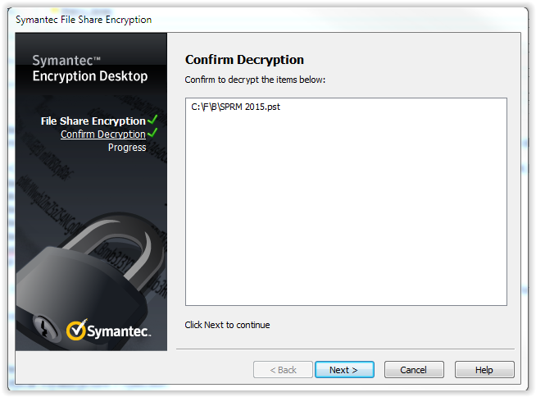

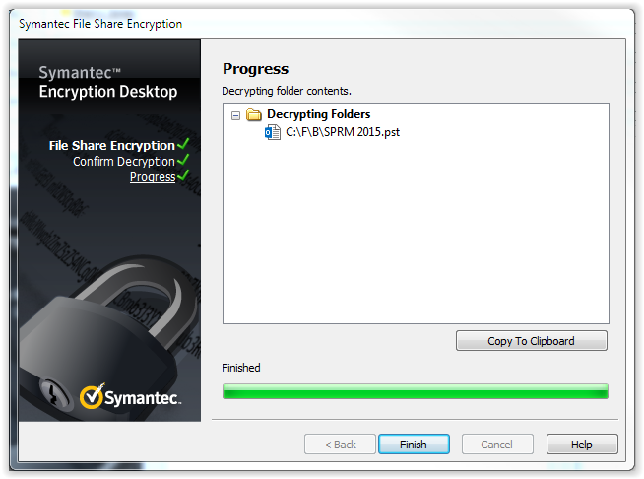

I then tried to open the decrypted .pst file in Outlook.  This is the file that I never tried to open while encrypted.  The .pst file opened just fine, suggesting it is not the encryption process itself that is corrupting the file, just whatever process is used internally to decrypt when the file is opened.

To verify my hypothesis, I copied the encrypted file from Folder #2 to my laptop.  This time I did not try to decrypt the file before opening it.  Interestingly, I was not able to reproduce the failure.  I tried it twice to make sure I had not copied the wrong file.

So far, the only differences are that (1) the file that failed was already in the folder when I encrypted the folder and (2) the failed file was opened on a network share drive, not my local laptop drive.

As a final test, I created a third folder, copied the good .pst file from my laptop to the network shared folder, and then encrypted the folder using File Share Encryption.  This reproduced the same initial condition as Folder #1.  I then copied the encrypted file back to my laptop and attempted to open the file.

Encrypting Folders

Y:\E-Mail_Test_3

User Access

Name <[name@spp.org](mailto:kperry@spp.org)>

SPP_RE

And, the file encrypted file opened just fine.

My conclusion is there is something about accessing the encrypted file directly on the network shared drive as opposed to opening the file on my laptop.  I do not have any problems opening Microsoft Office documents (.docx, .xlsx, etc.) or Adobe (.pdf) documents from the network shared drive, so this issue is unique to Microsoft Outlook.