This issue is on a newly implemented Workflow server. My assumption is that there are set up tasks that have not been completed correctly.

In my Dev environment I would check the Standalone Servers box and the local box underneath it. In the Production environment the local checkbox under Standalone Servers is not available.

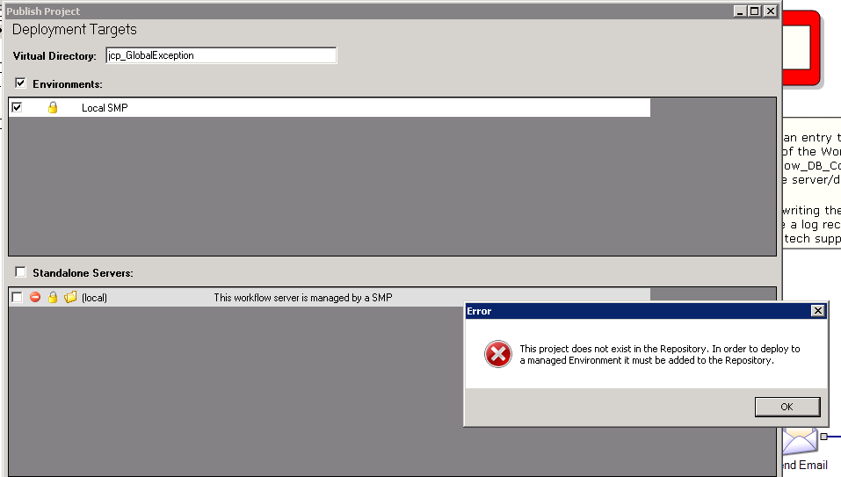

Notice that the icons next to the local checkbox indicate it is Invalid, Managed and Registered Locally. In Production it is only Registered Locally.