I think I know why no one is taking the survey:

**Step 1**

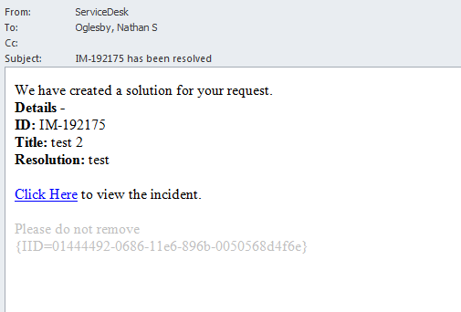

**Step 2**

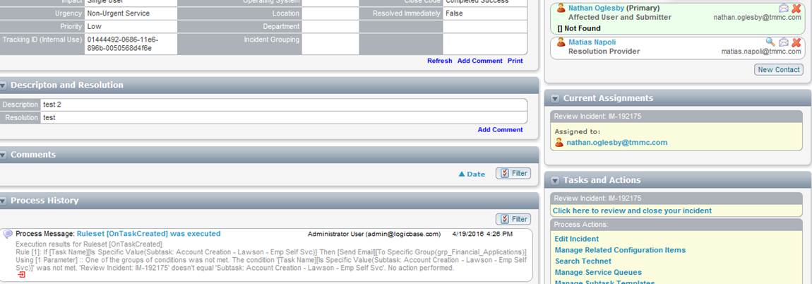

**Step 3**

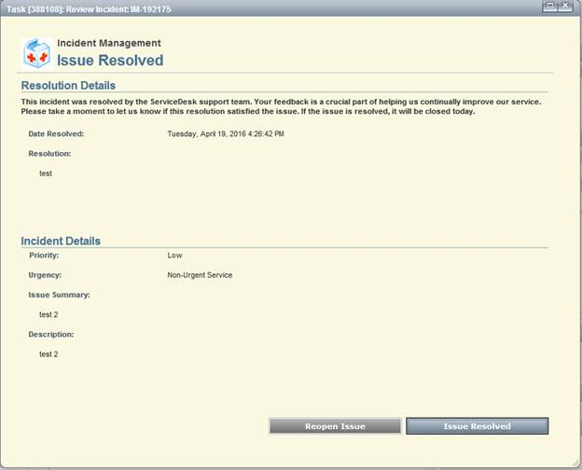

**Step 4**

c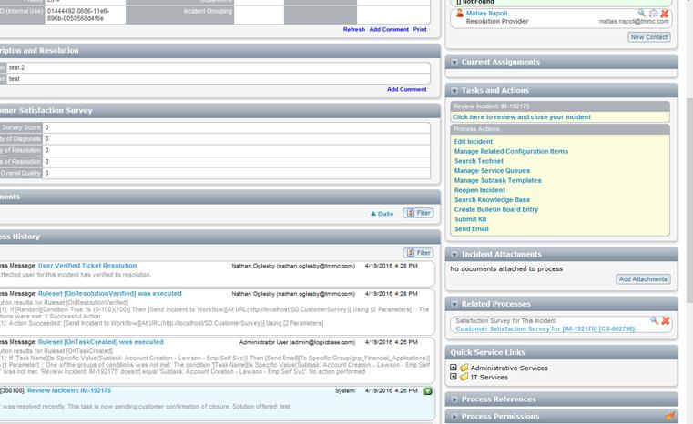

**(or if they see the email, they just come back to the previous step)**

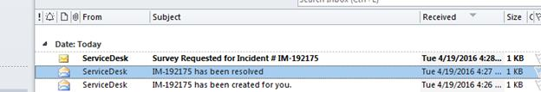

**Step 5**

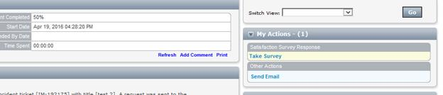

**Step 6**

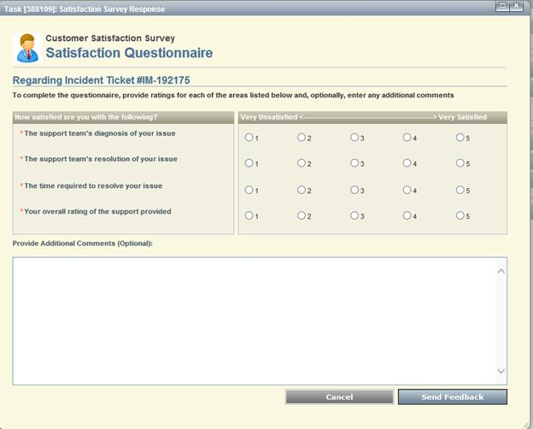

And if they never click on the first link, and even if they do, if they don’t see the “Click here to review and close your incident” and then even if they do that and close out before they see that a survey is available, they never get to that point. And I think they only have a finite time to go in and review and close the incident because I don’t see that option on my old tickets. I have a legitimate ticket that was closed for me earlier today 188403, I am going to wait and check tomorrow to see if I can still resolve/close it or if at some point in time that option goes away. But either way, it’s not super obvious and a lot of users may not even realize that the survey is even there.