Input-Parameter (date with timestamp) is defined with class: java.util.Date.

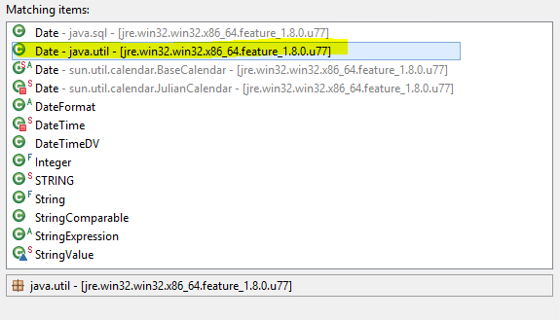

Execution in Jaspersoft Studio Professional (timestamp available):

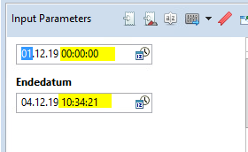

In JasperReport Server (Presentation Application) after publishing the setting of an timestamp is not able (only date):

