Hi,
Currently, I am working with CA SDM 17, and I created a custom field en WSP.
All working well, but I need to view any change in my ticket log.
In wsp, I added the following sintaxis in my fiels “zGroupF”
My custom field is “SREL” to “GRP”

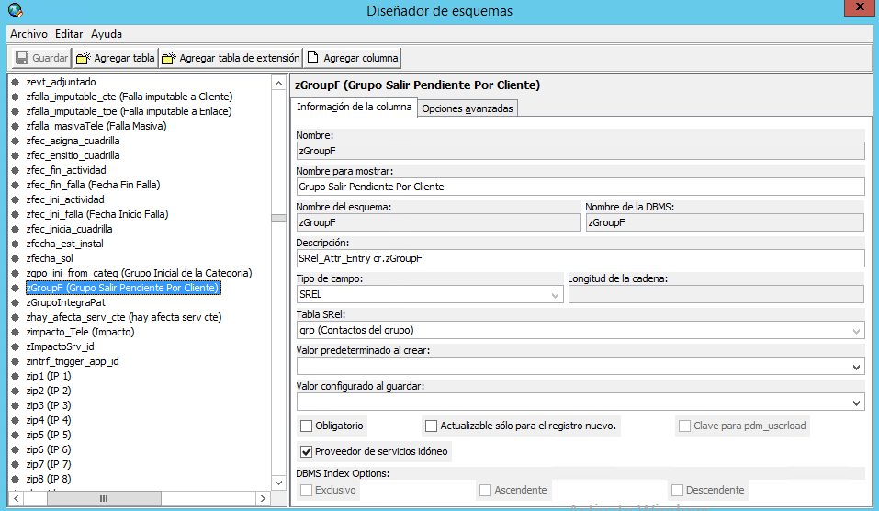

I added the sintaxis “AUDITLOG()”
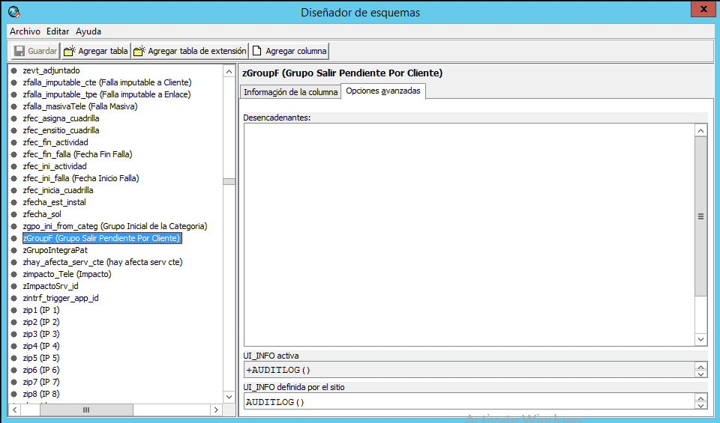
And in SDM, I created a Activity
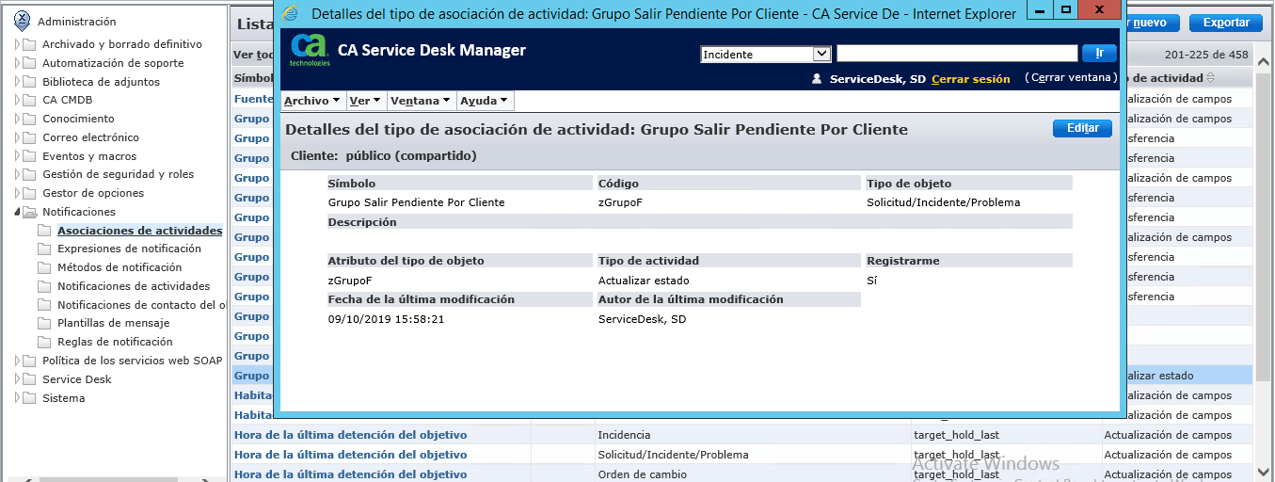

But the activity, is not registred in my ticket
Only show me the default field as Group o Description
