Symantec DLP Tool showing only 63 incident

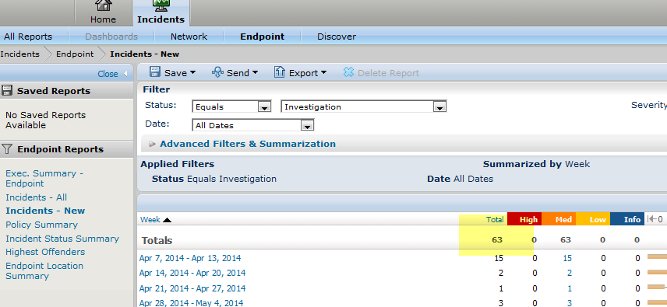

In Weekly report it showing 85incident count

