[Response Rule]

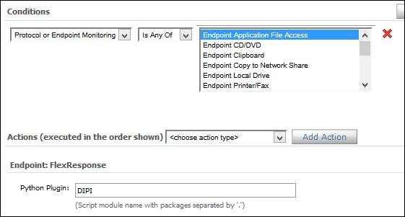

[Policy]

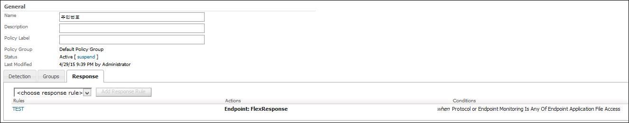

[Incident] **FlexResponse Icon was not shown**

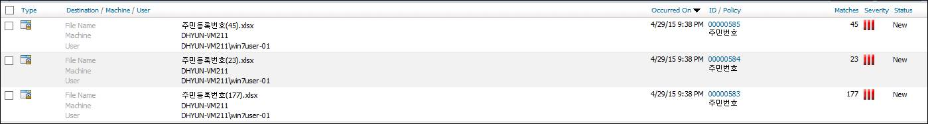

[Incident Hisotry] **FlexResponse calling path was not shown**

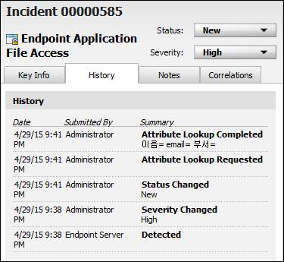

[Local Drive Monitoring] = FlexResponse Icon is shown.

