JasperSoft as a Service (JaaS)

Jaspersoft 5.6.1

CA Support

|  |  |
| --- | --- |
| Document Title | **JasperSoft as a Service (JaaS)** |
| Customer | N/A |
| Product | CA Clarity PPM 14.2 |
| Project | N/A |
| Last Saved Date | 10-Nov-2015 |
| Version | 1.0 |
| Authors |  |



Table of Contents

JasperSoft as a Service (JaaS) Directions 3

1.1 Configuration Check List 3

1.2 Installation Commands 3

1.3 Validate the settings in the UI 5

1.4 Start the Service in Troubleshooting Mode 6

1.5 If no errors 6

1.6 If you make any mistakes and want to start fresh 6

# JasperSoft as a Service (JaaS) Directions

## Configuration Check List

Details of all configuration that have to be in collected to install JaaS.

|  |  |  |
| --- | --- | --- |
| ITEM | CONFIGURATION | LOCATION |
| 1 | JasperSoft Apache Tomcat Location | C:\Program Files (x86)\CA\Jaspersoft 5.6.1\Tomcat\apache-tomcat-7.0.55 |
| 2 | Java SDK Location | Java = C:\Java\jdk1.7.0_67 |
| 3 | User who installed Jaspersoft | Administrator  Note: If you have installed by opening command prompt as administrator, you will need to copy JasperSoft license files from c:\users\<installer_user> to c:\users\Administrator folder |
| 4 | Service Name | CA PPM JasperSoft Tomcat 7 |

**Table 1 – Component Prerequisite/Configuration checklist**

## Installation Commands

Option 1:

From the C:\Program Files (x86)\CA\Jaspersoft 5.6.1\Tomcat\apache-tomcat-7.0.55\bin directory execute the following command:

(Update your Configuration Paths):

<Path to Tomcat/bin directory>/tomcat7 //IS//CA_PPM_JasperTomcat7 --DisplayName="CA PPM Jaspersoft Tomcat 7" --Install="C:\Program Files (x86)\CA\Jaspersoft 5.6.1\Tomcat\apache-tomcat-7.0.55\bin\tomcat7.exe" --Jvm=auto --StartMode=jvm --StopMode=jvm --StartClass=org.apache.catalina.startup.Bootstrap --StartParams=start --StopClass=org.apache.catalina.startup.Bootstrap --StopParams=stop --Classpath="C:\Java\jdk1.7.0_67\lib\tools.jar;C:\Program Files (x86)\CA\Jaspersoft 5.6.1\Tomcat\apache-tomcat-7.0.55\bin\bootstrap.jar;C:\Program Files (x86)\CA\Jaspersoft 5.6.1\Tomcat\apache-tomcat-7.0.55\bin\tomcat-juli.jar" --Startup=auto --JvmOptions="-XX:MaxPermSize=512m;-Duser.home=C:\users\administrator"

Option 2: (my personal preference)

* Open command prompt as administrator
* Go to Tomcat Bin Directory for example cd %TOMCAT_HOME%\bin
* Give command 🡪 service.bat install
* This will create windows service for Tomcat
* From Windows Explorer, explore %TOMCAT_HOME%\bin folder. You will see a file named ‘Tomcat7w’ with application type as follows:
* 
* Double click on tomcat7w
  + Make 2 changes as shown below in General Tab
    - Change Display Name to ‘CA Jaspersoft Tomcat 7’
    - Change Startup type to ‘Automatic’

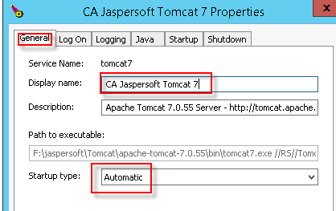

* Click on Java tab and make following 3 changes
  + Remove everything from Java Options and add following
    - -XX:MaxPermSize=3072m
    - -Duser.home=C:\Users\Administrator
  + Remove value from initial memory pool
  + Remove value from maximum memory pool

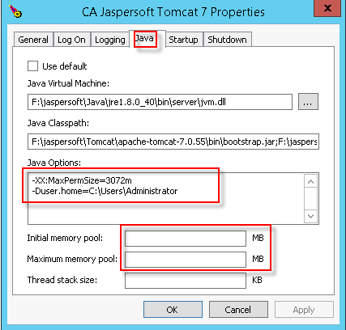

Note: If you have installed by opening command prompt as administrator, you will need to copy JasperSoft license files from c:\users\<installer_user> to c:\users\Administrator folder

Refer to following list for Jaspersoft License files (Japersoft 6.1)

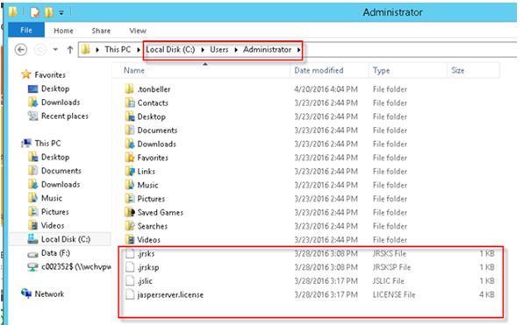

## Validate the settings in the UI

To load up the service that you just created to validate the settings, issue the following command:

C:\Program Files (x86)\CA\Jaspersoft 5.6.1\Tomcat\apache-tomcat-7.0.55\bin\tomcat7w //ES//CA_PPM_JasperTomcat7

Will get the following Window:

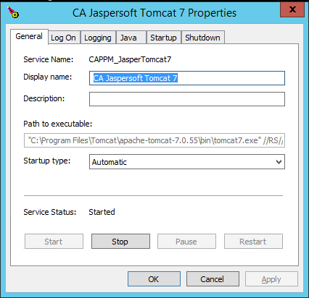 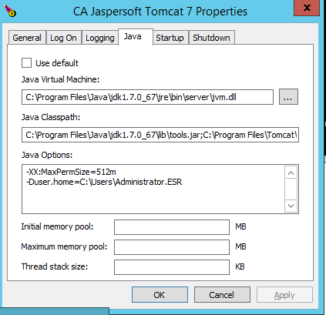

Validate the “Path to Executable” in the General Tab. If customer made any typo, you will have to go into the registery:

(HKEY_LOCAL_MACHINE\SYSTEM\CurrentControlSet\Services\CA_PPM_JasperTomcat7\ImagePath) and correct

## Start the Service in Troubleshooting Mode

To start this new service in Troubleshooting Mode (will display all message to Standard Output), execute the following command:

Then execute -> C:\Program Files (x86)\CA\Jaspersoft 5.6.1\Tomcat\apache-tomcat-7.0.55\bin\tomcat7 //TS//CAPPM_JasperTomcat7

Here you will look out for any errors:

1. RMI TCP Timeout errors
   1. Means the MaxPermSize is too low or not set
      1. set or increase the value.
2. Error - Exception in thread "main" java.lang.NoClassDefFoundError: org/apache/catalina/s   
   tartup/Bootstrap
   1. Means one of the paths to the executables are not found.
      1. Load the Service into the UI (tomcat7w //ES//CA_PPM_JasperTomcat7) and validate the paths
3. KeystoreManager.init was never called or there are errors instantiating an instance.
   1. Means the “-Duser.home” variable is incorrect.
      1. Validate that in that directory your have a .jasperserver directory and the files jasperserver.license, .jrsks, .jrsksp and .jslic exists in that file.
4. Service Owner – cannot be a non local admin
   1. Can we Local Service Account
      1. Currently cannot figure out what advanced Administrator privileges are required. Gave Logon as a Service – but that didn’t help.

## If no errors

Validate that you can log into Jaspersoft and if so, then close the command prompt (which will shutdown JasperSoft) – then start the service normally via services.msc

## If you make any mistakes and want to start fresh

To delete a service and start fresh:

Sc delete <service name>