# Installing Endpoint Using SCCM

The issue with SCCM and installing the endpoint agent is that there is no simple way to get SCCM to run an executable under the “Run as Administrator” umbrella of permissions. When SCCM does an installation it will run it under the SYSTEM level account, and that account dos not have the right permissions to successfully install the DLP agent.

As a result there are a few different methods that customers have used to install the DLP agent.

Here are a couple of the Options:

## Installing the Endpoint agent using a Task Sequence Approach

There is a work-around when it comes to permissions, and that is to use a custom Task sequence and the step Run Command Line. After R2 and R3 there is an option to run command line using a specific User Account. This approach has been used in many situations, for example when installing some Adobe Packages.

**Then you can the command line using an account that is local admin on the computer and it should work.**

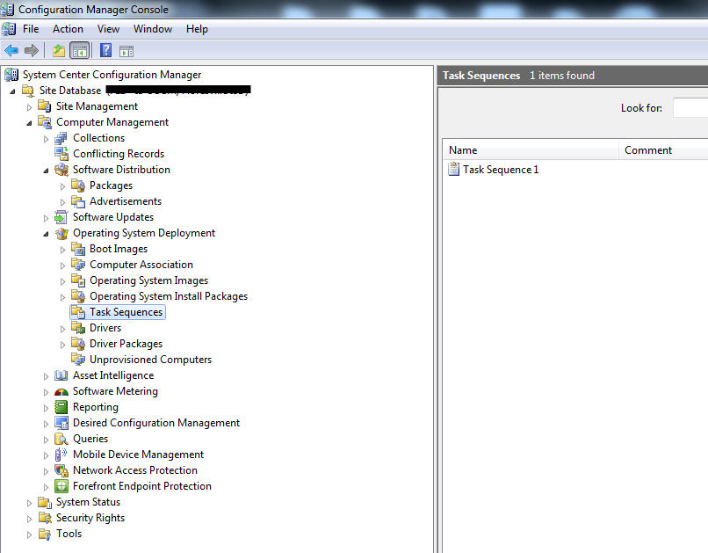

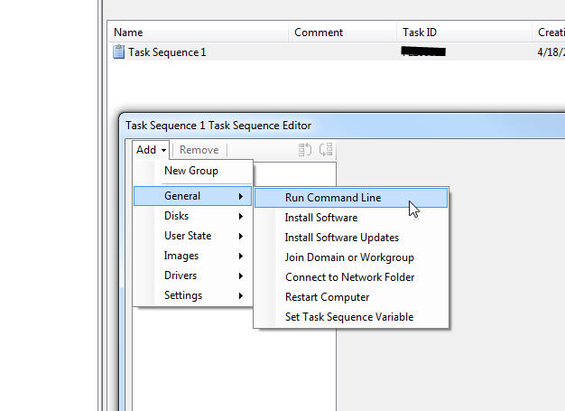

## Installing the DLP Agent using a duplicated CMD.exe file.

SCCM runs as the system account so it has rights to override the default 32bit cmd. The reason it didn’t work when tried with psexec and executed as the service account is because it had opened the command prompt to run psexec as the defaulted 32bit – if that makes sense

So what you can does is duplicate the cmd file as if it is another application and package it with the deployment.

* Copy the cmd.exe out of c:\windows\system32, renamed it to cmd64.exe and place it in the source folder.
* Then call the cmd64.exe to execute install_agent.bat.

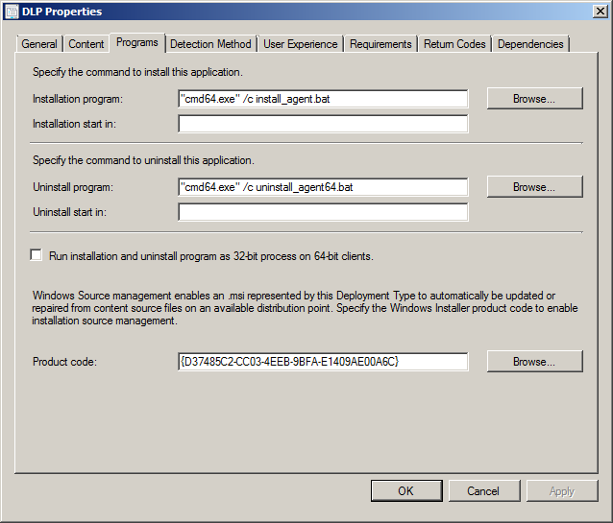

When the installer is running you will see the following:

