Please find screenshot of PXE boot process. I am not getting rapideploy screen for creating and restoring image. It directly goes to boot works .

We have also tried reinstalling PXE server.

Step 1

We select f12 for pxe boot

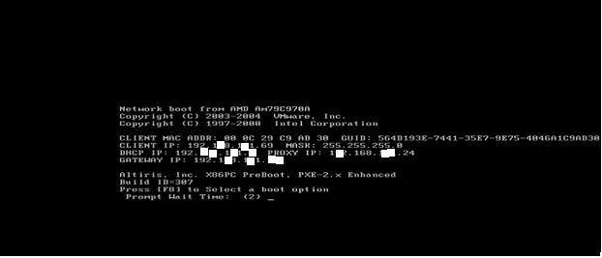

We select f8 for selecting pxe boot menu

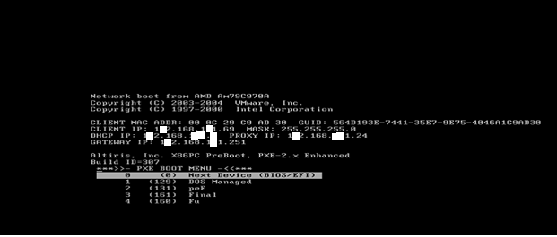

We select final from boot menu

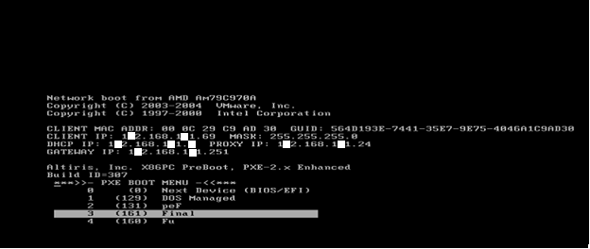

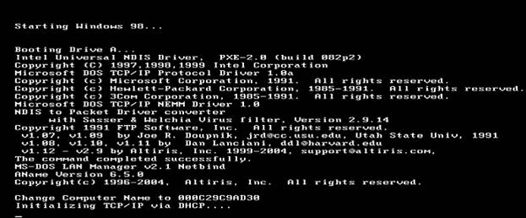

After this, we are not getting Rapideploy screen  it directly goes to bootworks screen as below.

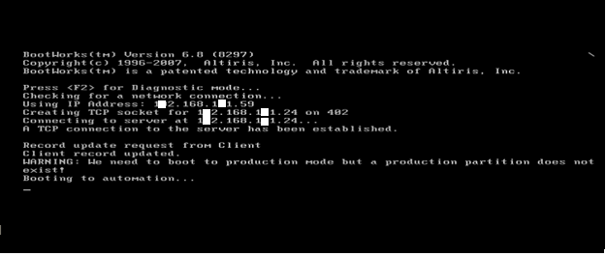

In short , we are not getting the below rapideploy screen for creating and restoring image.

