Steps to Creating a Custom report in Identity Governance

Contents
Prerequisites 1
Backup the Jasper database 2
Create the scenario dataset for the report you are writing 2
Review Structure of an OOTB Report 2
Copy an OOTB Report that is close to what you want 4
Copy any sub report that you want to customize 5
Copy any OOTB input controls you want to customize 6
Customize the Control 7
Add new Subreports and Input Controls into the report 8
Set up Parameters to be passed on the main report 8
Set up the sub reports 9
Edit the Subreport Parameters 10
Edit the Subreport Query 11
More Examples 13
Format the Report Body 14
Create a Group 15
Edit Formulas to Suit 15
Save the Report 15
View the Report in the JasperReports Server Repository 16
Test in the IG GUI 16
Migrate the report to Prod 16
Using the Report Wizard to Create a new Report 17

Prerequisites
Jasper Studio – Installed and Connected to the DB
ETL Run in IG for the test Dataset

Backup the Jasper database
Backup the Jasper database before making any changes.
Backup
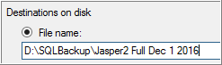
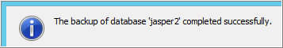

Create the scenario dataset for the report you are writing

For example, if you want to write a report to show only service accounts, create a certification that has some activity for service accounts. Include Approve, Reject, Comment, Reassign, Share my Work in the list of activities.
Once the work has been submitted, run the ETL to extract the data to the report database.

Review Structure of an OOTB Report
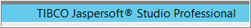
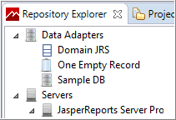
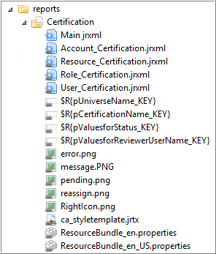
Main jrxml -- This is the only object actually stored in this folder. All of the others are links. This seems to be the expected way to store the report objects as saving the main configuration tries to add linked objects if it thinks they are missing.

“jrxml” – Jasper Reports xml
The jrxml files are the report descriptions.
In the screenshot we have:
1 Main Report
4 Subreports
Since we are doing resource certifications, we have only modified that one subreport, “Resource_Certification.jrxml”.

Note that everything about the OOTB report is a link except for the main report.
This can be problematic if you don’t understand that the objects you are editing may be used by multiple reports.
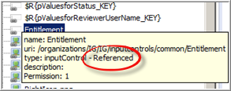

Copy an OOTB Report that is close to what you want
Click on one of the existing reports.
Click “Copy”
Right-Click on the “Reports” folder
Select “Paste”
Select “Create a copy”
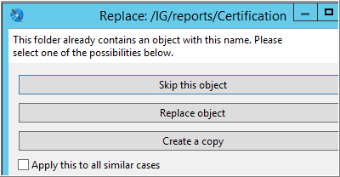

Give the copy a Name

Verify the Copy
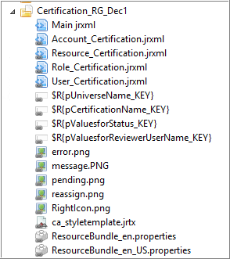

Note Again, that except for the Main.jrxml file, the copied report has links (the grey dash at the lower left of the icon) for all the rest of the report package.
Unless you make your own copy of these, editing them will affect all reports using these linked objects. Also, these base objects would get overwritten if you upgrade to a new version of the product(report set) at some later time.

Copy any sub report that you want to customize
Navigate to the subreports folder
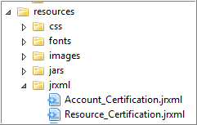
Select the report you want to copy.
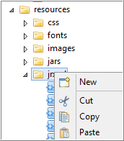
Right-Click the subreport, then Copy
Right-Click the jrxml folder, then Paste
Click “Create a Copy”
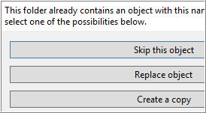
Rename as desired
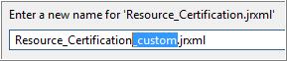
Click “OK”

Copy any OOTB input controls you want to customize
Navigate to the OOTB input controls
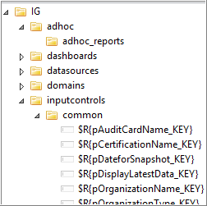

Make a copy of any controls you want to customize
Right-Click the control, then Copy
Right-Click the common folder, then Paste
Click “Create a Copy”

The OOTB use variables in the name to enable multiple language support. If that is not needed then type the desired name directly.

Customize the Control
If you created a copy, then there is an assumption that you needed it to work differently than the original.
The most common, and easy, change is to make the control optional.
Double-Click the control to edit it.
Uncheck “Mandatory”
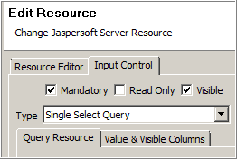
With “Mandatory” unchecked, if the end user does not select anything for the inputcontrol, then no filtering will be done on that variable.

Add new Subreports and Input Controls into the report

Copy and Paste the control or subreport into the new reports folder.
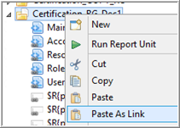
Make sure to choose “Paste As Link”

If the original report had a different version of the same control, delete that version.

Set up Parameters to be passed on the main report

Double-Click “Main.jrxml”

Note if it doesn’t open, try “Build All” from the Menu bar.
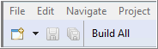
Open the Dataset and Query Editor
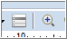
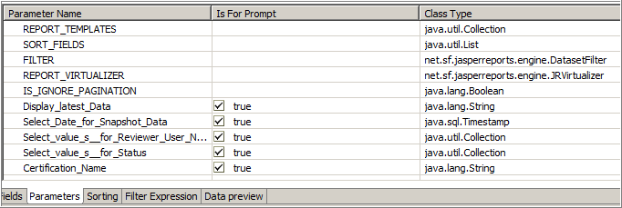
There needs to be a parameter for each input control

If changing to query to allow multiple certification in one report, the main query needs to be adjusted.
select I2_CAMPAIGN_SCD.TYPE from I2_CAMPAIGN_SCD
where $X{IN,I2_CAMPAIGN_SCD.NAME,Certification_Name_Multi}

Set up the sub reports

Click “Title”
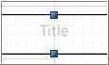
Click “Subreport”
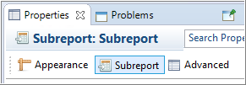

Click the Expression Editor icon
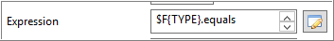

Change the subreport name to match the custom subreport name
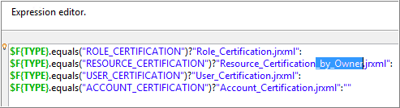

Edit the Subreport Parameters

In the Main report click the title.
In the “Prepoerties” tab, click the “Subreport” subtab.
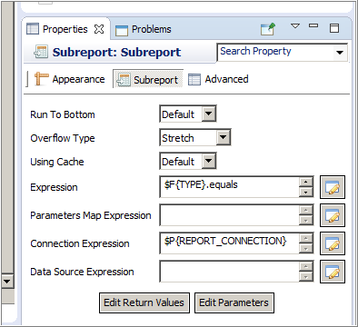

Click “Edit Parameters”
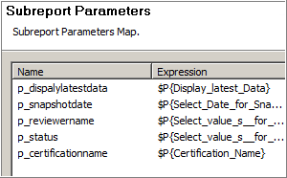

If you have customized the variable created by an input control or added new input control, add those here.
The convention is to name the parameter with a “p_”, but this is optional.

Edit the Subreport Query

Note Reference to Parameters in the Main report
Edit Resource_Certification_by_Owner.jrxml

Click “Dataset and Query Editor” icon. 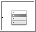
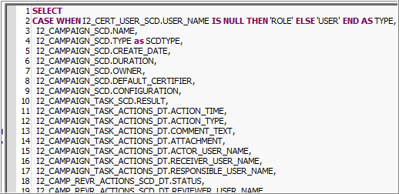
Edit the query as desired.
You will likely need to copy the query to Microsoft SQL Server Management Studio or other query writing tool if you are making major changes.
For the most part, useful reports can be created by simply modifying the where clause.
Example 1
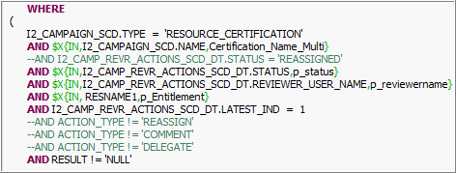

Example 2
WHERE
(
I2_CAMPAIGN_SCD.TYPE = 'RESOURCE_CERTIFICATION'
AND $X{IN,I2_CAMPAIGN_SCD.NAME,Certification_Name_Multi}
AND $X{IN,I2_CAMP_REVR_ACTIONS_SCD_DT.STATUS,p_status}
AND $X{IN,I2_CAMP_REVR_ACTIONS_SCD_DT.REVIEWER_USER_NAME,p_reviewername}
AND $X{IN, RESNAME1,p_Entitlement}
AND I2_CAMP_REVR_ACTIONS_SCD_DT.LATEST_IND = 1

--AND RESULT != 'NULL'

--AND I2_CAMP_REVR_ACTIONS_SCD_DT.STATUS != 'REASSIGNED'
--AND ACTION_TYPE not in ('REASSIGN','COMMENT','DELEGATE')
--AND RECEIVER_USER_NAME is null
AND I2_CERT_USER_SCD.PERSON_ID like 'Empty_Group%'
)

Note: The $X function is specific to Jasper and will not run in SQL Server. The report engine writes the proper SQL dynamically. This add flexibility in passing parameters to the query.

EQUAL – parameter must be of type “java.lang.String”
IN – parameter must be of type “java.util.Collection”

More Examples

By Group vs By Owner
Just switched the grouping order and associated formatting. Otherwise the same report.
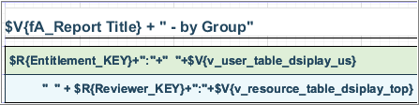

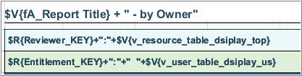

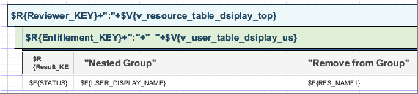

AND I2_CERT_USER_SCD.DISPLAY_NAME like 'Group: %'
AND RESULT = 'result.certification.reject'
AND (ACTION_TYPE = 'REJECT' /*OR ACTION_TYPE = 'COMMENT' */)
AND I2_CAMP_REVR_ACTIONS_SCD_DT.STATUS = 'REJECTED'
AND RECEIVER_USER_NAME is null

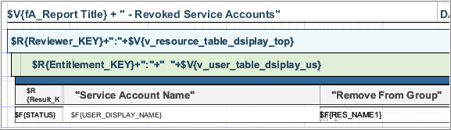

AND I2_CERT_USER_SCD.DISPLAY_NAME like '% (Service)'

AND RESULT = 'result.certification.reject'
AND (ACTION_TYPE = 'REJECT' /*OR ACTION_TYPE = 'COMMENT' */)
AND I2_CAMP_REVR_ACTIONS_SCD_DT.STATUS = 'REJECTED'
AND RECEIVER_USER_NAME is null

Format the Report Body
See Palette on the right
Note: The body elements are encapsulated in “Frames”. Try to edit the whole frame as much as possible instead of individual objects.
Edit the container, not the individual objects

Compare format of
Note csv version has a much simpler layout so that if saved to csv, there are no format breaks in the data.

Reassignments
OOTB Report + a focus on the reassign information
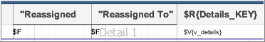

Create a Group
Right Click the very top item in the Report Inspector and choose Add Report Group
Or click on the space above the Title band or below the Summary band then right click in there for the same thing
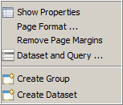

Edit Formulas to Suit

Save the Report

View the Report in the JasperReports Server Repository
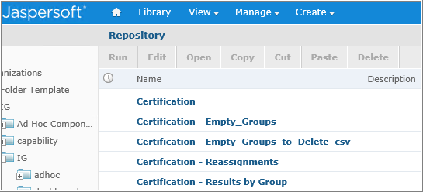

Test in the IG GUI
Double-Click the Title
Add “ – by Owner” to the title
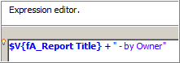

Migrate the report to Prod

Using the Report Wizard to Create a new Report
This is beyond the scope of this document, but just for fun…. While easy to create a basic report, you have a lot of work to do to make the report interactive (ie. add input controls).

The following is some testing
Create a Data Source
File > New Report

Pick a template
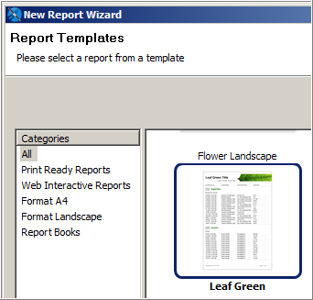

Name the report file
Pick a location to save the report to
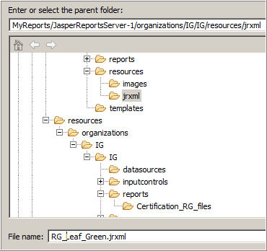

Create a New Data Source
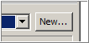

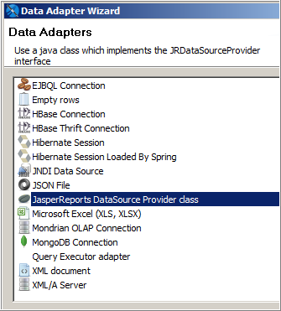
Choose Query Executor Adapter

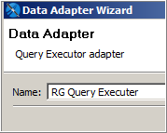
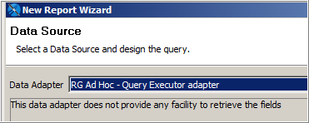
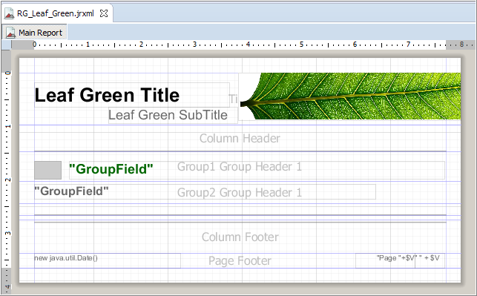
A report has been created empty.

Publish to Report Server
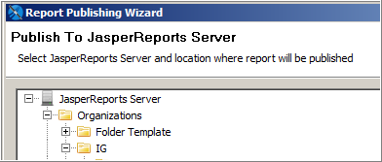
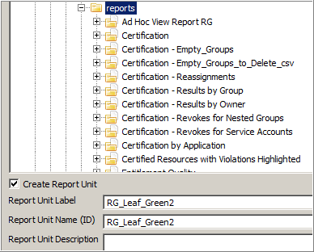

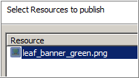
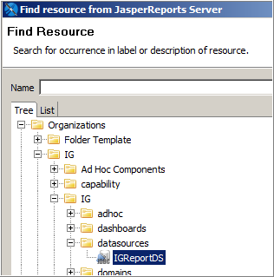
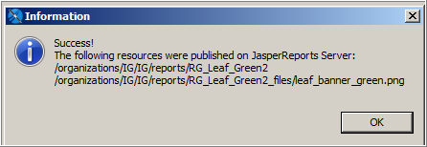

Right-Click on the report folder
