Capacity vs Allocation by Resource OBS

Current Functionality:
Employment Type: Employees and Contractors
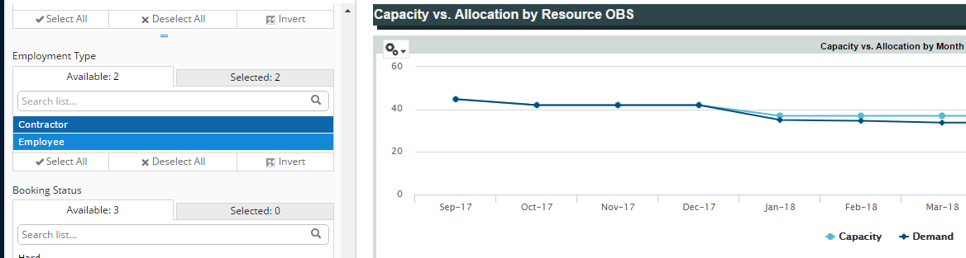
Demand = 45 FTEs
Employment Type: Employees
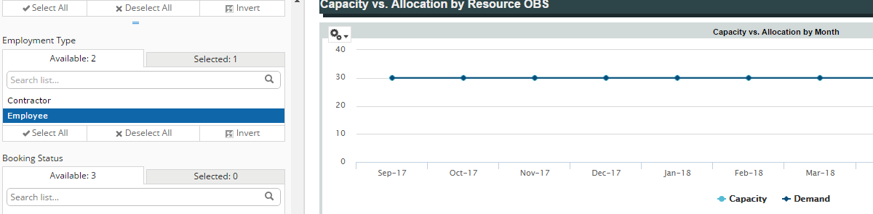
Demand = 30 FTEs

Requested Functionality (edited screenshot):
Employment Type: Employees
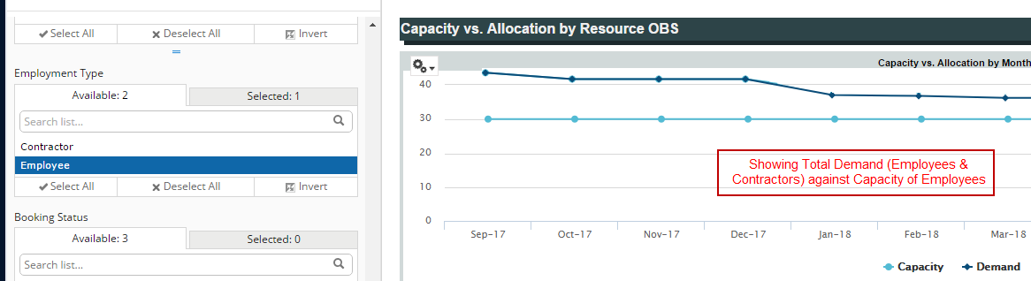
Demand = 45 FTES

