Creating an Computer Group Filters based on AD Group using the User import Rule

Create a custom Data Class – AD User Group

In the SMC select Setting and then All Settings
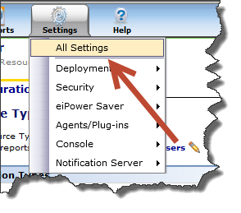
Navigate to Settings | Notification Server | Resource and Data Class Settings | Inventory | User and Group
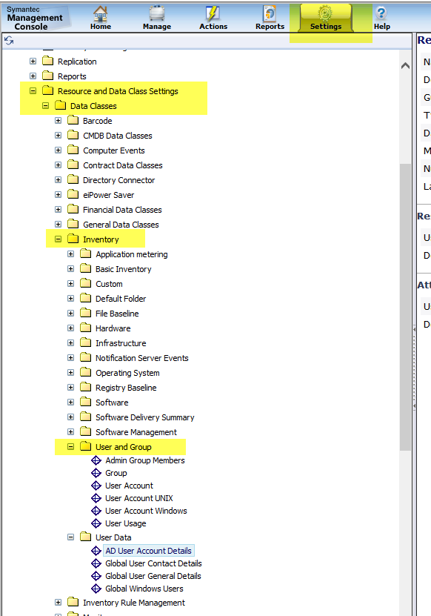

Highlight right click on the “User and Group” folder select new | Editable Data class
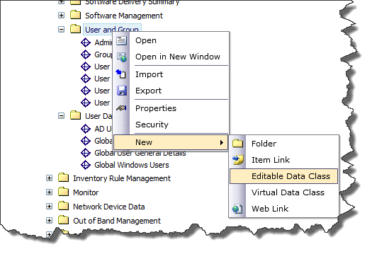

Rename the new Data Class
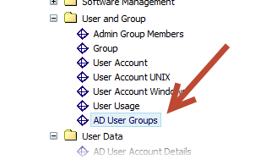
Select Add New attribute
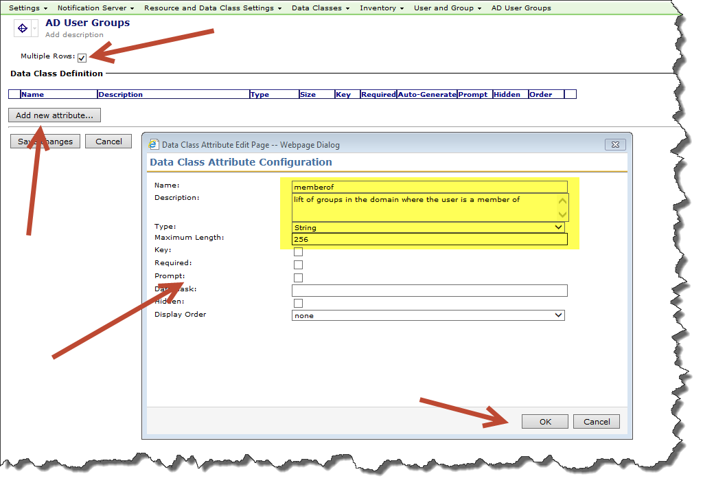
Save Changes
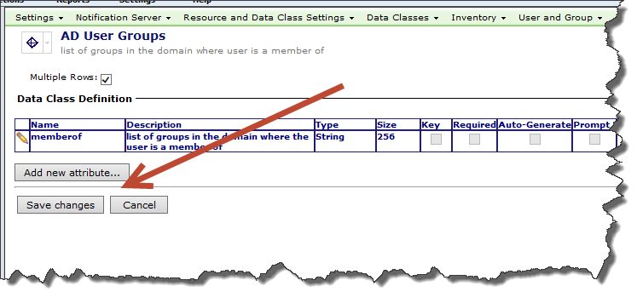

Associate the new Data Class to the User Resource Type

Navigate to Settings | Notification Server | Resource and Data Class Settings | Resource Types | Organizational Types and select the User Resource Type.
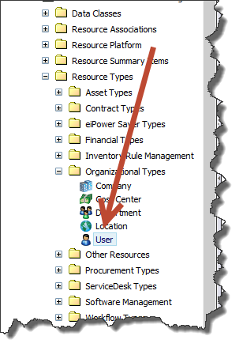
Add the new AD User Groups Data Class and select Save changes
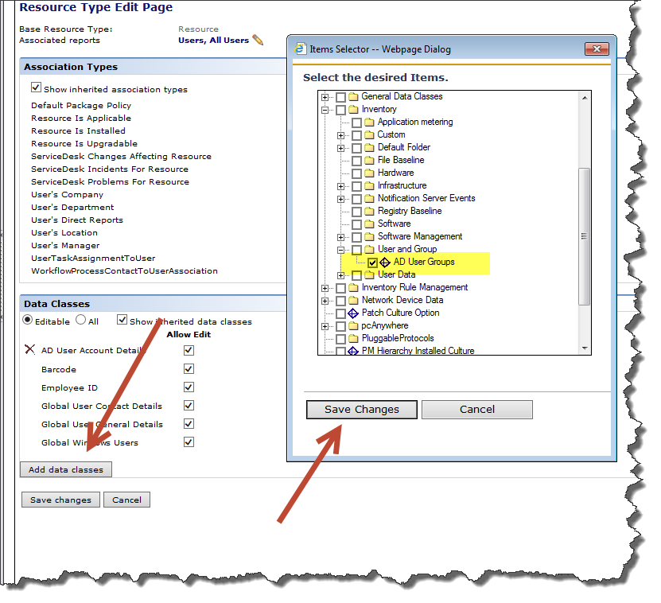
Save Changes
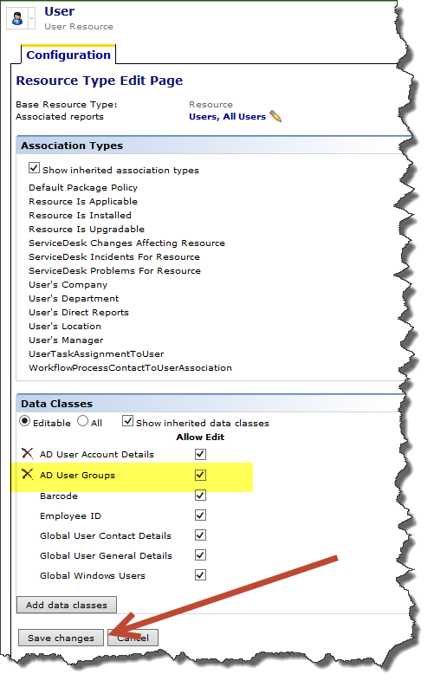

Update the User Import Rule column mapping to use the new data class

In the SMC go to settings then “All Settings”
Navigate to Settings | Notification Server | Microsoft Active Directory Import
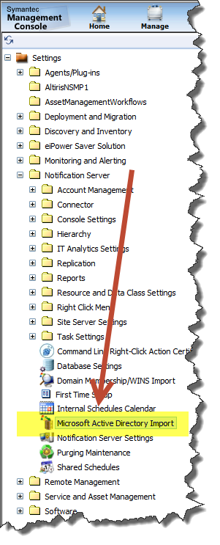
Select the User Import Rule and then select “Specified column mappings”
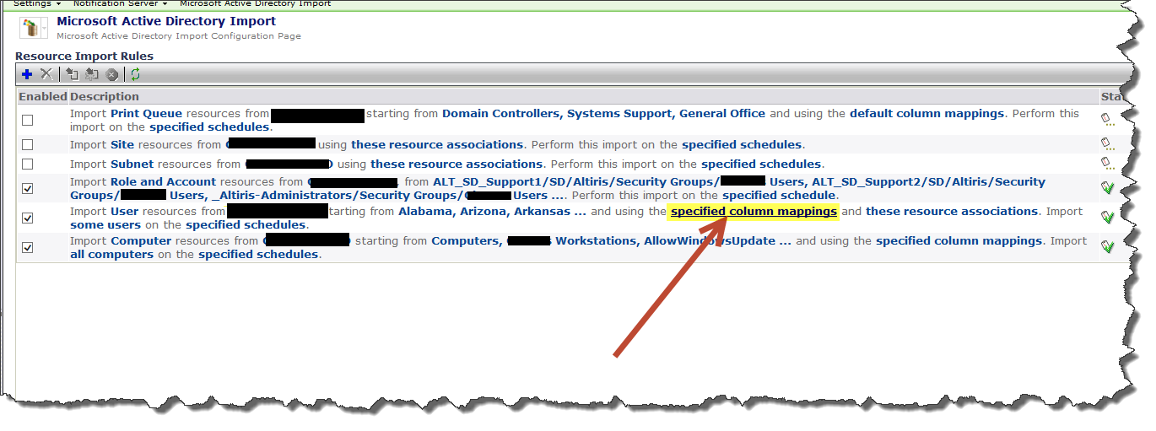
Map the new “AD User Groups” Data Class to map to the AD User’s attribute “memberOf” and select OK.
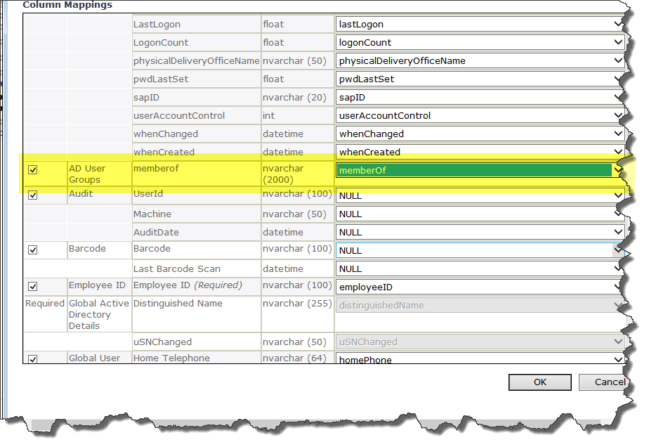

Highlight the user Import rule and run a full import on the User import rule
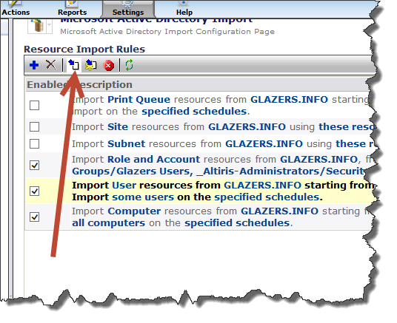
The Resource Manager now shows the new Data Class AD User Groups for a User Resource
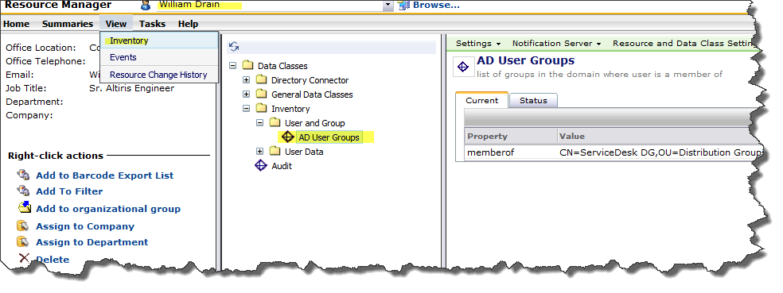

Create a Computer filter using the new AD User group

In the SMC console select Manage | Filters
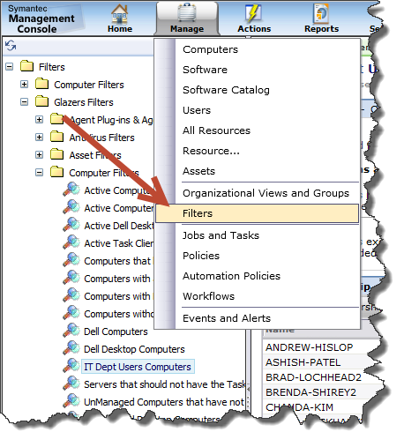
Select a filter folder, Right click and select filter
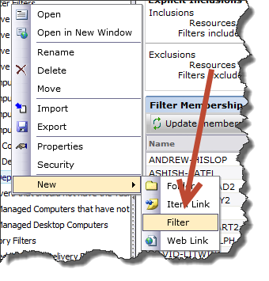

Past the following sql query in the filter
declare @adgrpname as varchar(100)
--Replace with AD group name
set @adgrpname = '%serviceDesk%'

select vc.guid, vu.[Display Name], aug.memberof, vc.Name
from vUser vu
-- Computer resourceassociation based on user
join ResourceAssociation ra on ra.ChildResourceGuid = vu.Guid
join vComputer vc on vc.Guid = ra.ParentResourceGuid
-- join
join Inv_AD_User_Groups aug on aug._resourceguid = vu.Guid
where aug.memberof like @adgrpname

