Leveraging CA ASM Real Browser Monitors (RBM) to generate session data for CA AXA.

This document explains how to leverage CA ASM and the RBM tests to simulate user transactions against an instrumented webapp that will send session data to CA AXA.
The target webapp will need to be instrumented as described here:
https://docops.ca.com/ca-app-experience-analytics/16-4/en/configuring/collect-data-from-your-web-application

- CA ASM uses “CA Cloud Monitor Recorder” to record scripts.
The recorder uses IE for recording a navigation session. To avoid problems when running the AXA snipped on IE (on compatibility mode) follow these instructions:
https://www.yammer.com/ca.com/threads/956769981
NOTE: https://docops.ca.com/ca-app-experience-analytics/16-4/en/supportability-matrix/
Microsoft Internet Explorer 11: Compatibility View is not supported.

- Record the script using the ASM recorder “CA Cloud Monitor Recorder”.
Make sure you add “sleep” timers between each step, otherwise when the ASM station executes the navigation it might be too fast and the BA.js script will not be executed.
(Necessary because BA.js snipped is executed asynchronously after the “onLoad” event)
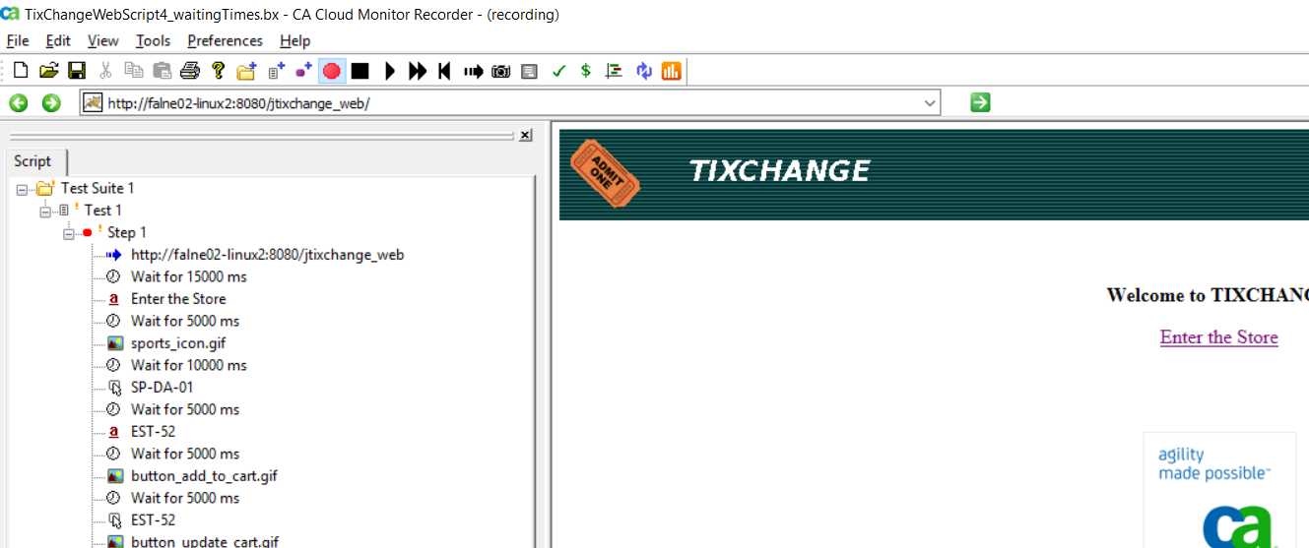

- Select “Record javascript requests” under Preferences-Recording:
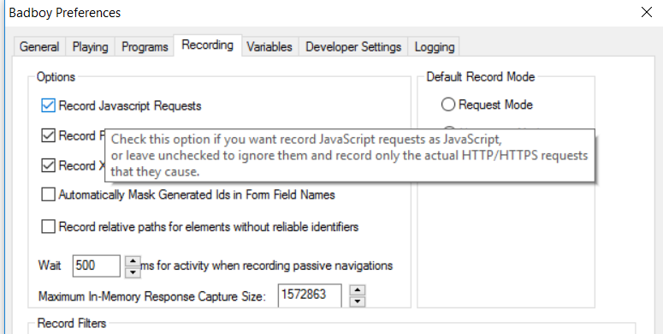

- Make sure your ASM account is entitled to run recorded scripts
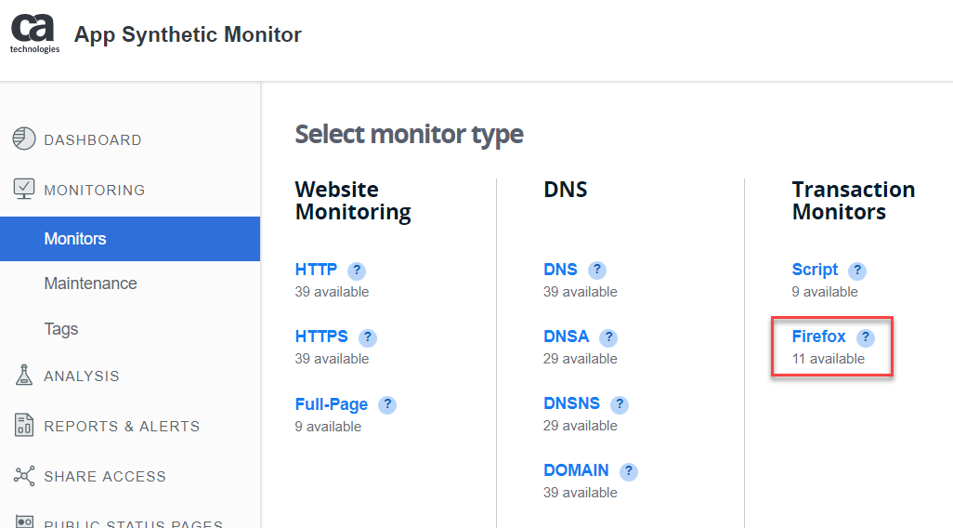

NOTE: Run the script from an On-Prem station if your target URL is on CA network:
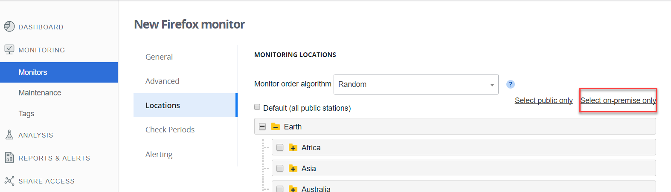

- In the Monitor configuration, select the browser/OS announced by the RBM when running the script:
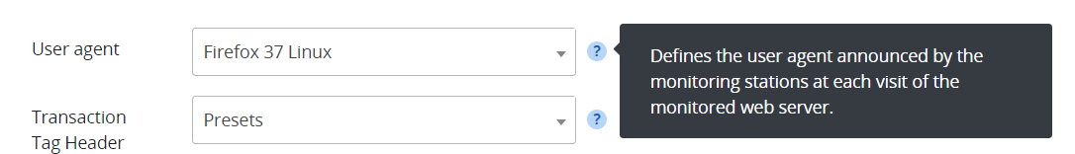

- Run the monitor. After some time, you will see the ASM Real Browser sessions appear in AXA dashboard:

