Thank you for your reply

We receive a file from HMRC which is secure and needs to be decrypted by us when we receive it. This is done via our private keys in PGP.

PGP has been holding the keys for the past 2 years and just last month we decrypted the file without any problems. PGP ‘s licence says never expired but our software maintenance expired in Feb 2013. But we have been using the existing keys with out any issues.

The existing keys expired this month so I have started the process to renew . I have purchased new SHA-1 certificates from COMODO and have converted the new signed CSRs file into security keys using OPENSSL and I create a new EXPORT password myself.

This then creates a “to” and “from” P.12 files. I then drag and drop these keys into PGP.

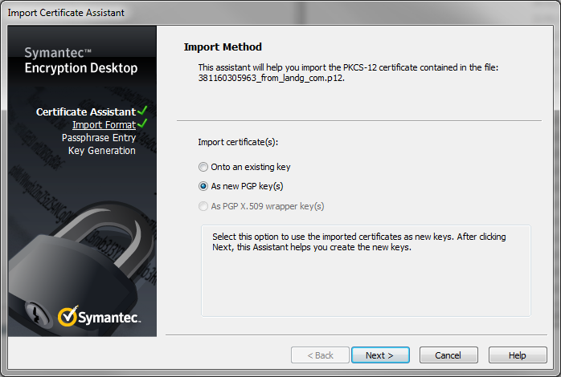

I click on next

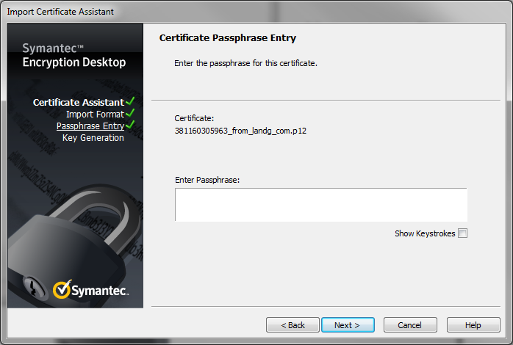

Input the export password that I created myself.

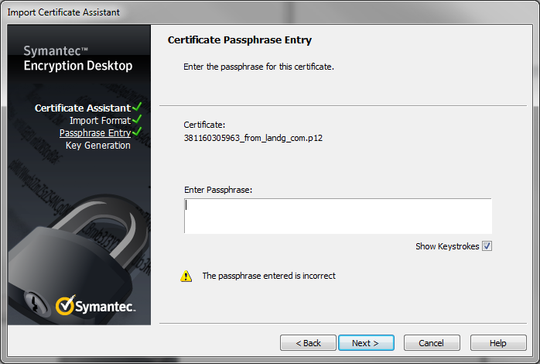

Tried it for the from P.12 file and get the error, I have installed PGP again, tried on a new machine, recreated the keys on openssl several times. Still stops at this point.
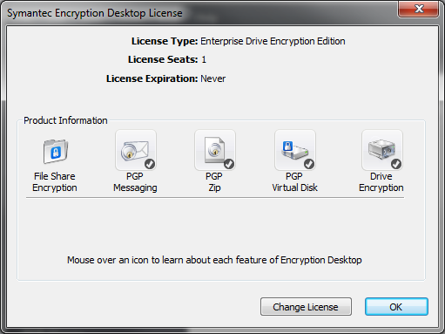

Is it because PGP has expired and it just wont accept the new keys ??

Any Advice would be appreciated.

