Siteminder external authentication:
Navigate Administration->Admin UI->Configure Administrative authentication

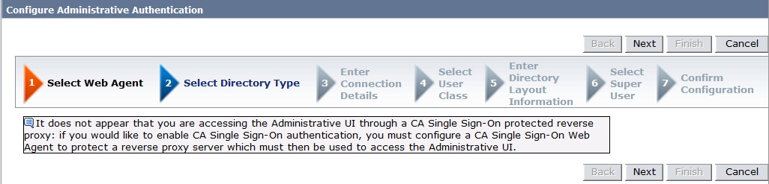

Click On Next

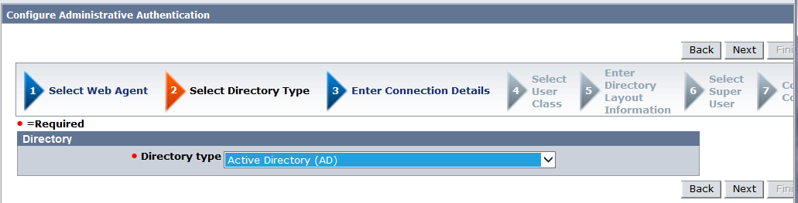

Select AD and click on Next

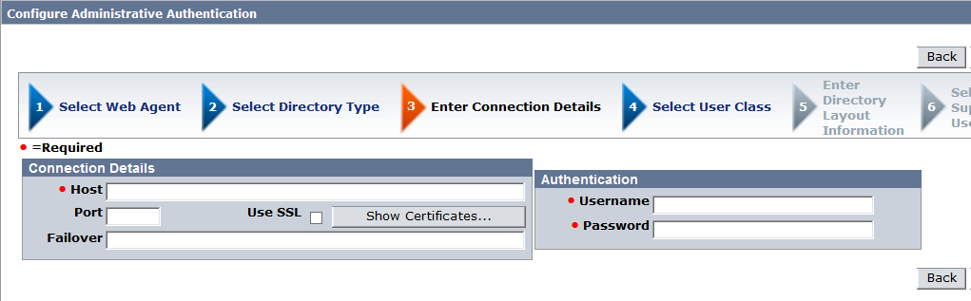

Enter the host, port, username and password, and click on Next

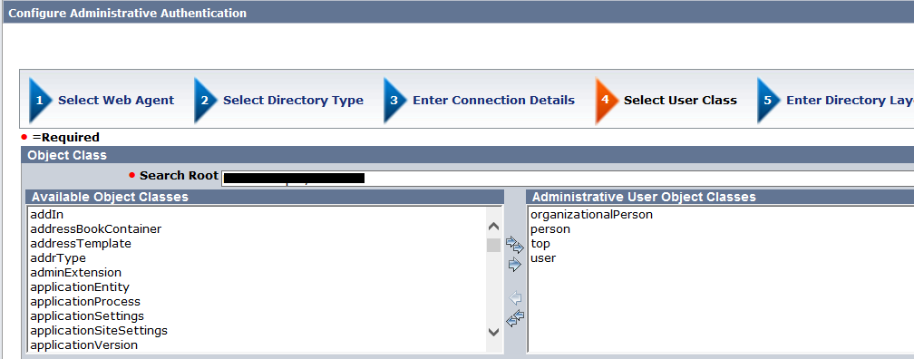

Enter the search root and click on Next

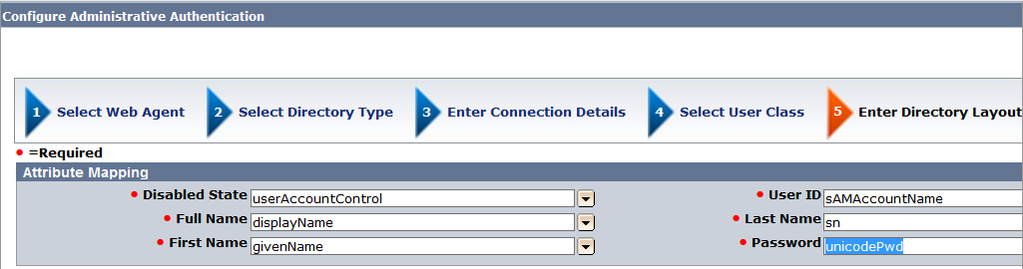

Select the AD attributes and click Next

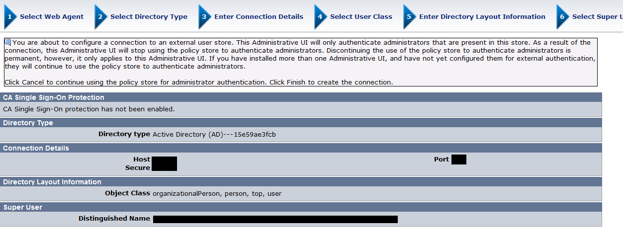
Select a super user by searching in the external store

Click on finish and Jboss for admin UI restarts.

