JDBCPing Tests
Pre-requisites
The following pre-requisites must be in place in order for JDBC Ping communication to succeed between the various members participating in the Clarity cluster:
- All members must use useJDBCPing = “true” option in <nsa element
Note: Don’t remove the multicast port and multicast address as these are mandatory fields
- All members must share a common NSA password
  - Run “admin password” to reset if needed
- If the server has multiple IP addresses (NICs) then configure the Beacon to bind to a single specific IP address (Note: this is not required to ‘enable’ multicast but if the Beacons are not configured correctly then that will prevent servers being visible in the NSA) – Stop, Remove, Add and Deploy the Beacon Service after making any changes.
- Once the JDBCPing is enabled, a table called CMN_JGROUPS_PING will be created in PPM DB.
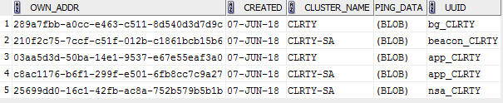
Created: Date and time of last message which has posted
Cluster Name: Topic name
Ping data: message content
UUID: Unique identifier - application instance id and topic name (currently topic name is set to CLRTY in all cases)

Test 1: Nikuadmin Tower
1. Ensure the beacon services have started successfully on ALL servers in the cluster (“niku start beacon” on all application servers, followed by “niku status beacon” on each application server to confirm the beacon service has started and is staying up)
2. On the server running the NSA, run the following command:
admin tower
Next run this command:
> trace on
You should then start to see packets of traffic being transferred between ALL servers in the Clarity cluster. If packets of data are not being sent between ALL servers then we have a problem.
PPM has two topics used for messaging. CLRTY for application specific and CLRTY-SA for system admin level messaging.
To see the messages flow for a specific topic, group needs to be configured in tower console. By default, tower group is mapped to CLRTY-SA topic
Below is the screenshot showing the message flow for application specific messages
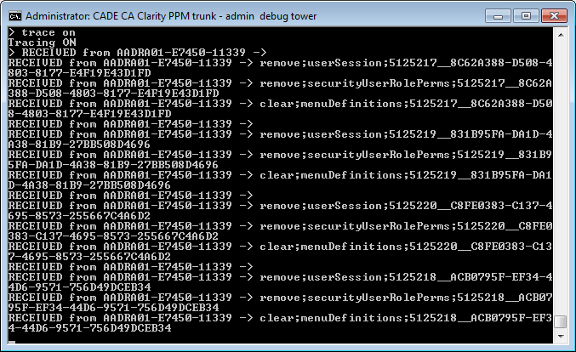
> group CLRTY-SA
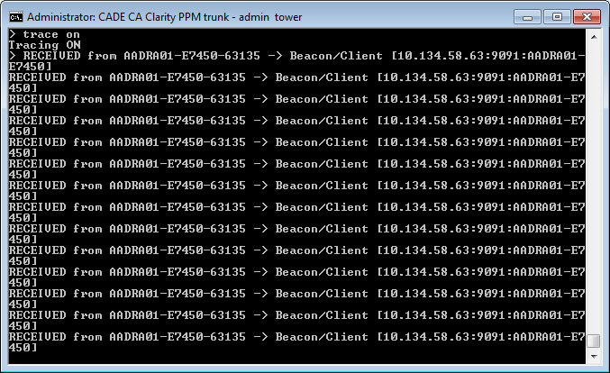

- If you want to change the Jgroup to see the message for respective groups you will need to run below commands
admin tower
  - Next run this command:
  - group CLARTY

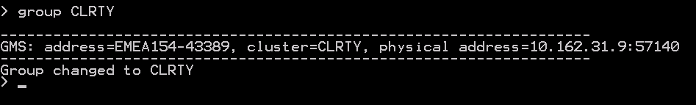
Trace on – This will show the messaging on the group CLARTY
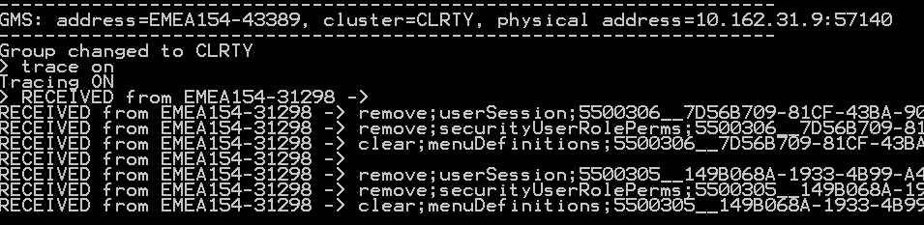

Test 2: CSA Passwords on servers
Ensure that all of your NSA passwords on ALL servers are set to the same value. This password is used to validate multicast packets sent by the various cluster nodes. If these are not the same then we have a problem and we need to reset them all to the same value. Run “nikuadmin password” to reset the password in the .passwd file.
Test 3: Bind Order of Network Interfaces
It has been observed that in the case of Windows, that the bind order of network interfaces can affect the Beacon services. In one instance in the field, a client had the MS LOOPBACK adaptor as first in the list – this caused issues for the Beacons and the issue was rectified after amending the order. Instructions on how to do this below:
Windows 2012 Server
1. Start → Run → ncpa.cpl
2. ALT + n (“Advanced”) menu, choose “Advanced Settings”
3. Use the Up and Down arrows to set the bind order as required.

