Update Policies After Computers Have Been Added To Filters

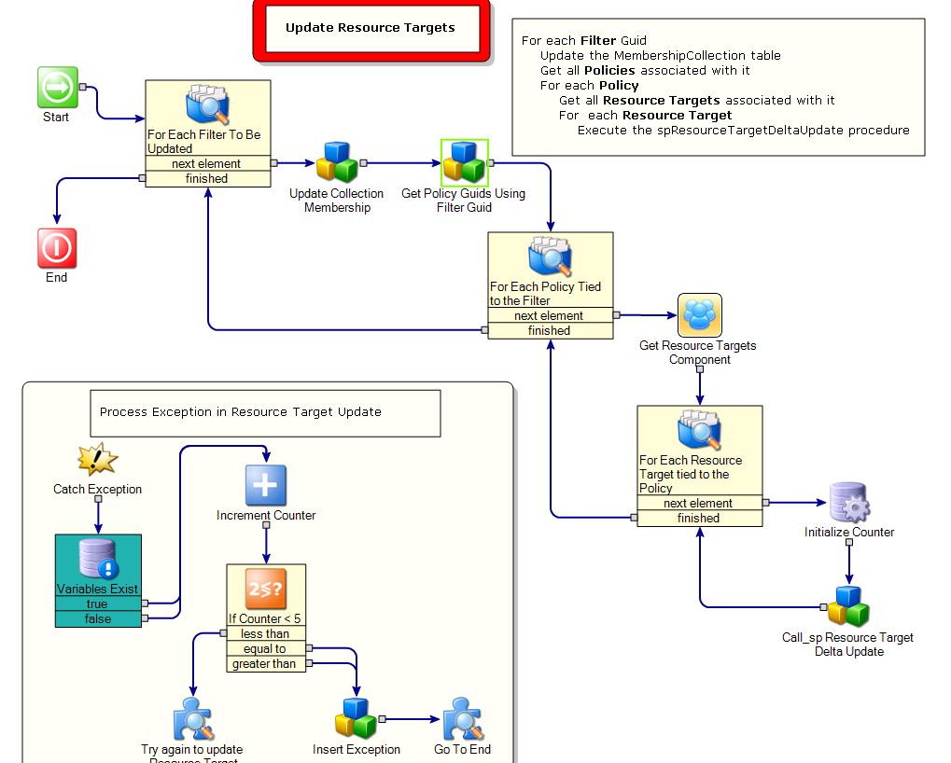

1 - The Update collection Membership component is of the type Call_sp Delta Update Collection_ With Temp Table Creation.

2 - The Get Policy Guids Using Filter Guid component is one I created. It is based on the following query:
Select Distinct vI1.[Guid] as PolicyGuid
From vItem as vI1 WITH (NOLOCK)
Join ItemActive as IA WITH (NOLOCK) On vI1.[Guid] = IA.[Guid] And IA.[Enabled] = 1
Join vPolicyAppliesToResource as vPATR WITH (NOLOCK) On vPATR.PolicyGuid = vI1.[Guid]
Join TargetFilter as TF WITH (NOLOCK) On TF.ResourceTargetGuid = vPATR.ResourceTargetGuid
Join TargetFilterCollection as TFC WITH (NOLOCK) On TFC.TargetFilterGuid = TF.[Guid]
Join vItem as vI2 WITH (NOLOCK) On vI2.[Guid] = TFC.CollectionGuid
And vI2.ClassGuid = 'AECA2D91-C615-4D99-BAD5-612CA159DA4F' -- Filter Class Guid
Where vI2.[Guid] = @FilterGuid
Order by PolicyGuid

3 – The Call_sp Resource Target Delta Update is an integration project I created that calls a stored procedure named spResourceTargetDeltaUpdate.

4 – When I implemented this change I had problems with deadlocks on the database. To get around this issue I added the Initialize Counter component to set a variable to zero prior to executing the Call_sp Resource Target Delta Update component. If that component takes a deadlock error, the exception is caught and the counter is incremented. If the variable is less than 5, I try again to execute the Resource Target Delta Update.

