Actuals Not Displaying for Non-Labor Transaction
I added a resource called "Software" to a project with $25K in allocations. I created a task called "Purchase Software" and assigned the resource called "Software" to the task. This populated the ETC on both the assignment and the Team Tab TSV. I then entered a transaction on the task called "Purchase Software" for $25K. The following jobs have completed: Post Transactions to Financials, Post to WIP, Import Financial Actuals, Investment Allocation, and Update Aggregated Data.
The Posted Transaction Review shows the correct data:
The Project List displays the Actual Cost field correctly:
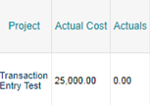
The Cost Plan shows the $25K transaction correctly:
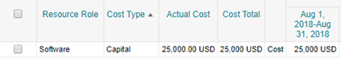
The Team tab does not display the Actuals:
The Task does not display the Actuals:
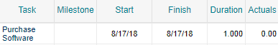
The Task Assignment page does not display the Actuals:
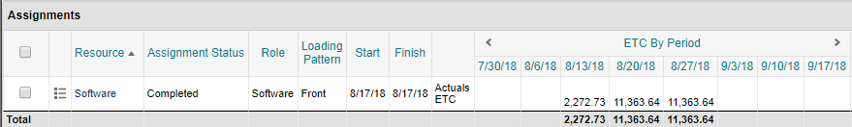
Am I missing a step?
Thanks

