Web Services Scripting Lab
- Go to the service repository
  - http://www.service-repository.com/

- Select the Global Weather call
  - http://www.service-repository.com/service/overview/-2082028434
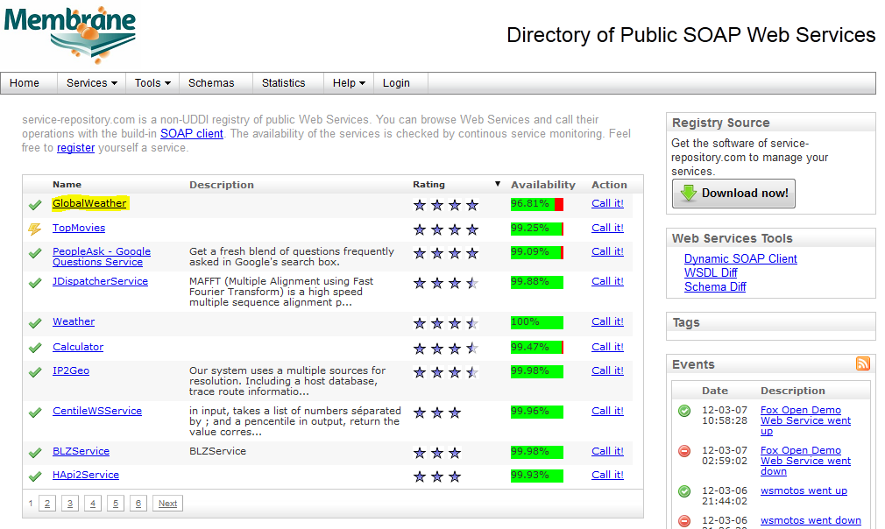
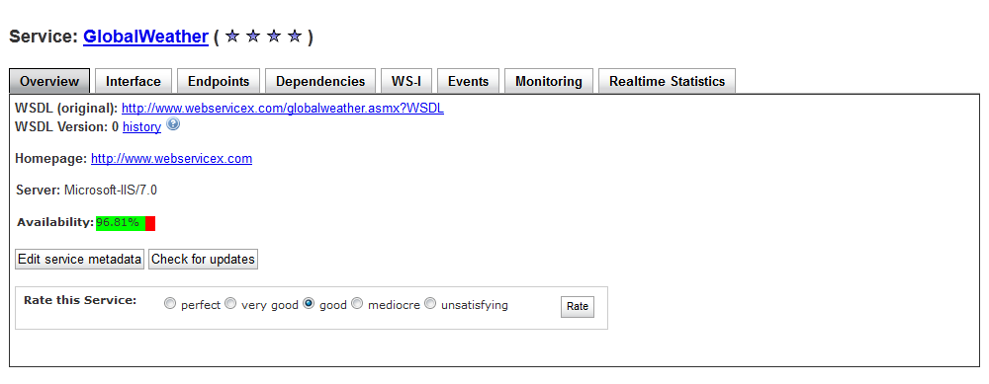
- Click on interface
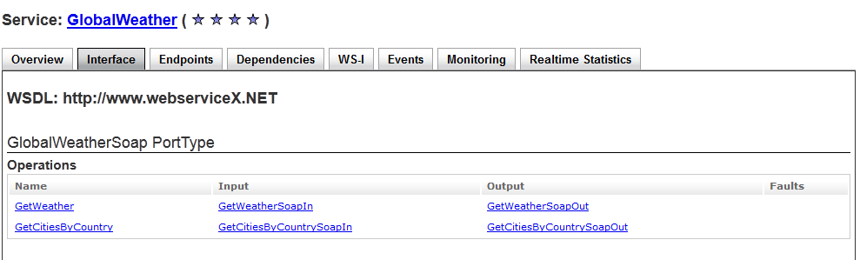

- Click on “GetWeather” Operation
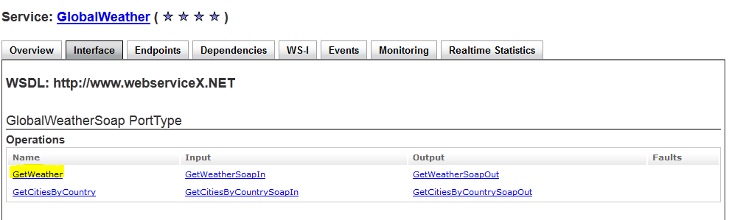

- Highlight and copy the Endpoint address, Provide the City name Miami or Orlando and execute the SOAP Call
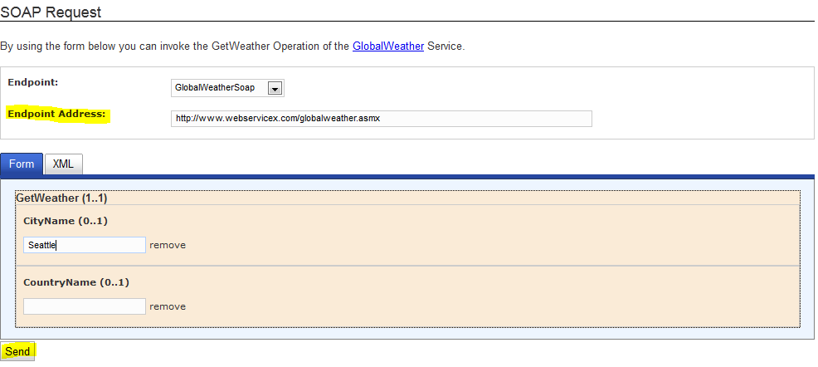

- Copy and paste the SOAP request and response
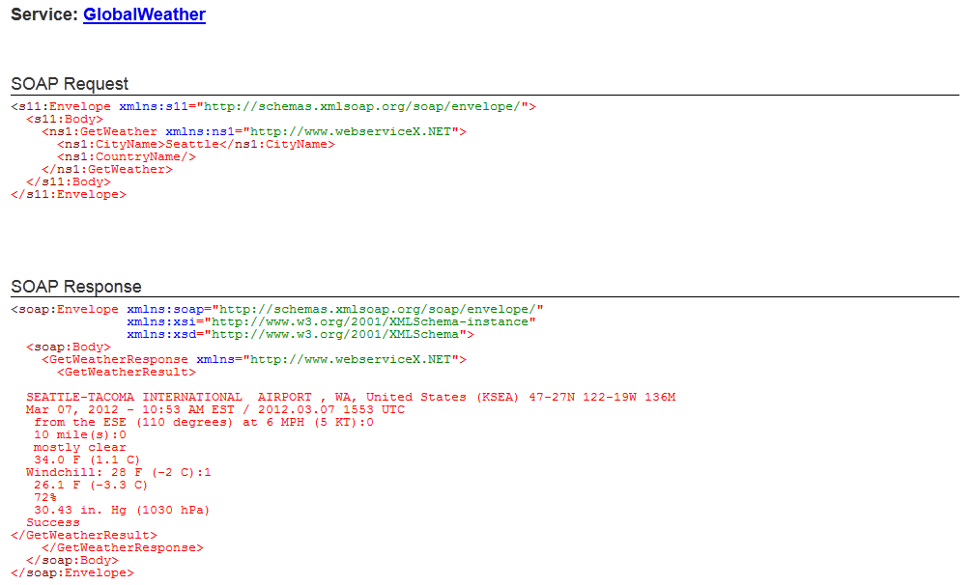

- Open JMeter and create a script
  - Click on the Test Plan, right click and add a Thread Group
    - Add
      - Threads (Users)
        - Thread Group
  - Click on the Thread Group and add a Loop Controller
    - Add
      - Logic Controller
        - Loop Controller
  - Click on the Loop Controller and add a SOAP/XML-RPC Request Sampler
    - Add
      - Sampler
        - SOAP/XML-RPC Request Sampler
  - Click on the Loop Controller and add a View Results Tree Listener
    - Add
      - Listener
        - View Results Listener
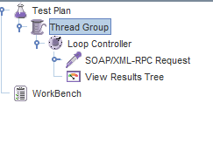
- Incorporate the SOAP call
  - Click on the SOAP/XML-RPC Request Sampler
  - Copy and paste the Endpoint address into the URL field
  - Uncheck the Send SOAPAction box
  - Copy and paste the SOAP Request in the Soap/XML-RPC Datafield
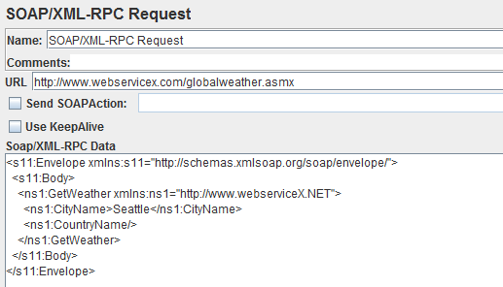
- Save the Script and Run to test the SOAP call
  - Run Menu
    - Click on Run
  - Click on View Results Tree to see the response data.
- Create an Advanced Monitor and upload you JMeter script in CUE. Test your results.

Based on the expected results of this Web Service call, you can add assertions to validate the results.
For Example we can test a response and XPath assertion against the SOAP response for the follow values:
- Response Assertion
  - Success
  - SEATTLE
- XPath Assertion
  - /Envelope/Body/GetWeatherResponse/GetWeatherResult

SOAP Response
<soap:Envelope xmlns:soap="http://schemas.xmlsoap.org/soap/envelope/"
xmlns:xsi="http://www.w3.org/2001/XMLSchema-instance"
xmlns:xsd="http://www.w3.org/2001/XMLSchema">
<soap:Body>
<GetWeatherResponse xmlns="http://www.webserviceX.NET">
<GetWeatherResult>

SEATTLE-TACOMA INTERNATIONAL AIRPORT , WA, United States (KSEA) 47-27N 122-19W 136M
Mar 07, 2012 - 01:53 PM EST / 2012.03.07 1853 UTC
Calm:0
10 mile(s):0
mostly cloudy
43.0 F (6.1 C)
23.0 F (-5.0 C)
44%
30.47 in. Hg (1031 hPa)
Success
</GetWeatherResult>
</GetWeatherResponse>
</soap:Body>
</soap:Envelope>

- Click on the SOAP/XML-RPC Request and right click to add Response and XPath Assertions.
  - Add
    - Assertions
      - Response Assertion
      - XPath Assertion
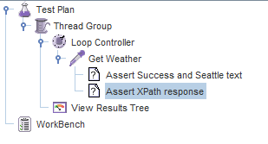

- Configure your Assertions
  - Response Assertion
    - Success
    - SEATTLE
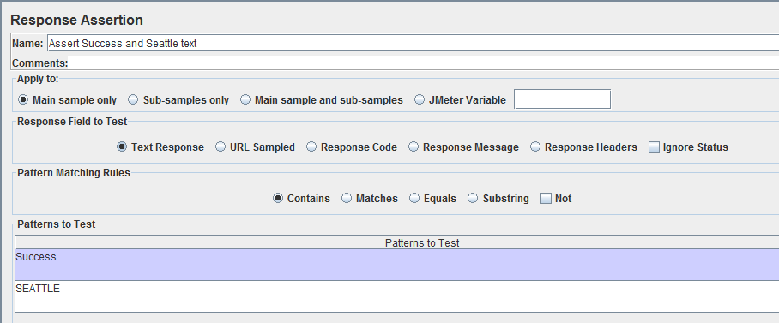
  - XPath Assertion
    - /Envelope/Body/GetWeatherResponse/GetWeatherResult
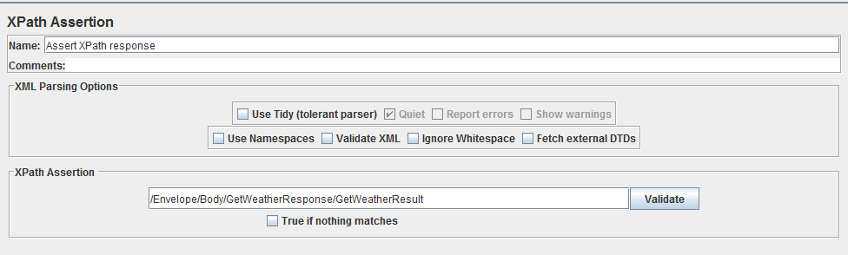

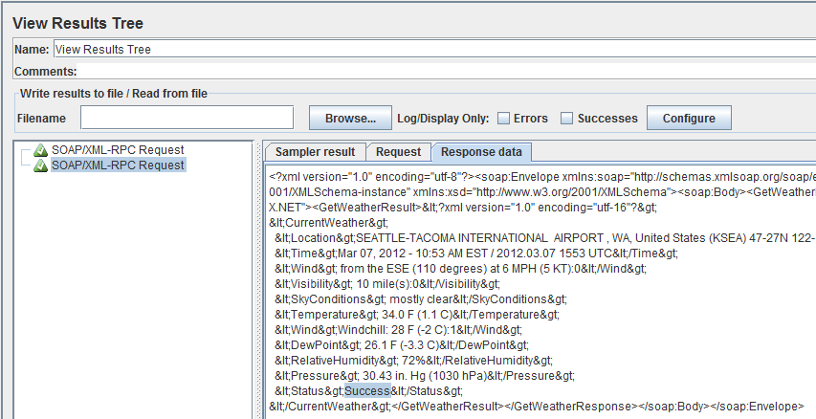
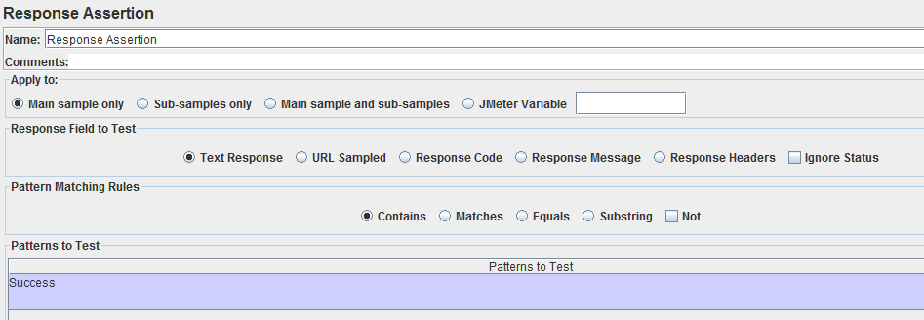
- Run your test to validate the response assertion

