CA DevTest configuration between two networks separated by a Firewall

Version: 1.0
Last Updated: July 27, 2015
Authors: Solutions Engineering Validation Team
Document Change History
Revision | Date | Author | Change Description
1.0 | 07/27/2015 | Hima Bindu | Initial Document
TABLE OF CONTENTS
1 Introduction 4
2 Architecture 5
3 Ports to be opend in private network 6

Introduction

This document provides architecture and required configuration to execute Test Cases in an isolated lab environment from public network.

The goal is to execute the test cases in an isolated lab environment from central CA DevTest server in the public/corporate network. Since the lab environment is
separated by firewall, the communication between the networks is restricted. We need access the Test Cases from the central location, execute the Test Cases and report the results back to the CA DevTest server.

The Document describes the CA DetTest Implementation Architecture and required communication port configuration.

Architecture

Below is the architecture diagram for the distributed DevTest architecture residing in corporate and private network.

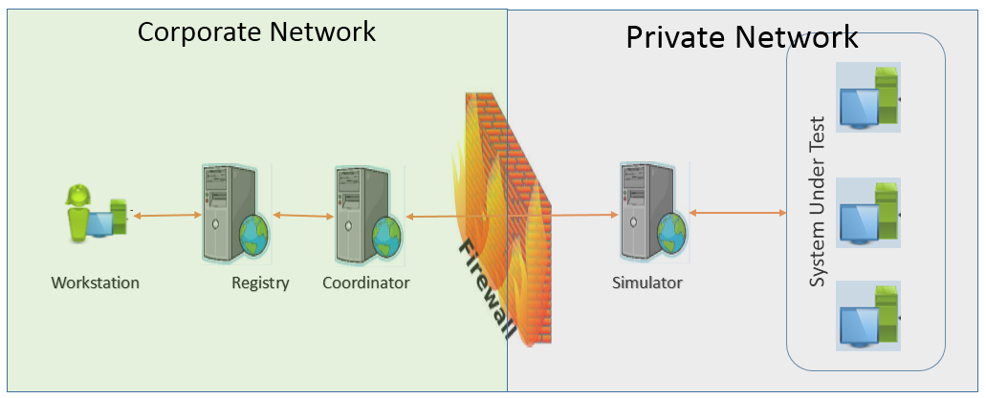

The Workstation, Registry and Coordinator Server components are in the
Public/Corporate network and Simulator resides in the Lab/Private network.

The tests are executed from the workstation. Workstation connects to the
Registry and Registry connects to the Cordinator Server and Simulator. The tests are executed on the Simulator and posts the results back.

In the above architecture we used CA DevTest version 8.01 and Derby as
database installed on Registry server.

Ports to be opend in private network
Below are the ports that needs be opened Bi-Directional in the firewall
configuration.

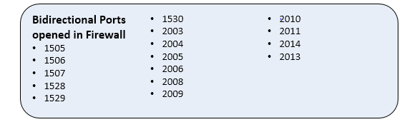

Note: If MS SQL is used for CA DevTest database, need to open SQL Server port (1443 SQL Default).

