Up gradation of SEPM from 11.0.X to 12.1:

Prepared by :Mohankumar
Technical Executive

STEP 1: Login into the SEPM and Disable the auto up gradation of the SEP client package.

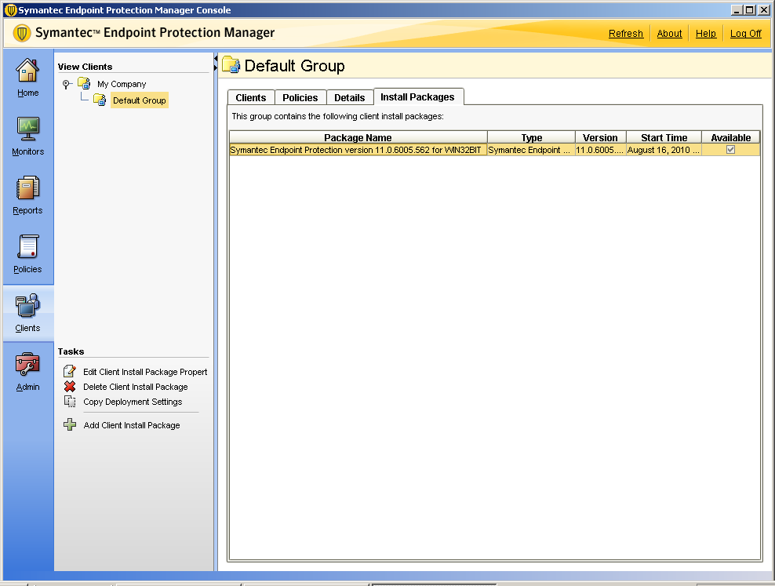

Clients Tab -> Select the group-> on the right hand as shown in the snapshot -> Install packages
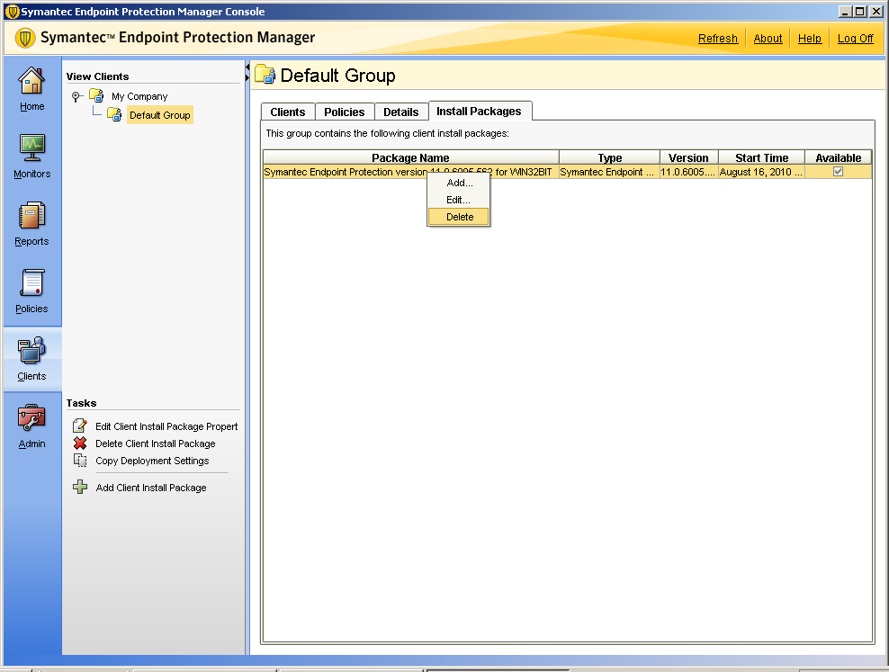

Select the existing Install package and right click and Delete it.

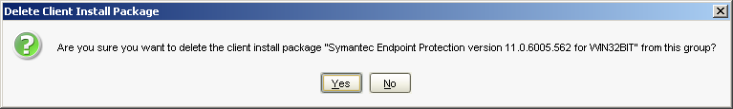

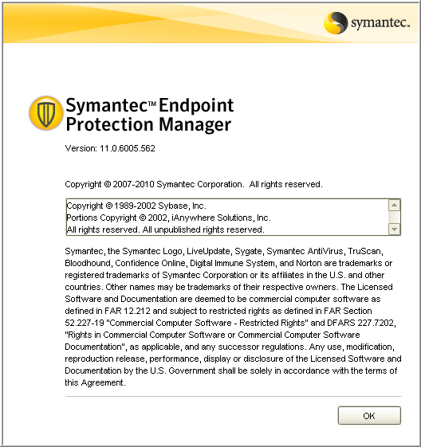

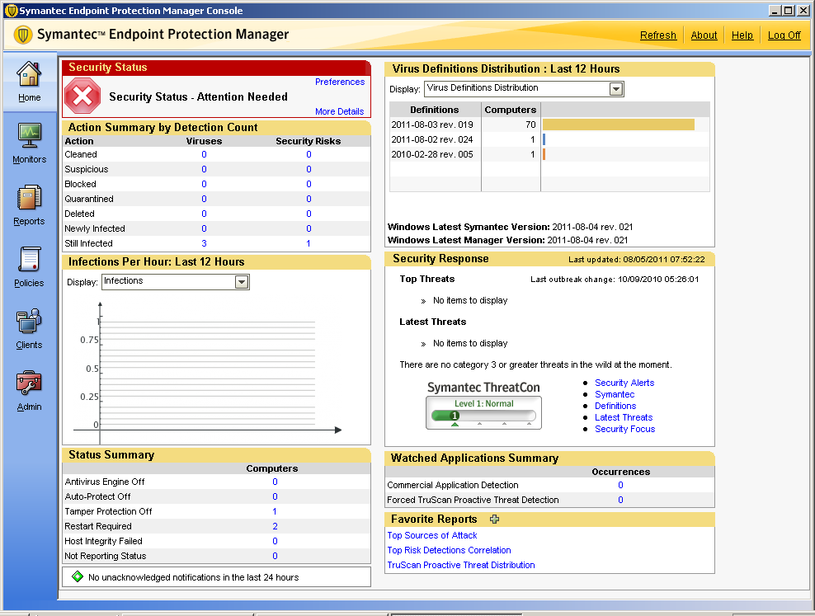

STEP 2: Now take a fresh BACKUP of the database of the SEPM.
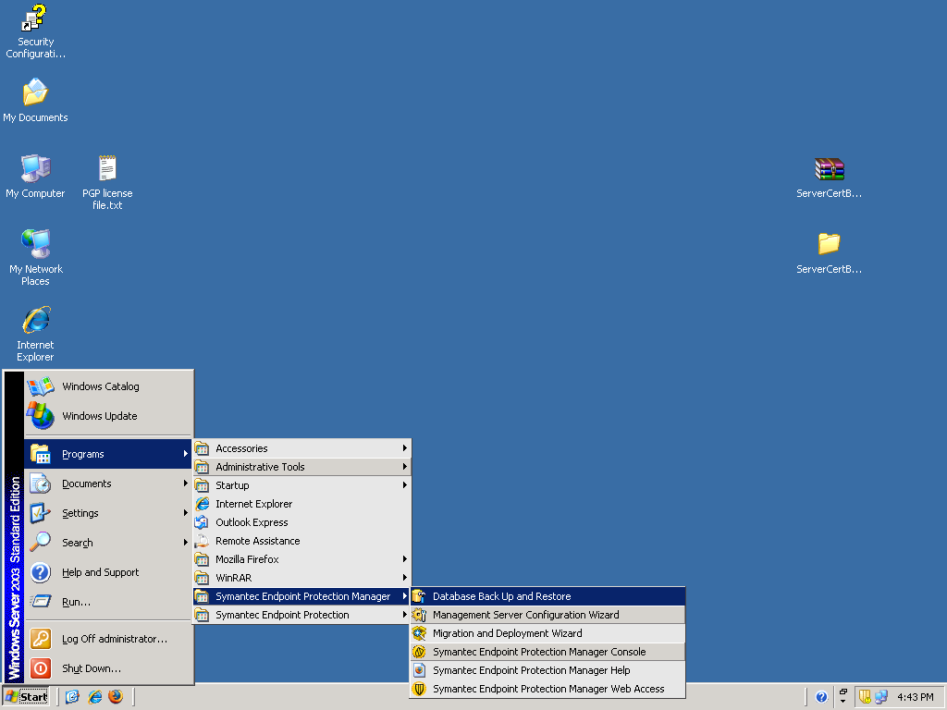

Select Database Backup and Restore tool

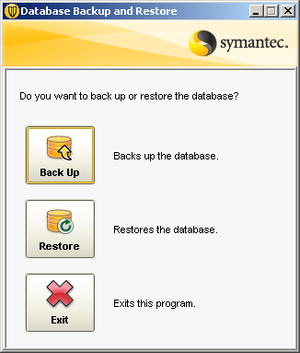

Now Select Backup option.

If you like to take Backup of the SEPM logs then you can put a check mark and click on YES.

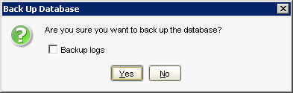

Then the tool starts taking backup and stores in the below location

X:\Program Files\Symantec\Symantec Endpoint Protection Manager\data\backup

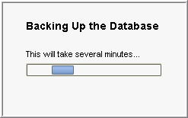

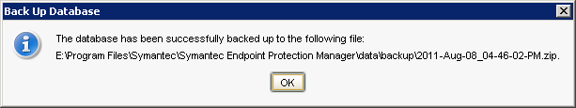

Backup is done you see this above message after it is completed.

Later go the services window and select the Symantec Endpoint protection Manager Service and STOP the service and close the window.

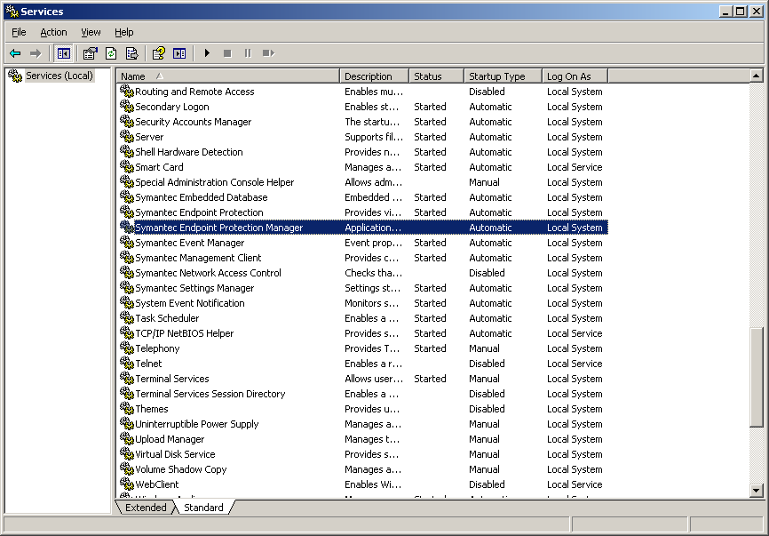

STEP 3: Start the setup to upgrade SEPM 12.1

Symantec_Endpoint_Protection_12.1.671.4971_Xplat_EN_DVD/ Setup.exe

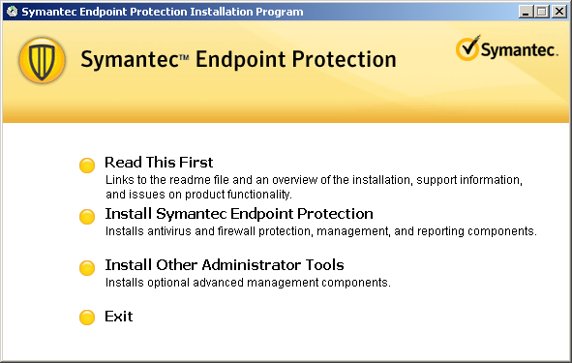

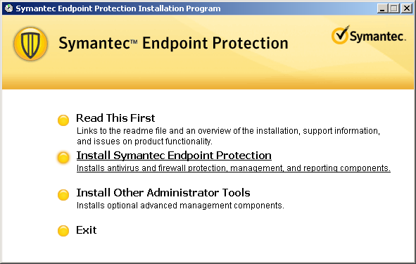

Select the Install Symantec Endpoint protection .which will allow you to start up gradation or a fresh Installation
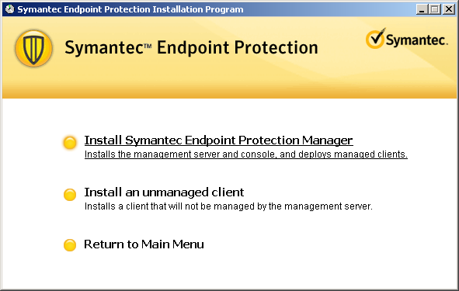

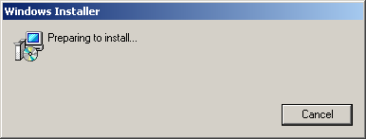

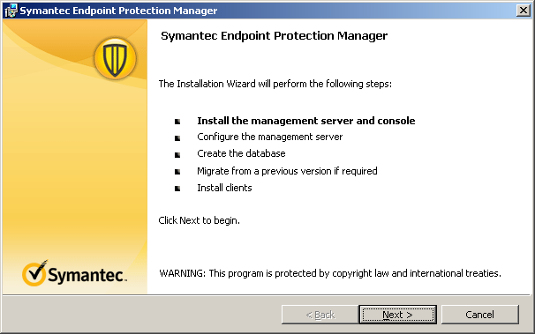

Click on NEXT

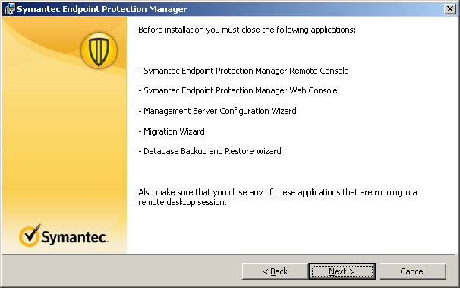

Click on NEXT

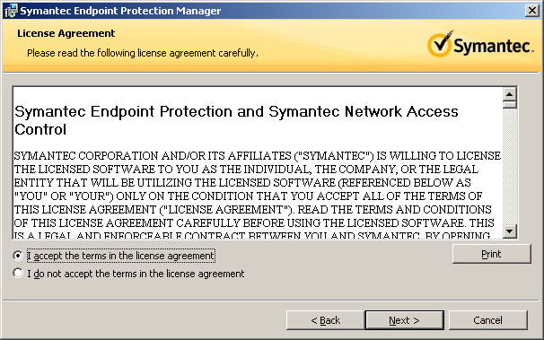

Select I accept and Click on NEXT

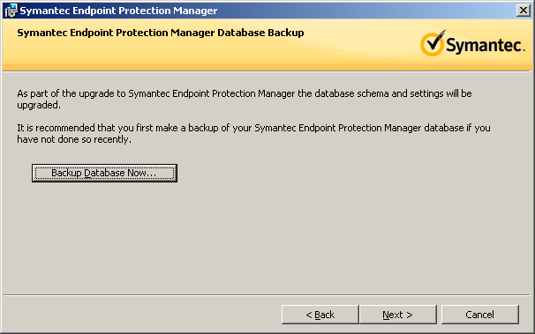

If you have not taken Backup then it will prompt you to take Backup at this point of the time.

If not you can Click on NEXT

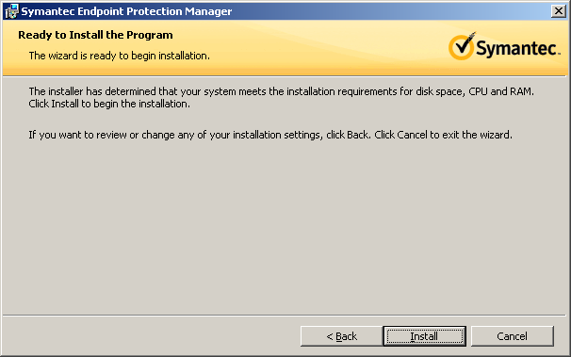

Click on Install

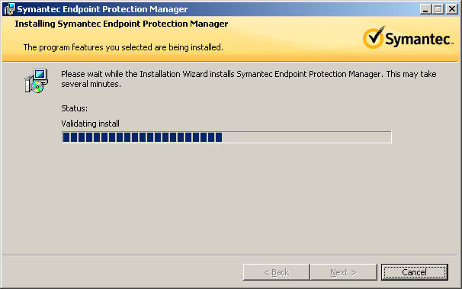

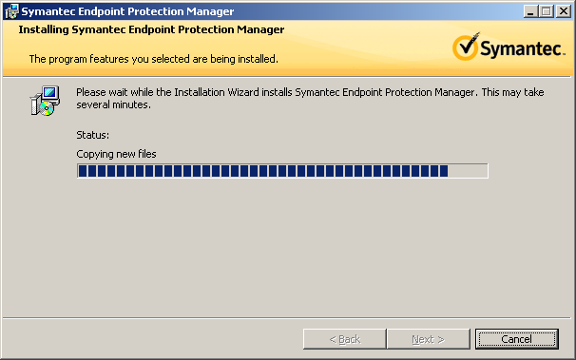

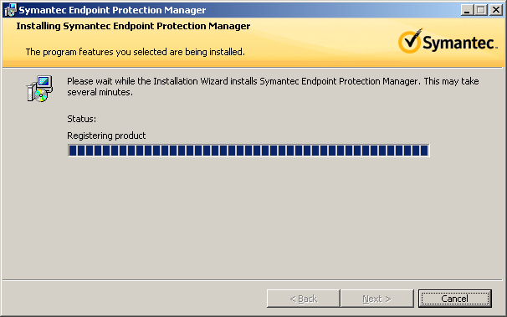

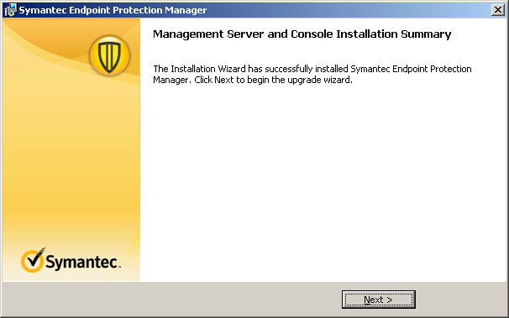

Click on NEXT

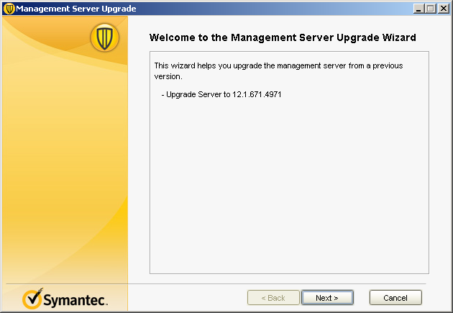

Click on NEXT

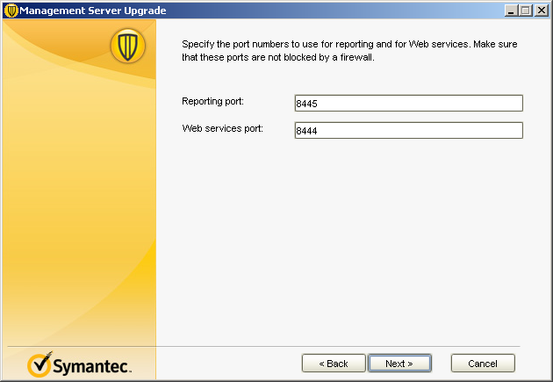
Click on NEXT

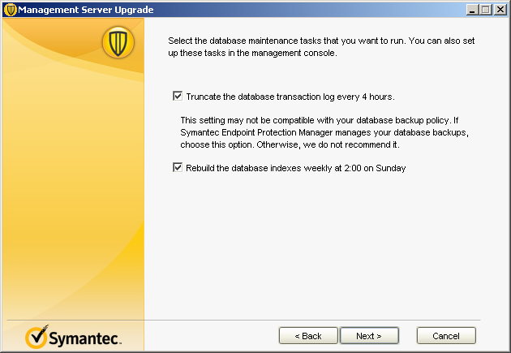

Click on NEXT

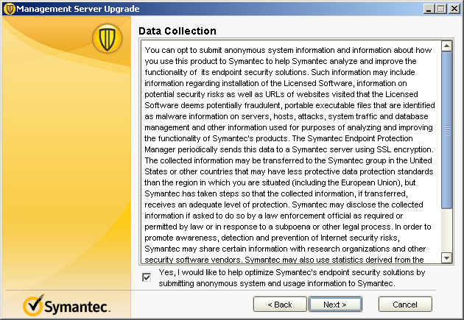

Click on NEXT

Now the Up gradation of the SEPM wizard will appear Click on NEXT

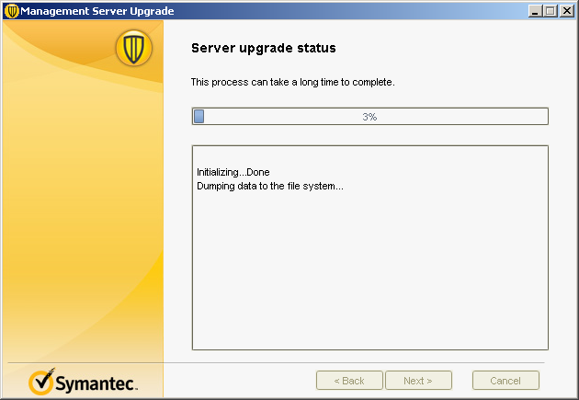

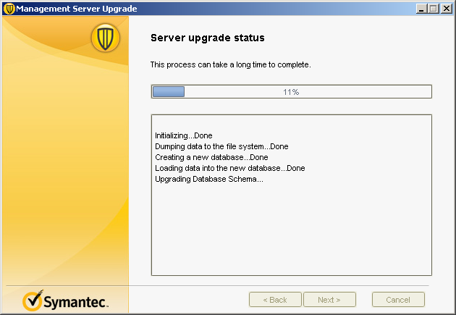

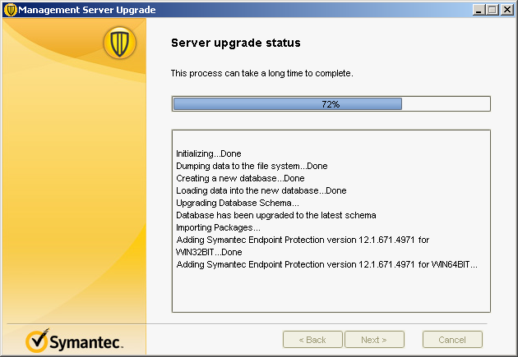

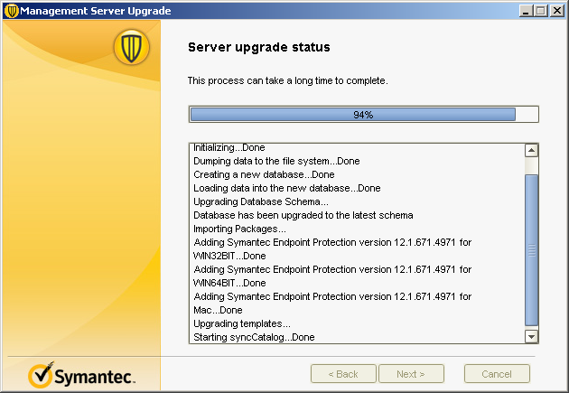

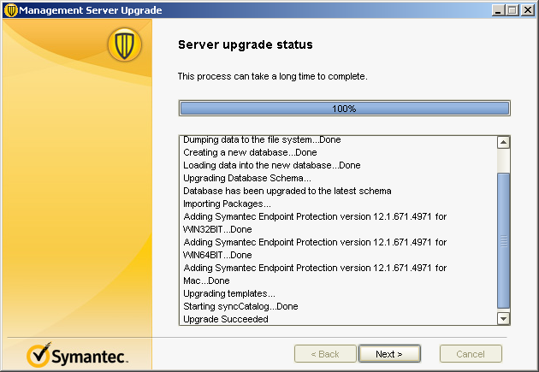
Click on NEXT

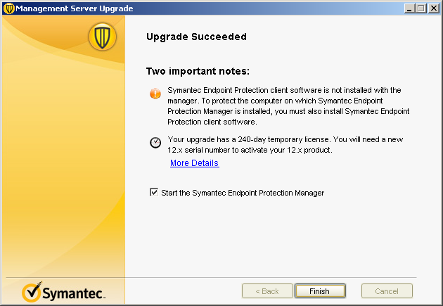
Click on the FINISH

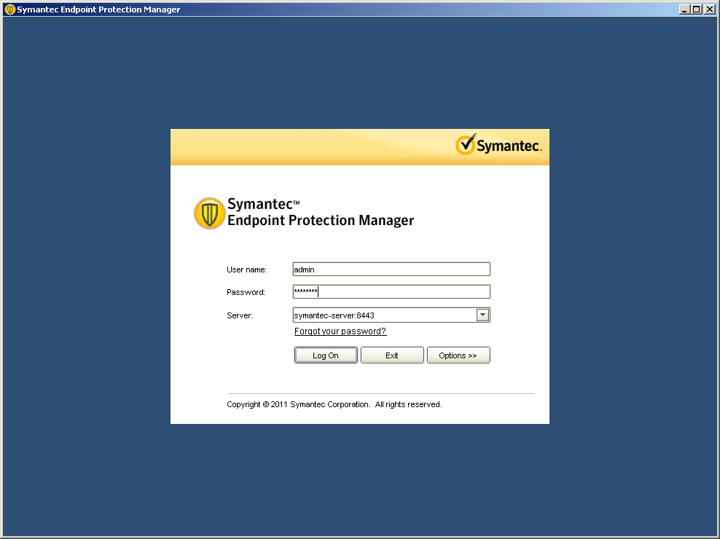

STEP 4: Activating SEPM 12.1 licenses

Now Log in to the SEPM for the first time after up gradation, type in your credentials and login

NOTE: Do not restart or shutdown the machine for at least 15 minutes. Because after the up gradation the server need to rebuilt the new files so it requires some time.
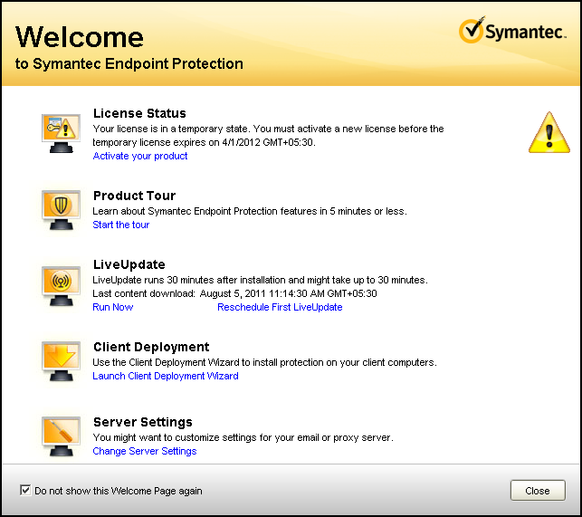

For the first time this wizard will appear for activation of License. So select Activate your product

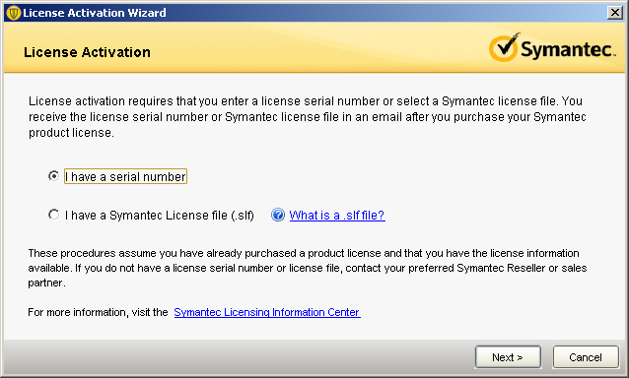
Select if you have a serial no. or a .slf file . You can activate using any of them

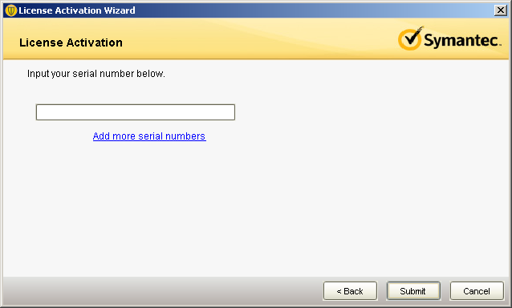

Type the serial no. and the click on submit.
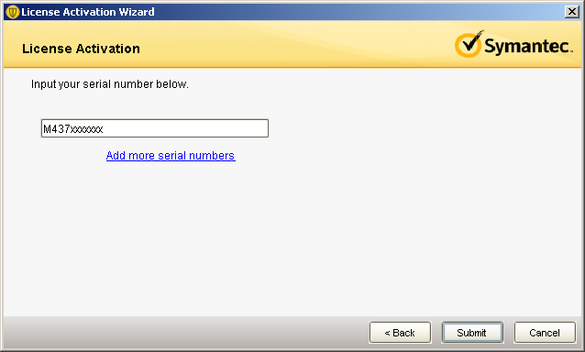

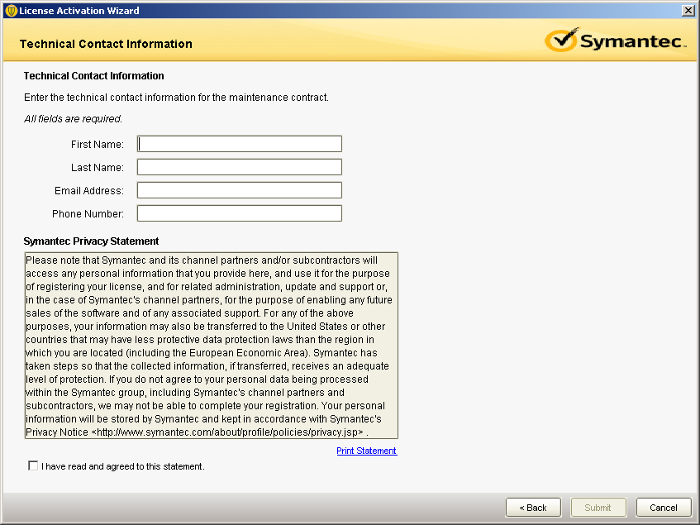

Type your contact details this will be help full at the time of support.
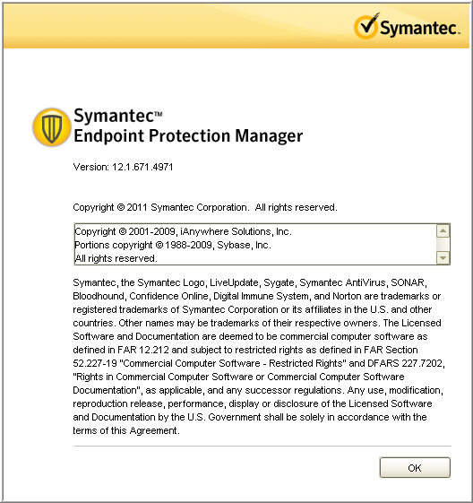

Finally you are done.

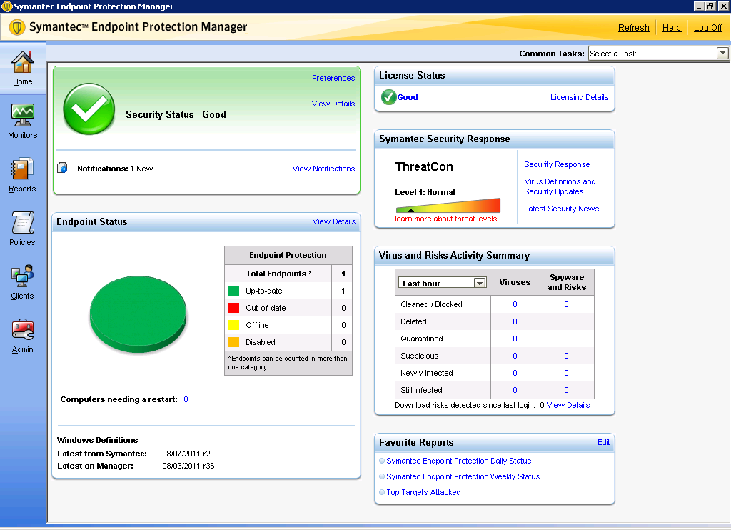

The SEPM 12.1 console looks like this

STEP 5: Adding client Install package

The very important step is to add the Install Package in the clients Tab for auto upgrade of the clients. You need to add the package on all the groups manually if not the upgrade will not happen on all the groups and clients.

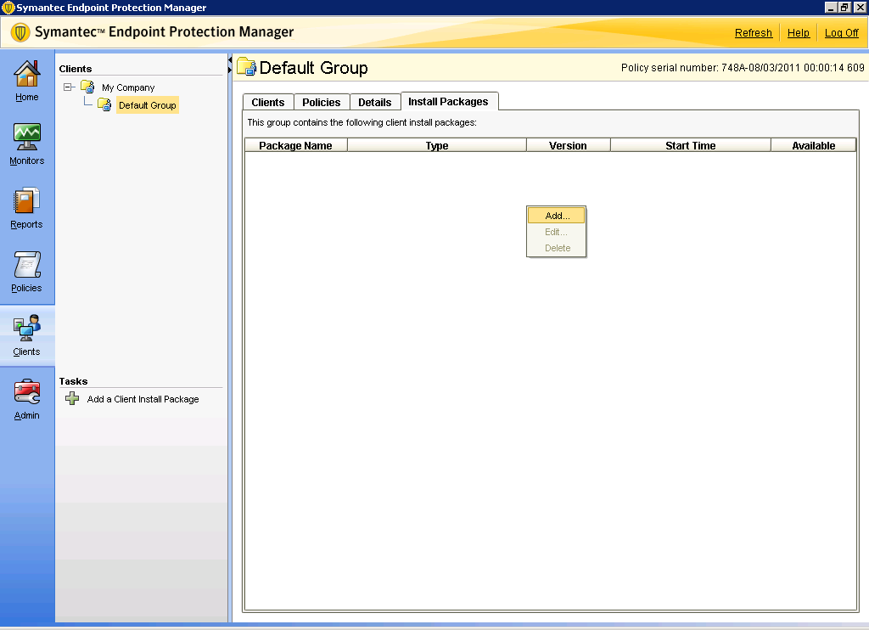

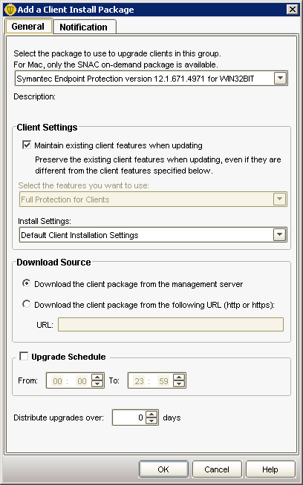

Now from the drop down box select the latest version of the SEP client version and select it
Click OK . So the SEPM will push the required files for the clients and once the SEP client Restarts then the version will be changed from 11.0.x to 12.1

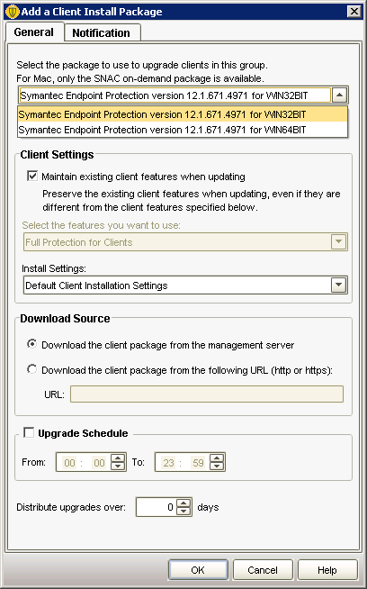

Don’t change any setting and keep it as defaults

The upgraded client will be like this:
