PAM can be configured to integrate with several Service Desk applications in 2 ways. The first is using a web portal to auto connect to the application. The second is using a Password View Policy to integrate with the Service Desk. This PVP is attached to the Policy for a device to be used for auto connect. When the applet or service is launched from the Access page, or the password is viewed, a form will be presented on which the Reason must be selected, the Reason Description and Ticket number must be entered. After submitting this data the applet or service will open, or the password will be displayed.

Start by creating a web portal Service. Here is an example for CA SDM. The Service for other Service Desk applications will look similar, though the extension to the Launch URL will vary with the application being used. Note that CA PAM HTML Web SSO is selected.

The next step is to create a device to which the Service will be applied.

Create a Target Application.

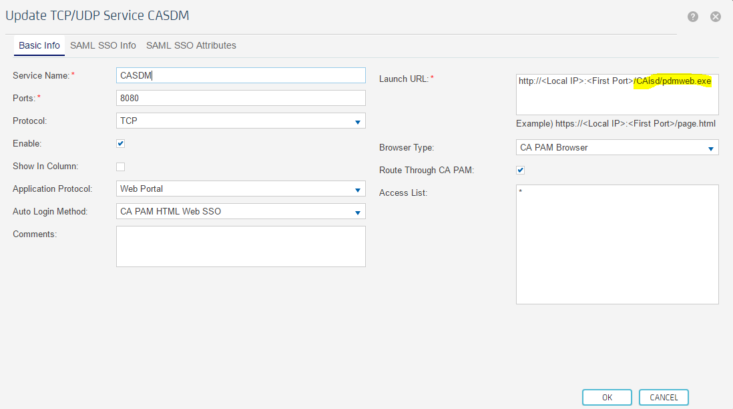

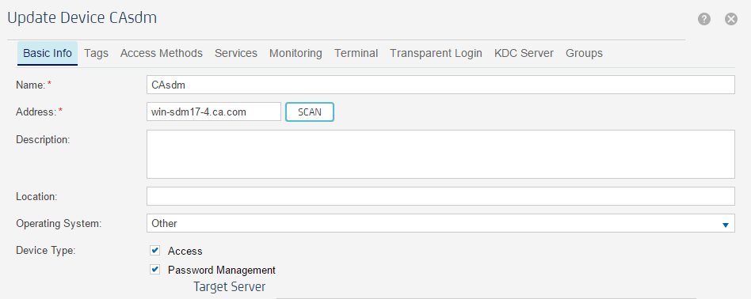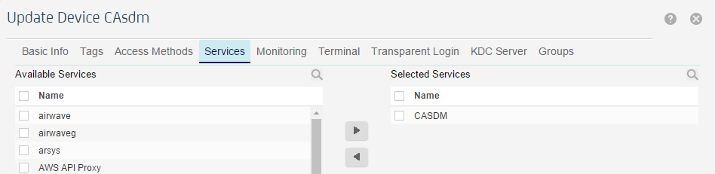

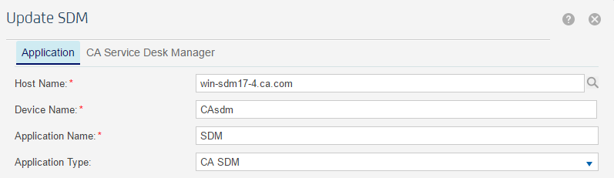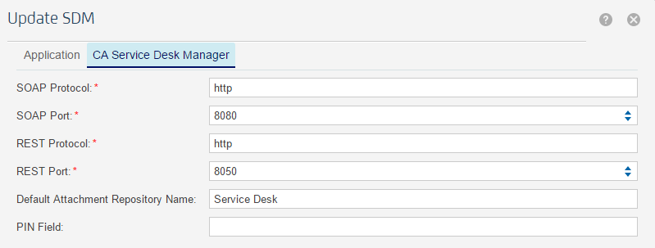
Create a Target Account to be used with the web portal. Configuring the account to be Synchronized will confirm connectivity to the server.

Create a Policy, to which the credentials created above will be applied.

On the Access page click on the Service icon and select Learn Mode. Right click and mark the Account field, the Password field and the Submit button. Click the save button. It will now be possible to launch the web portal and be automatically logged in to the Service Desk application.

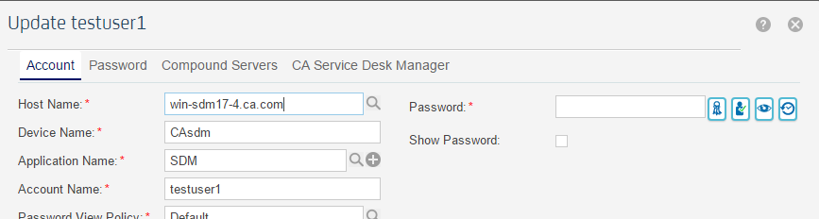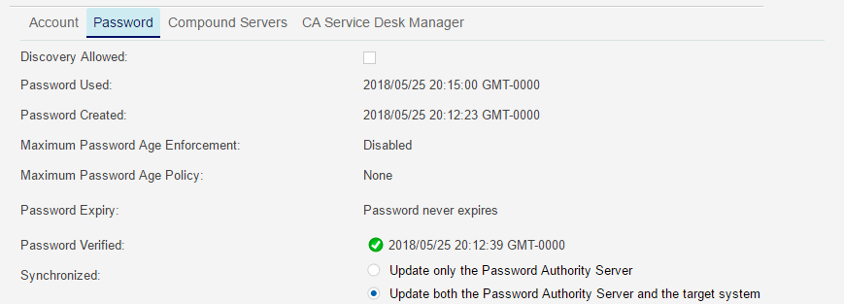

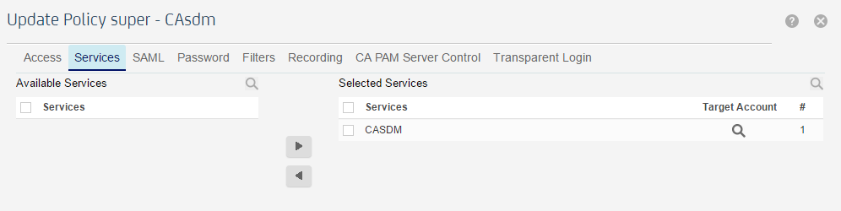

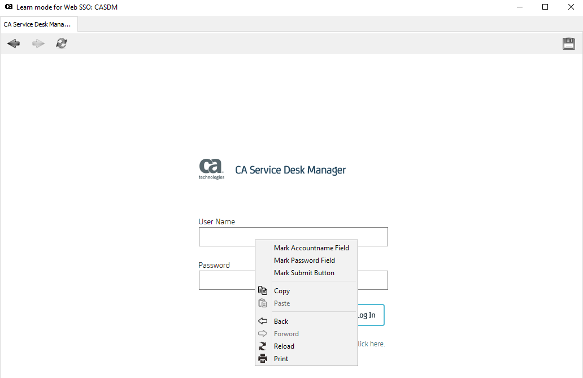
This completes the procedure for configuring auto connect to the Service Desk application.
Next is the procedure for configuring a Password View Policy to integrate with the Service Desk.
First create a PVP and select the type of Service Desk application being integrated. This requires setting the Server, Application and Account to be used. This can be the same credentials used for auto connect.

Apply this PVP to the Target Account to be integrated with the Service Desk.

Create a Policy to which the target account will be added.

Click on the icon to launch the desired applet or service. A window will open into which the Reason, Description and Ticket Number must be entered. As long as the Ticket Number is correct the applet or service will be launched. The same form will appear when the password is viewed, and the password will be displayed after the form is submitted.
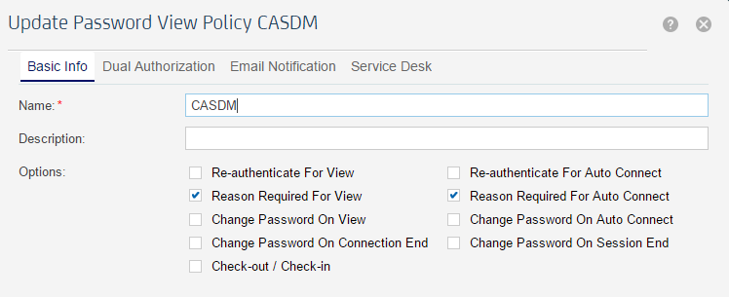 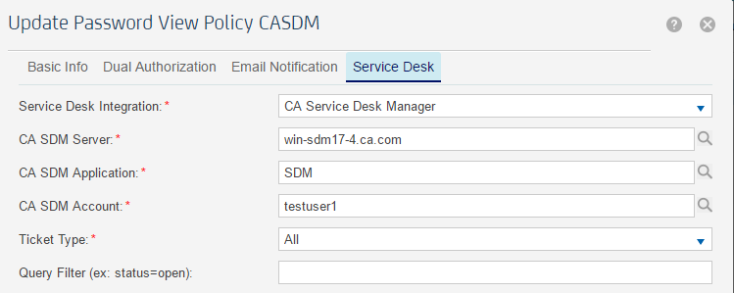

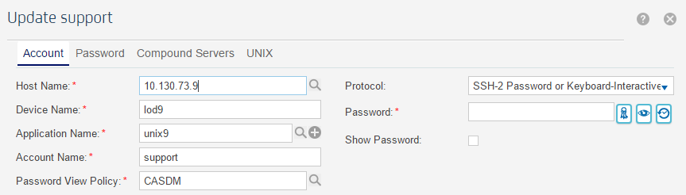

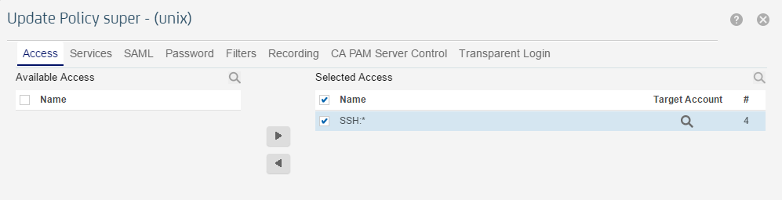

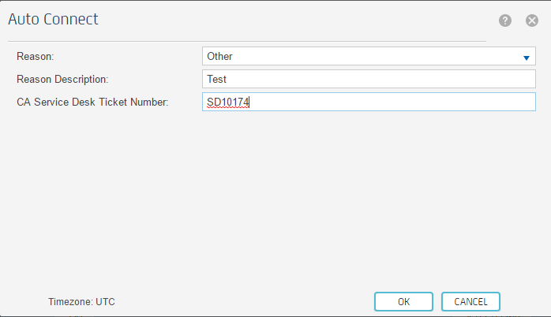

This completes the procedure for integrating PAM with Service Desk. The same procedure may be used for HP Service Manager, Remedy, ServiceNow and Salesforce Service Cloud.

