Windows 10 Feature 1511 Deployment

As Software Delivery via Altiris Client Management Suite 7.6 HF7

Resources
https://support.symantec.com/en_US/article.HOWTO124389.html

Altiris Agent
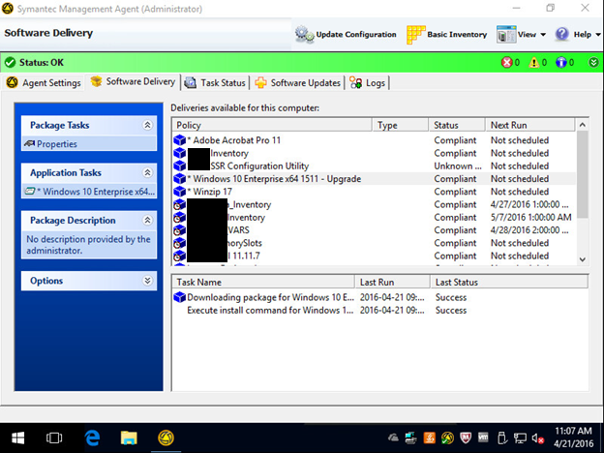

Altiris Delivery Report
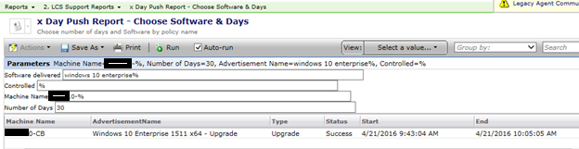

Installation Timeline
- 8:43am started 1511
- 9:18am 56%
- 9:42am 100%
- 9:43am - started
- 9:57am - all controls removed - install starts
- 10:22am - 22%
- 10:44am - 76%
- 11:00am - 100% OS upgraded

Installation Screenshots
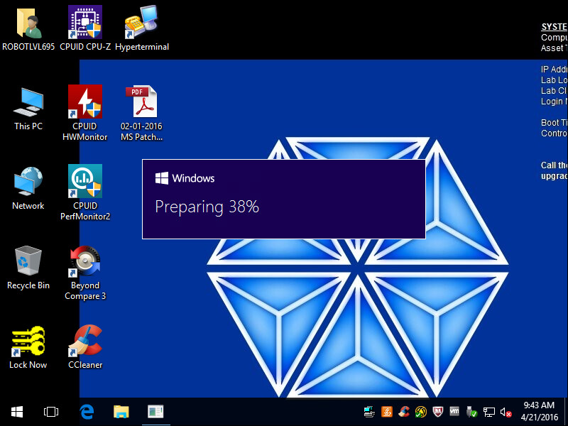
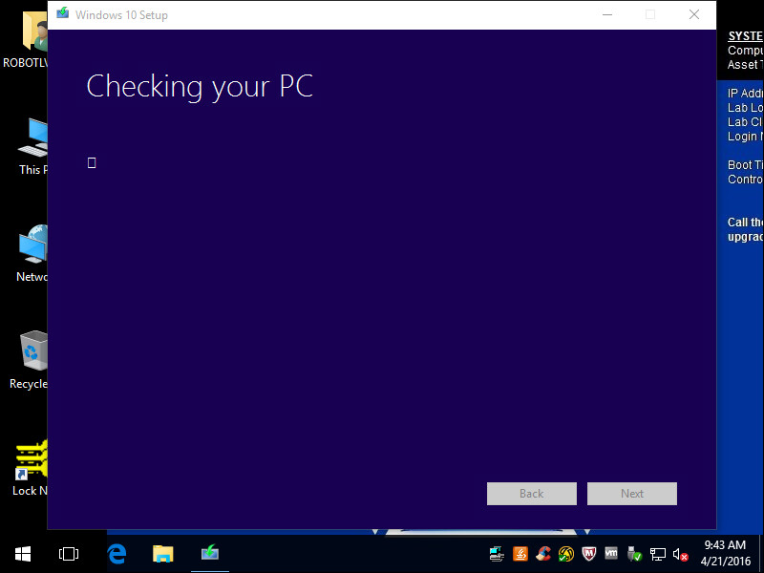
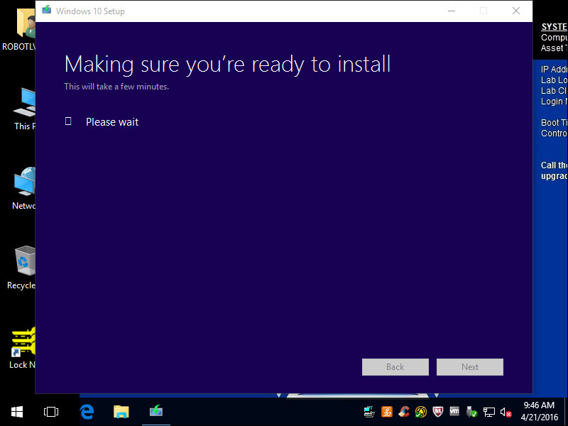
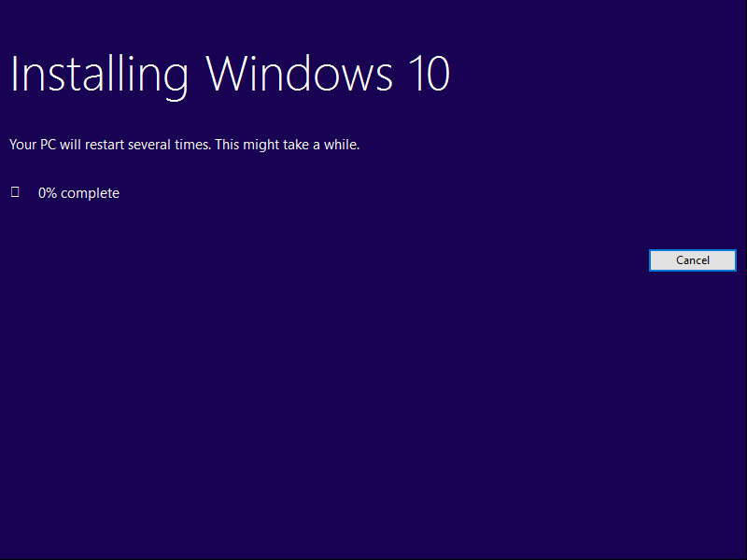
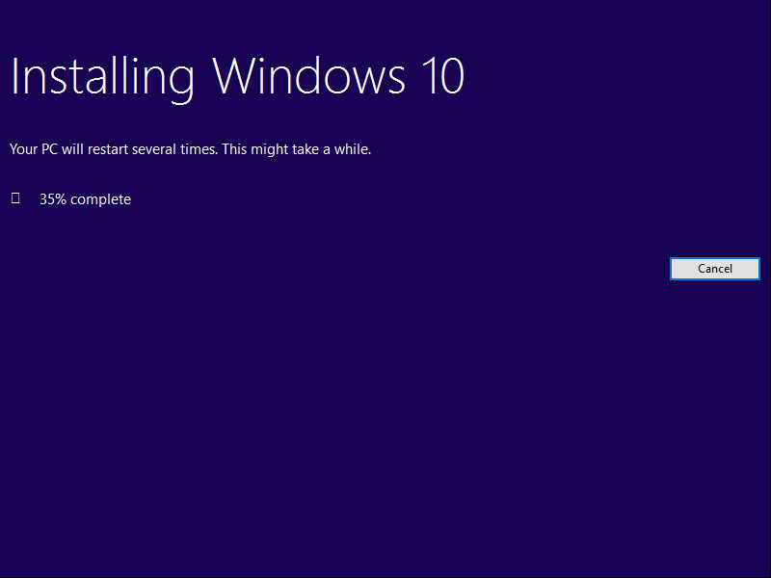

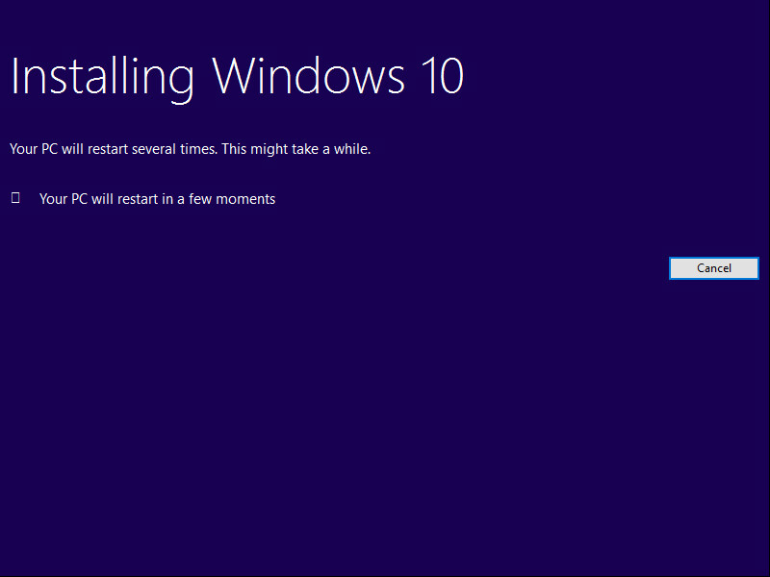

You can click Cancel and this is what you get… need to find setting to not allow
