Below is what the PC shows when I click on the SEP shield icon in the system tray
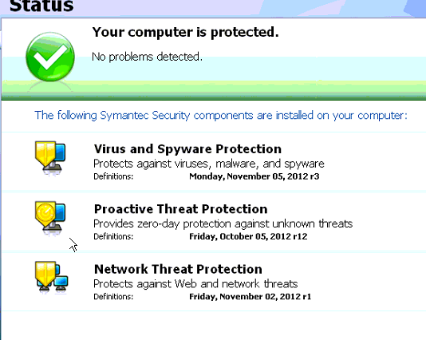
Also below is the connection status
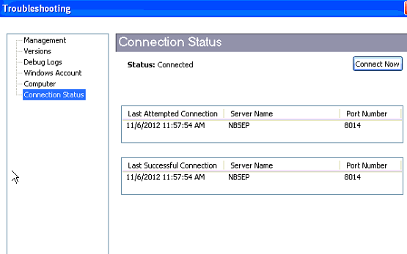
Below is what is showing in SEPM
