To set the password
Go to SEPM.
Login Console with Admin Id.
Go client Tab and then choose the Group where you want to set the password.
Under that Group choose the policy TAB.
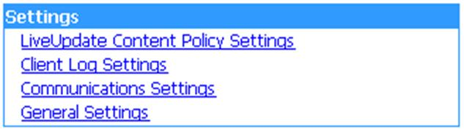
Click on General Setting then tab on Security Setting.
There four option avail
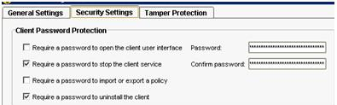
Check the "Require a password to stop the client service"
Enter the passwor that have mention on right hand side of the security tab.
Then ok and then right click on that Group and update the conent.
It will set the passwor to stop the SEP.(command smc -stop)

