We are trying to use the Microsoft provided Odata connector from here:
https://www.microsoft.com/en-US/download/details.aspx?id=42280
with the Broadcomm API url:
url = https://odata.xxx.moventus.com/odata/api4/

We are using Basic Authentication: I set up the connector like this
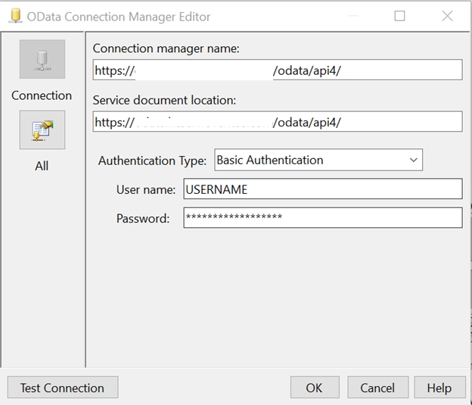
And get the following response:
Visual Studio Error message:
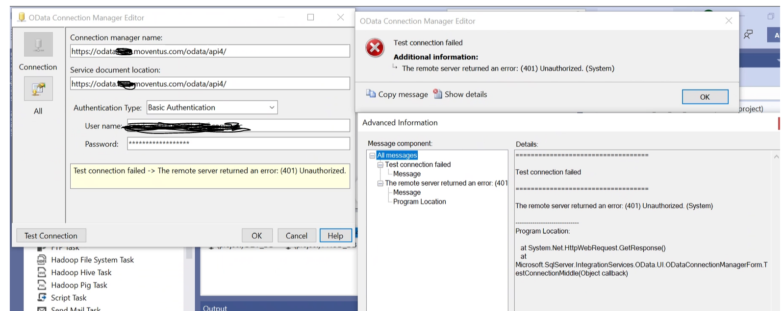
From powerBI and excel the url connects perfectly and returns the data
We used postman to check the API and were able to connect with python and Jupyter Notebook
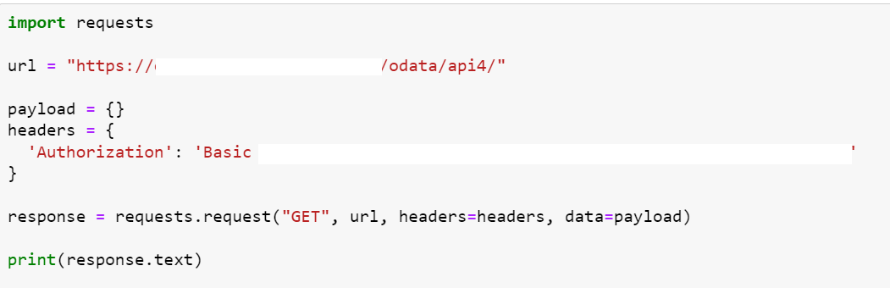
And this worked and gave us back the metadata.
I don’t know how to proceed from there to actually get the data but it seems if we can get the metadata then we should be able to connect to the Api through SSIS.
Has anyone connected using the Microsoft SSIS connector to anything other than Northwind:
https://services.odata.org/northwind/northwind.svc/

