July 31, 2015

To: CA Risk Authentication Customers
From: The CA Technologies CA Advanced Authentication Product Team
Subject: General Availability of Quova Data Files
On behalf of CA Technologies, we appreciate your business and the opportunity to provide you with high-quality, innovative software and services. As part of our ongoing commitment to customer success, we’d like to announce that Quova Data Files can now be downloaded directly from CA Support Online.
Note: Updates to the Quova Data Files will be available on the 4th of every month or subsequent business day.
Quova Inc., an industry leading provider of geolocation information, provides CA Risk Authentication geolocation and anonymizer data. Quova provides the following types of data to CA Risk Authentication:
- Geolocation data. This data classifies each IP by latitude, longitude, continent, country, and city. By default, the data is used in the Negative Country Check rule and in calculating the distance for the Zone Hopping Check rule. You can also use this data for any rules that you create by using the Rule Builder. The Country and City elements are both useful for checks on the point of access.
- Connection information. Each IP is classified by routing type, connection type, and line speed. This information, especially routing type, is useful in assessing the validity of the geolocation information. For example, if the connection type is Satellite, then the user’s location is not reliable. In practice, you can ignore this information for geolocation purposes. However, fixed connection types such as cable, DSL, and OCX are less likely to be origins of fraud because their locations are more easily backtracked to Internet accounts. You can use this data to evaluate fraud.
- Anonymizer data. Quova performs rigorous testing of IP addresses to determine if their location information is reliable. As part of this testing, Quova identifies some IP addresses as "Anonymizers". IP addresses with this status have tested positive as anonymous proxies that are used to hide the true location of the end user. While this does not necessarily indicate that the intent is fraudulent, it does clearly indicate that the user is hiding their location, and therefore represents a high risk access potential.

Perform the following steps to download the Quova Data files for CA Risk Authentication.
- Logon to https://support.ca.com.
- Click on Download Solutions under the Download Center icon.
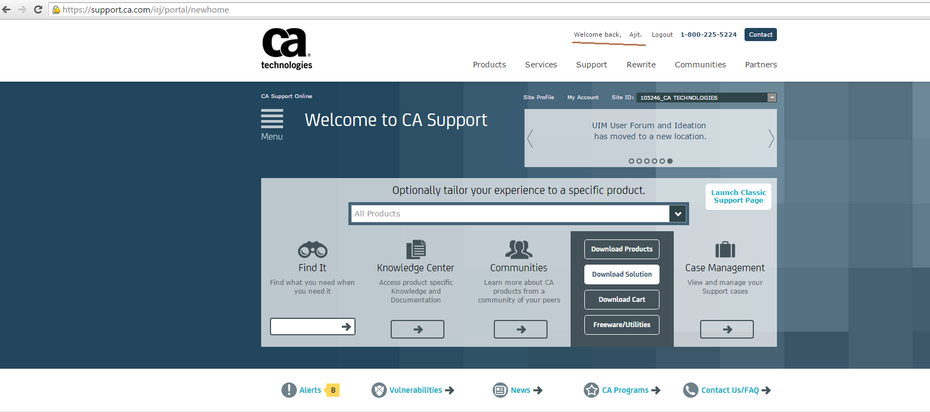

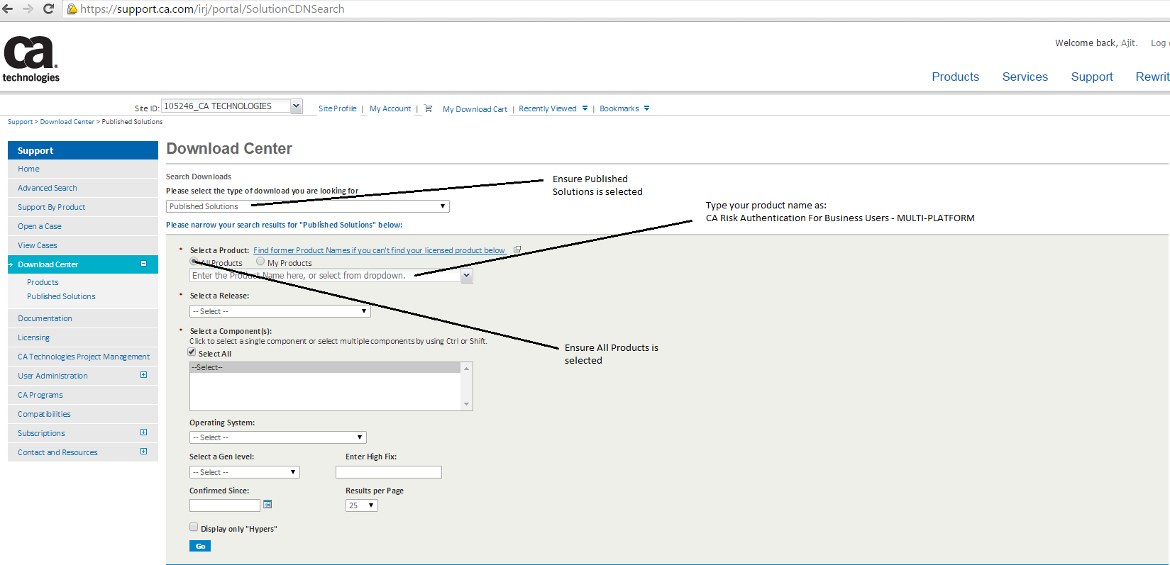

- In the “Please select the type of download you are looking for” box, please select ‘Published Solutions”.
- Select “All Products” radio button.
- Specify the product name “CA Risk Authentication for Business Users - MULTI-PLATFORM”.
- Select a release in the “Select a Release” drop down box.
- Check the box “Select All” if it’s not already checked.
- Click on the Go button.

The new screen shows the “Quova Data Files”
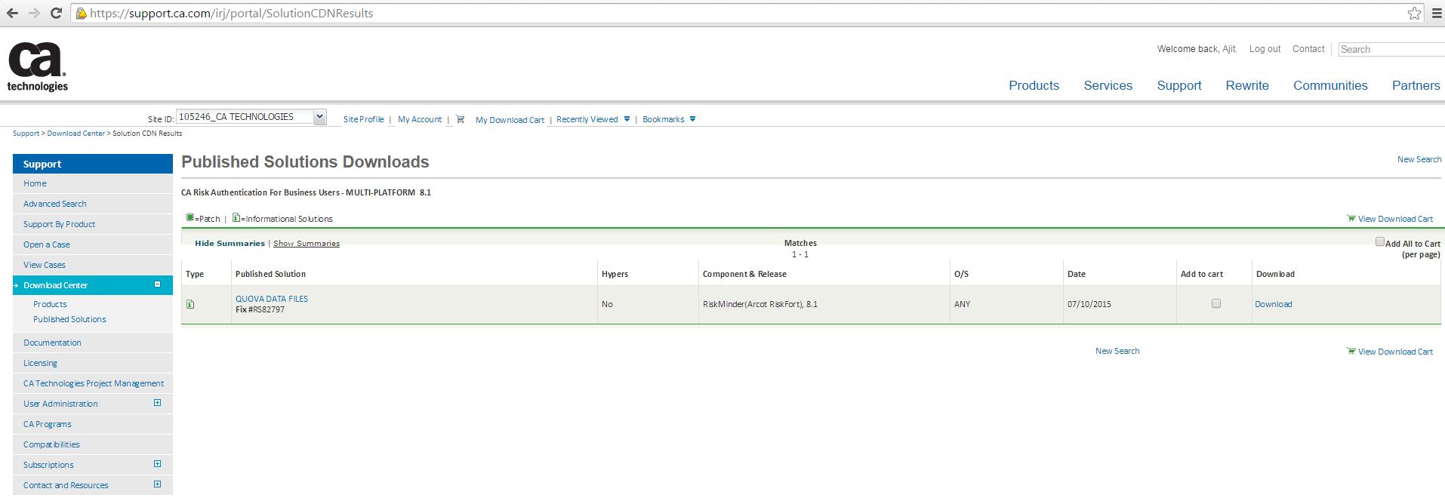
- Click on “Download”.
- Choose your Download Method and download the Quova data files.

If you have any questions or require assistance please contact CA Customer Care online at http://www.ca.com/us/customer-care.aspx where you can submit an online request using the Customer Care web form: https://communities.ca.com/web/guest/customercare. You can also call CA Customer Care at +1-800-225-5224 in North America or see http://www.ca.com/phone for the local number in your country.
Should you need any assistance, our CA Services experts can help. For more information on CA Services and how you can leverage our experience, please visit www.ca.com/services.
Your success is very important to us, and we look forward to continuing our successful partnership with you.

