How to block USB devices while excluding mouse and keyboard?

Problem
How to block USB devices while excluding mouse and keyboard?
Solution
1. Block USB devices
a. Login into the SEPM console.
b. Click Policies, then click Application and Device Control under View Policies.
c. Select the Application and Device Control policy which needs to be modified on the right-hand side.

d. Click Edit the Policy under Tasks.
e. In the pop-up window, click Device Control.
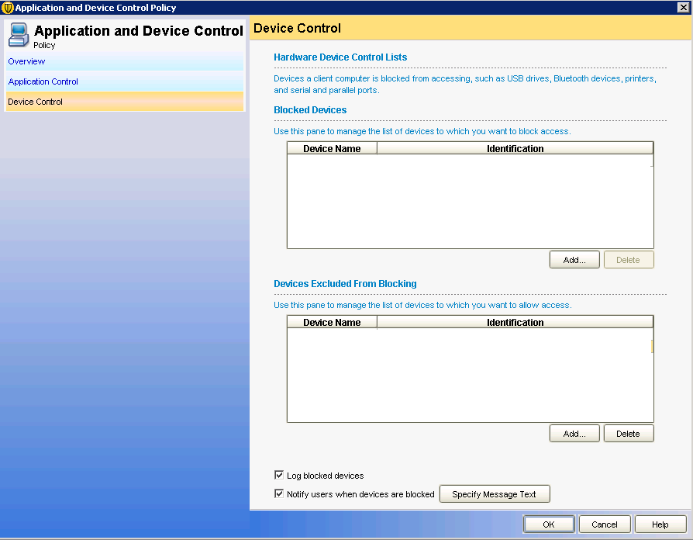
f. In the Blocked Devices section, click the Add... button.
e. Select USB in the next pop-up window.
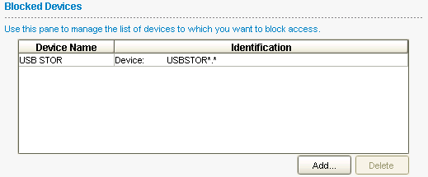
g. Click OK to confirm.
USB will be added into Blocked Devices section.

2. Exclude mouse and keyboard from being blocked.
a. In the Application and Device Control policy pop-up window, Add Human Interface Devices into the Devices Excluded From Blocking section.
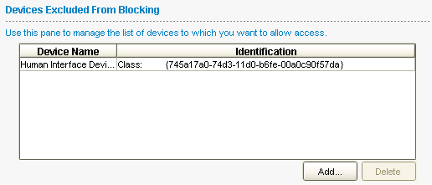
3. Assign the policy to the groups.

